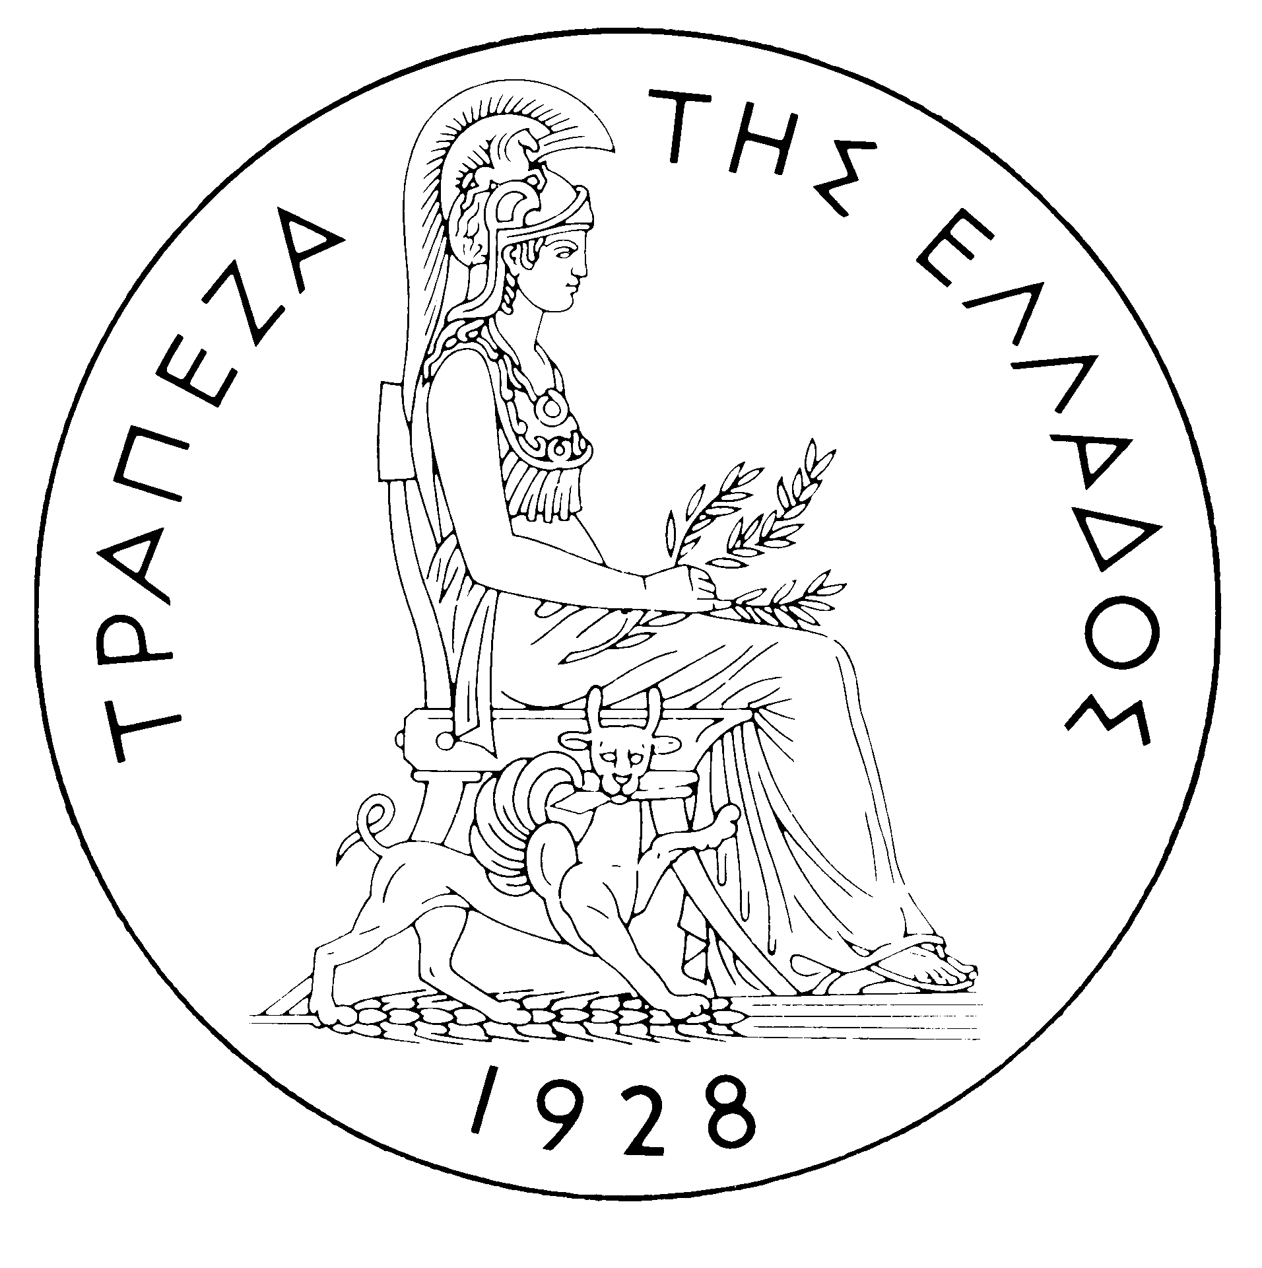
BANK OF GREECE

PRESS RELEASE

Athens, 14 February 2003
Subject: Balance of payments: DECEMBER 2002

Current account balance

In December 2002, the current account balance recorded a €1,556 million deficit, €447 million higher than in December 2001. This increase resulted from the widening of the trade deficit and the narrowing in the services surplus. The income account deficit also increased, same as the transfers surplus.

The widening of the trade deficit was mainly accounted for by the significant rise in the net oil import bill during December. At the same time, the non-oil trade deficit grew slightlyl. The decrease in the services surplus mainly resulted from the apparent drop in net travel receipts. It should be recalled at this point that, as from May 2002, travel receipts and payments are calculated on the basis of a sample survey (‘‘border survey’’) instead of data announced by banks. The large reduction observed in December 2002 (same as in November) in recorded travel receipts and travel payments is largely attributable to the fact that they reflect expenditure incurred by travellers in December 2002, while in 2001, due to the method then applied, relevant flows recorded through the banking system for the reference month may have included travellers’ expenditure incurred in previous months. For this reason, the data in question are not comparable with those for 2001. The income account deficit increased in December 2002, mainly because of the rise in net payments for interest, dividends and profits. Finally, the increase in the transfers surplus reflects the rise in net receipts of general government (mainly net receipts from the EU) in that month.

In 2002 (year total), the current account deficit grew by €951 million, compared with that in 2001, and came to €9,120 million. This development reflects mainly the narrowing of the transfers surplus and the widening of the trade deficit, the latter being connected to a rise in both the non-oil trade deficit and the net oil import bill. A small increase was also recorded in the income account deficit. These developments were only partly offset by the considerable rise in the services surplus.

The non-oil trade deficit grew by €589 million in 2002, as a result of the considerable reduction (of €584 million) in export receipts, with the import bill remaining unchanged and net oil imports rising by €508 million.

In 2002, the services surplus increased, as the fall in net transport receipts was more than offset by the apparent considerable rise in net receipts from travel services, which is partly due to the aforementioned change in the methodology of recording travel receipts and payments. Moreover, upon compiling the balance of payments for December 2002, previous months' data on travel services were revised. Specifically for the period May-October 2002, data were reassessed with corrections on the expenditures of residents and non-residents, which on the basis of the border survey had been initially recorded under a reference month, while on the basis of the travellers' length of stay, it turns out that they partly concern the previous month also. This reassessment did not affect total amounts for the year. For the period January-April 2002, however, data have – on the whole -- been revised downwards; thus, monthly data for 2002 are mutually comparable and consistent with the seasonal pattern recorded by the border survey. This revision took into consideration travellers' per capita expenses and the seasonality of arrivals-departures, as these are estimated on the basis of the border survey. Nevertheless, it is stressed once again that the data for the year 2002 ARE NOT COMPARABLE with those for 2001.

The income account deficit rose in 2002, because of the fall in net receipts from fees and wages and the slight rise in net payments for interest, dividends and profits. Finally, the decrease in the transfers surplus is attributable to the drop both in the net receipts of "other" (non-general government) sectors and in net EU transfers. It should be recalled that, as from September 2002, general government receipts from, and payments to, the EU are recorded separately (and not on a "net" basis, as was the case in the past). Back data have been revised accordingly, so as to be comparable with new data.

Financial account balance

In December 2002, residents' direct investment abroad came to €150 million, of which €101 million concern the acquisition of BP Cyprus by Hellenic Petroleum. Under portfolio investment, a small net outflow of €46 million was recorded, mainly reflecting the large outflow of residents' funds for the purchase of foreign bonds, which, however, was offset to a large extent by the inflow of non-residents' funds for the purchase of Greek bonds and shares. As regards "other investment", a net inflow of €2,030 million was recorded, connected mainly to the increase in deposits and repo holdings by non-residents.

In 2002, direct investment recorded net outflows of €643 million, mainly attributable to residents’ investment abroad. During the year, there was a substantial net inflow (of €10,938 million) for portfolio investment, connected with the considerable inflow of foreign investors’ funds, mainly for the purchase of Greek bonds and, to a lesser extent, for the purchase of shares. The outflow of funds for the purchase of, mainly, foreign bonds by Greek investors is also considerable. The continuing shift of both foreign and Greek investors to the bond market reflects the cautiousness with which investors still view developments in the international stock markets. Finally, "other investment" recorded a net inflow of €1,999 million. This development is connected to the considerable rise in deposits and repo holdings by non-residents in Greece and by residents abroad. It should also be noted, as far as liabilities are concerned, that repayment of general government loans was quite substantial (€4,510 million).

At year-end, Greece’s reserve assets came to €9 billion, compared with €7 billion at the end of 2001. (It should be recalled that, since Greece joined the euro area in January 2001, reserve assets, as defined by the European Central Bank, include only monetary gold, the "reserve position" at the IMF, "Special Drawing Rights", and Bank of Greece's claims in foreign currency on residents of non-euro area countries. Conversely, reserve assets do not include claims in euro on residents of non-euro area countries, claims in foreign currency and in euro on residents of euro area countries, and the Bank of Greece participation in the capital and the reserve assets of the ECB.)

Note: Balance of payment data for January 2003 will be released on 17 March 2003.

