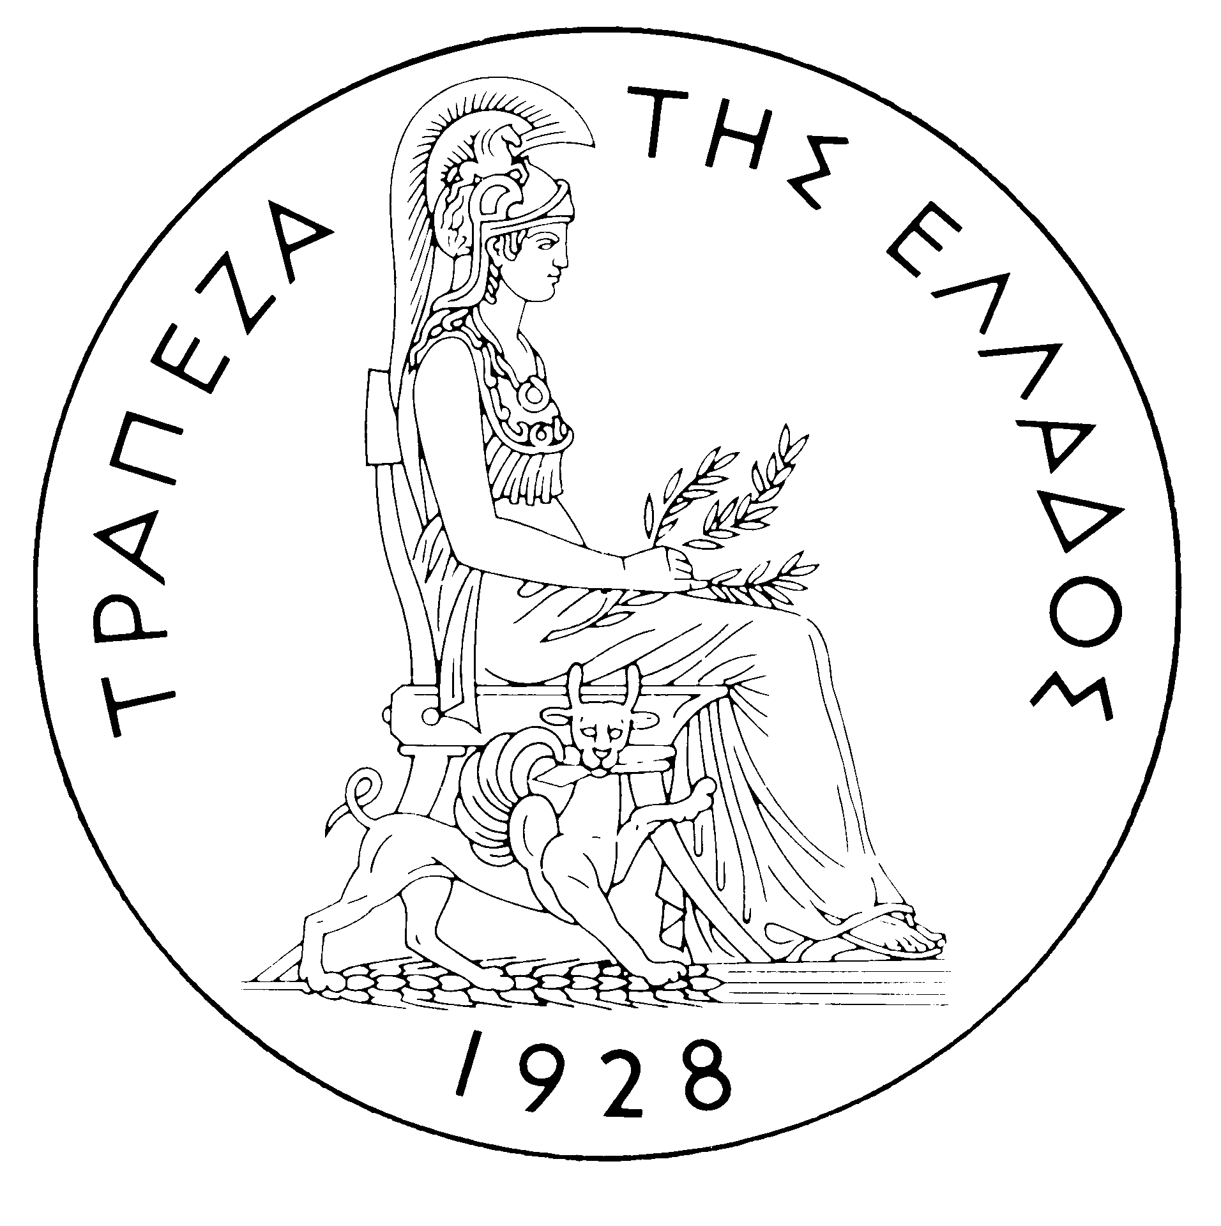
BANK OF GREECE

PRESS RELEASE

Athens, 23 January 2004

Re: Balance of payments NOVEMBER 2003

Current account balance

In November 2003, the current account deficit narrowed considerably year-on-year. This mainly came as a result of a decrease in the trade deficit and, to a lesser extent, of an increase in the services surplus and a decline in the income account deficit. These favourable developments were partly offset by a fall in the transfers surplus.

In particular, the improvement of the trade balance is mainly due to a decrease in the non-oil import bill, as well as an increase in non-oil export receipts, while the net oil import bill showed a small rise. The increase in the services surplus mainly stemmed from the growth of net transport receipts and, secondarily, of travel receipts. It should be stressed that the November 2003 travel receipts and payments data are comparable year-on-year and are derived from a border survey. The narrowing of the income account deficit is accounted for by a decrease in net interest, dividend and profit payments. Finally, the decrease in the transfers surplus mainly reflects a decline in net EU transfers to general government, which is connected with a large increase in general government transfers to the EU.

In January-November 2003, the non-oil trade deficit fell, while the services surplus grew. These favourable developments, however, were offset by the rise in the net oil import bill, the widening of the income account deficit and the narrowing of the transfers surplus, all of which led to a slight increase (of €43 million year-on-year) in the current account deficit, which reached €7,057 million.

Specifically, as a result of a €468 million rise in non-oil export receipts in January-November 2003 and a decline of €337 million in the non-oil import bill, the non-oil trade deficit narrowed by €805 million. By contrast, over the same period, the net oil import bill increased by €481. Despite the drop in net travel receipts, the services surplus grew owing to a considerable rise in net transport receipts. (It should be recalled that the travel balance statistics for the entire January-November 2003 period are not comparable with those in the corresponding period of 2002, as their compilation on the basis of the relevant border survey started in mid-May 2002.) The income account deficit widened by €512 million as a result of increased net interest payments on Greek government bonds, owing to the continued rise in non-residents’ holdings of such securities. Finally, underlying the €472 million reduction in the transfers surplus was a decline in net EU transfers to general government. This decrease more than offset the growth of net transfers to other sectors.

Financial account balance

In November 2003, a substantial outflow was observed under direct investment, associated with the sale by Deutsche Bank of its Eurobank equity package. Under portfolio investment, a net outflow of €514 million reflects an outflow of residents’ funds for the purchase of foreign bonds, which more than offset the inflow of non-residents’ funds for the purchase of Greek government bonds and shares of Greek firms (including the purchase of shares of the Public Power Corporation by non-residents). Finally, as regards "other investment", the net inflow of €2,017 million was mainly connected with an increase in non-residents’ deposits and repo holdings in Greece.

In January-November 2003, a net outflow of €599 million was observed under direct investment. Over the same period, a substantial net inflow of €10,641 million was recorded under portfolio investment. This development is mainly associated with an inflow of foreign investors’ funds for the purchase of Greek bonds, which was considerably larger than in the corresponding period in 2002. At the same time, residents’ portfolio investment abroad grew notably, mainly as a result of Bank of Greece’s investment in bonds issued by euro area Member States. It should be recalled that, in the context of its portfolio restructuring, the Bank of Greece reduced its holdings of non-euro area currencies; this led to an equal reduction in its reserve assets. Finally, under ‘‘other investment’’ a net outflow of €6,180 million was recorded, which is connected with residents’ (mainly credit institutions’) continued sizeable outflows to deposits and repos abroad, on the one hand, and substantial loan repayments (mainly by general government), on the other.

At end-November 2003, Greece’s reserve assets came to €5.1 billion. (It should be recalled that, since Greece joined the euro area in January 2001, reserve assets, as defined by the European Central Bank, include only monetary gold, the "reserve position" with the IMF, "Special Drawing Rights", and Bank of Greece claims in foreign currency on residents of non-euro area countries. Conversely, reserve assets do not include claims in euro on residents of non-euro area countries, claims in foreign currency and in euro on residents of euro area countries, and the Bank of Greece participation in the capital and the reserve assets of the ECB.)

Note: Balance of payments data for December 2003 will be released on 19 February 2004.

