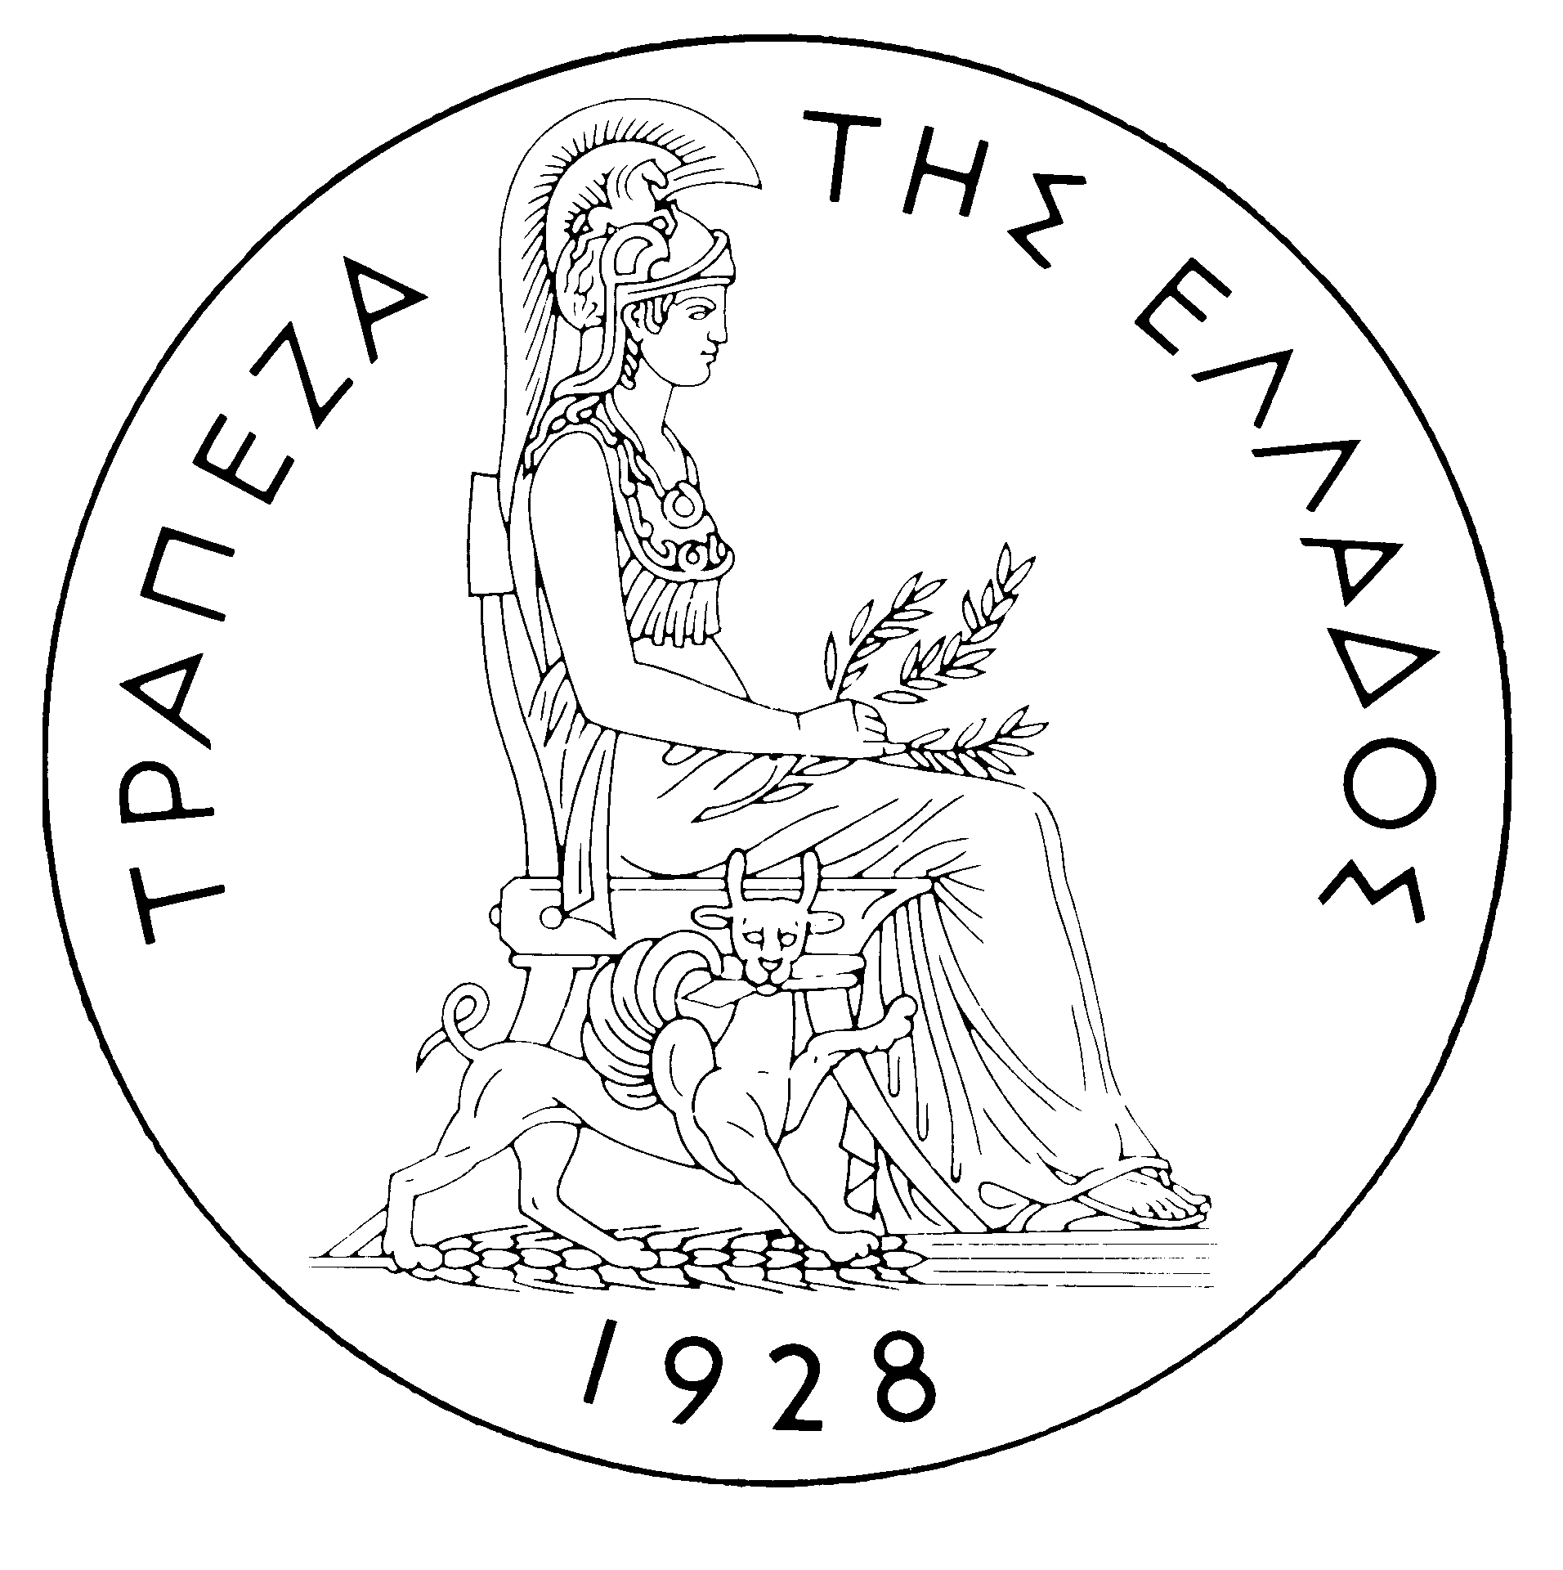
BANK OF GREECE

PRESS RELEASE

Athens, 20 April 2005

Re: Balance of payments FEBRUARY 2005

Current account balance

In February 2005, the current account deficit showed a deficit of €402 million, compared with a surplus of €102 million in the same month of 2004. This development is accounted for by a considerable widening of the trade and the income account deficits and a decrease in the transfers surplus, which were not offset by the increase in the services surplus.

Underlying the widening of the trade deficit was mainly a rise in the non-oil trade deficit, while at the same time the net oil import bill grew. The improvement in the services surplus is attributable to a rise in net transport (mainly shipping) receipts, while net travel receipts remained virtually unchanged and net payments for “other” services rose. The income account deficit more than doubled, mainly as a result of the increase, year-on-year, in interest payments on Greek Government bonds and loans. Finally, the year-on-year decline in the transfers surplus mainly reflects a decrease in net EU transfers to general government, while the net receipts of the other sectors (emigrants' remittances etc.) also fell.

In the January-February 2005 period, the current account deficit rose considerably (by €813 million) over the same period of 2004 and reached €2,009 million. This development reflects a substantial increase in the trade deficit, a narrowing of the transfers surplus and a small rise in the income account deficit. These developments were only partly offset by the growth of the services surplus.

The trade deficit grew by €582 million over the same period of 2004. Specifically, the non-oil import bill rose by €351 million (or 7.3%), while non-oil export receipts were virtually unchanged. However, it should be noted that this deterioration in the non-oil trade deficit is attributable to net payments for the purchase of ocean-going vessels. Thus, the trade deficit excluding ships and oil improved by €105 million in the period under review (January-February 2005: €3,203 million, January-February 2004: €3,308 million).) Over the same period, the net oil import bill increased by €211 million.

By contrast, the services surplus grew by €154 million, mainly owing to a €266 million rise in net transport receipts (mainly from shipping). This increase more than offset the decline in net travel receipts and the growth of net payments for ‘‘other’’ services. Over the same period, the income account deficit widened by €61 million due to increased interest, dividend and profit payments, as already mentioned.

Finally, a €324 million year-on-year decline in the transfers surplus is mainly accounted for by a decrease in EU transfers to general government and, to a lesser extent, a fall in the net receipts of the “other” sectors.

Financial account balance

In February 2005, a €184 million outflow was observed under residents’ direct investment abroad. The most important investments concern the acquisition of JUBANKA bank in Serbia by ALPHA BANK (€152 million), as well as the participation of the National Bank of Greece in the increase of the share capital of ROMANEASCA Bank in Romania (€32 million). Moreover, a €30 million net inflow was observed under non-residents’ investment in Greece. Under portfolio investment, a net inflow of €947 million was mainly accounted for by non-residents’ investment in Greek government bonds and shares of Greek firms. This inflow was largely offset by residents’ outflows for the purchase of bonds issued by non-residents. Finally, as regards "other investment", a substantial inflow of non-residents’ funds was observed, mainly to deposits and repos, which was more than offset by an outflow of residents', mainly credit institutions’ and institutional investors’, funds to deposits and repo holdings abroad and, secondarily, by an outflow of funds for the repayment of loans granted by non-residents.

In January-February 2005, non-residents’ direct investment in Greece reached €100 million, while residents’ direct investment abroad came to €208 million. Over the same period, a net inflow of €1,117 million was recorded under portfolio investment, as the outflow of residents’ funds for investment abroad (mainly purchases of bonds, of €3,985 million) was more than offset by the inflow of non-residents’ funds for investment in Greece (mainly purchases of Greek government bonds and shares of Greek firms, of €4,424 and €974 million respectively). Finally, a net inflow of €416 million under ‘‘other’’ investment is mainly associated with substantial inflows of non-residents’ funds to deposits and repos in Greece (of €11,283), which were offset by outflows of residents’ funds (of €10,091 million) to deposits and repos abroad and outflows (of €748 million) for the repayment of loans granted to residents by non-residents.

At end-February 2005, Greece’s reserve assets came to €1.8 billion. (It should be recalled that since the first months of 2003 the Bank of Greece has started to diversify its portfolio, by reducing its non-euro area currency holdings, which are included in reserve assets, and increasing its assets which had higher yields and are mainly denominated in euro – predominantly bonds issued by euro area Member States, which are not included in reserve assets. It has been noted repeatedly that, since Greece joined the euro area in January 2001, reserve assets, as defined by the European Central Bank, include only monetary gold, the reserve position in the IMF, special drawing rights, and Bank of Greece claims in foreign currency on residents of non-euro area countries. Conversely, reserve assets do not include claims in euro on residents of non-euro area countries, claims in foreign currency and in euro on residents of euro area countries, and the Bank of Greece participation in the capital and the reserve assets of the ECB.)

Note: Balance of payments data for March 2005 will be released on 24 May 2005.

