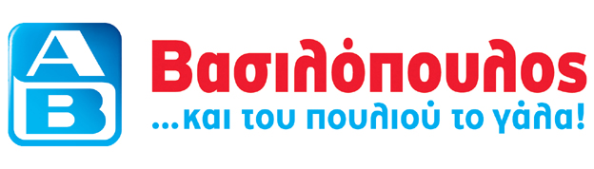
May 26, 2005

PRESS RELEASE

RECYCLING CENTERS ALFA BETA VASSILOPOULOS S.A.

Environmental Protection is yet another way «ALFA-BETA» demonstrates its social role. In full knowledge of the fact that the environment should be protected for the future, «ALFA-BETA» has been implementing the most advanced practices.
«ALFA-BETA» VASSILOPOULOS is the only Greek company to have received a «Μinistry of the Environment and Public Works» certification for Individual System for Alternative Packaging Management, (FEK 1108/22.7.04), for developing the first individual management system for recyclable packaging for its own label products and those for which it is the exclusive importer. «ALFA-BETA» VASSILOPOULOS in collaboration with TEXAN (Environmental Systems οf Alternative Management L.T.D.), is the only company in Greece and in Europe that apply the Individual System for Alternative Packaging Management.
There are already three integrated systems for the collection of a large group of recyclable materials in Mega Helliniko, Mega Ethniki and Vrilissia stores. These collection points are fully equipped with automatic apparatus for collecting plastic bottles, metal tins (aluminum-tin can), paper, flasks, plastic bags, batteries, metal receptacles and plastic dispensers. Recycling Centers have been installed in the main entrance of the stores, making possible for the customers and the residents of the surrounding areas to recycle at the same point, eight different materials, 24 hours a day.
«ΑLFA-BETA» has put into practice an innovative award system to support and encourage recycling; it gives a voucher to anyone who recycles flasks, plastic bottles (refreshments, water, milk…), metal boxes (aluminum and tin-can). The voucher can be redeemed at the store as a discount on purchases. Alternatively, it can be offered as a social contribution in support of the «Child’s Smile» (To hamogelo tou paidiou) a non-profit foundation. Our customers’ response to the first collection point for different products was impressive.
Further significant investment in recycling, by installing plastic bottles and metal boxes collection apparatus, has been done in the 23 stores below:
viroναs (34 Karaoli dimitriou) | VARI | GLYFADA | ΖOGRAFOU* | ΙLION | ΚIFISSIA
ΚΑSTELLA | ΜΕLISSIA | Ν.ΜΑKRI | ΠΑTISSIA (342 Patissia) | PAGRATI | PERISTERI* (54, Eth. Makariou)
PETROUPOLI | PEYKI | FILOTHEI | CHAIDARI | PSYCHICO* | VOLOS (107, 2nd Νοvember)
ΚΑLAMATA (13, Crete) | CORFU (2nd klm N.R. Corfu-Palaiokastritsa | PATRA* (Dimeon Coast) | PATRA* (National Road) | CHALKIDA (G.Papandreou) | *Αutomatic centers for aluminum boxes

More recycling centers will open in rest «ALFA-BETA» stores soon!
Least but not last, the recycling logo, which characterizes all the recycling centers and soon the private label products that their packages consist of recyclable materials, has been patented by «ΑLFA-BETA» VASSILOPOULOS.
For further information, you can visit our website: www.ab.gr

«ALFA-BETA» VASSILOPOULOS S.A.
«ALFA-BETA» VASSILOPOULOS S.A., is a food retail company established in 1969 and member of the Belgian Delhaize Group since 1992. At the end of 2004, the group «ALFA-BETA» operated 129 stores (100 retail sales points, 10 Cash-and-Carry stores, & 19 franchising stores) and employed 6,517 people. In 2004, Consolidated Turnover amounted to EUR 934.6 million and Consolidated Net Profit before taxes to EUR 15.8 million. «ALFA-BETA» VASSILOPOULOS S.A. is listed on the Athens Stock Exchange (BASIK) since 1990.

