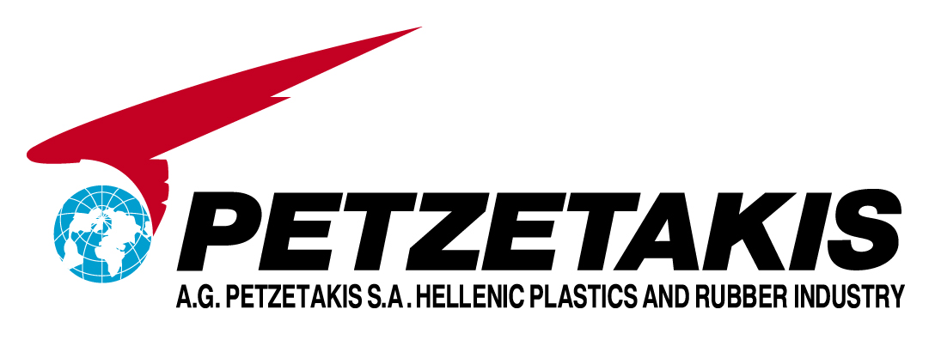

ARISTOVOULOS G. PETZETAKIS S.A.
HELLENIC INDUSTRY OF PLASTICS AND RUBBER

PRESS RELEASE
1ST QUARTER FINANCIAL RESULTS (in accordance with IFRS)

- Strong improvement in the operational results despite slower sales
  - EBIT at €2.4 ml, 32% increase vs 1st quarter of 2004
  - EBITDA at €5.2ml, 23% increase vs 1st quarter of 2004
- Disposal of Cyclon participation resulted in α € 5ml non-cash loss that affected results
- Net worth at €64 ml under IFRS despite Cyclon disposal and Imperial Plastech write-off.

Company results for the 1st quarter of 2005, as management has already warned, were negatively affected by the sales decline in Greece and S. Africa. However, operational improvements in the group have lead to strong operational results, as seen in the table below.

Profit & Loss Account for the period (amounts in ‘000 Euro )

It should be noted the improvements seen at the parent company level despite the (i) decline in the sales volume, (ii) the absence of economies of scale and (iii) the increase in marketing expenditures in relation to the previous year. The improvements at the operational level came as the result from the sustained focus of the group’s management to continuously improve sales quality and the lower the production costs.

Net results were affected by increased interest expenses amounting to €2.1 mil due to default interest resulting from the continuous delays in the signing of the company’s refinancing, as well as a one-off and non-cash loss of €4.9 mil resulting from the disposal of the group’s participation in Cyclon. It should be noted that the group’s net worth remains at €64 ml under IFRS despite Cyclon participation liquidation and the Imperial Plastech write-off.

ΕΒITDA per Geographical Area
Geographical Area |  |  | 2005 vs 2004 | % Group
Geographical Area | 2005 | 2004 | 2005 vs 2004 | 2005 | 2004
Greece | 2.741 | 1.951 | 40.5% | 53% | 46%
Rest of Europe | 1.365 | 832 | 64.1% | 26% | 20%
Africa | 1.051 | 1.421 | -26.0% | 20% | 34%
Petzetakis Group | 5.157 | 4.204 | 22.7% | 100% | 100%

Sales: The sales in Greece and S. Africa dropped by aapproximately 16%, whereas the Spanish subsidiary reported a sales increase of 33% thanks to a successful launch of new products, in the constructions’ market, that were designed with the technical know-how of the parent company. This increase counterbalanced the decline in sales; hence, the decline rate was limited to 8.7%.

Sales Analysis per Geographical Area
Geographical Area |  |  | 2005 vs 2004 | % Group
Geographical Area | 2005 | 2004 | 2005 vs 2004 | 2005 | 2004
Greece | 18.677 | 22.209 | -15.9% | 41% | 44%
Rest of Europe | 12.667 | 11.461 | 10.5% | 28% | 23%
Africa | 18.720 | 22.313 | -16.1% | 41% | 44%
Intercompany Sales | 4.018 | 5.575 |  | 9% | 11%
Petzetakis Group | 46.046 | 50.408 | -8.7% | 100% | 100%

S. Africa is steadily coming out of a slow-start for the year. The prolonged slowdown of the Greek market and especially the Public Infrastructure Projects, finds the group’s management concerned regarding the outlook of the turnover in the Greek market. Overall however, the group’s management remains firm in its initial stand in the Press Release of April 26th; the results of the current year will increase in comparison to those of 2004.

Objectives
Group’ management has set the following objectives for the forthcoming quarters

- Lowering the interest costs by examining alternative ways to finance the group
- Further improvement of operational results by
- reducing operational costs and improving overall productivity in the plants of the group,
- Strengthening distribution channels,
- Improving sales volume in Greece for Infrastructure projects in N. Africa and the Balkans while expanding S. Africa’s sales around its neighboring countries.

