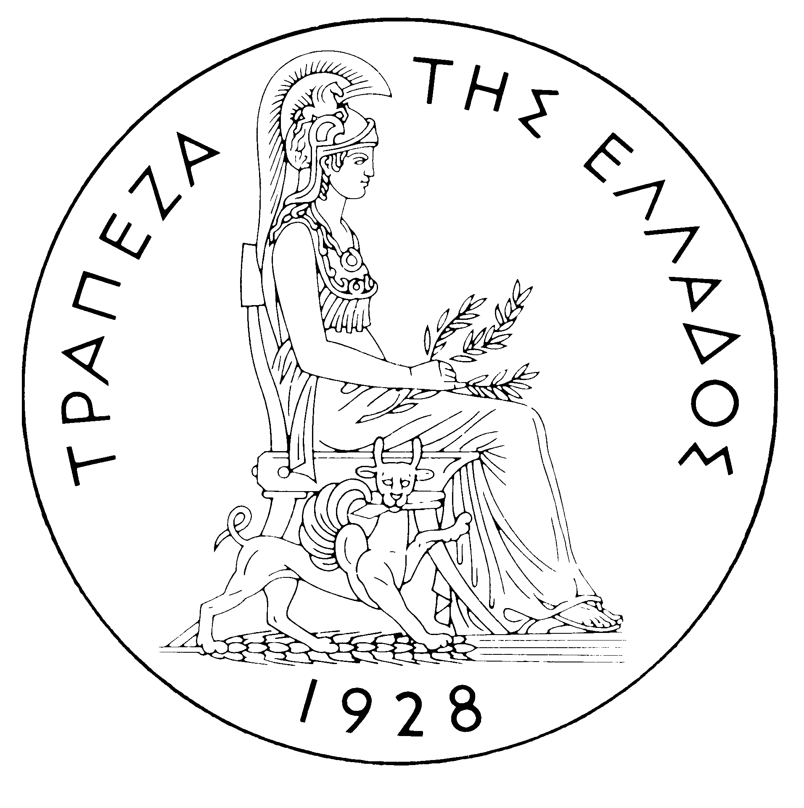
BANK OF GREECE

PRESS RELEASE

Athens, 23 June 2005

Re: Balance of payments APRIL 2005

Current account balance

In April 2005, the current account showed a deficit of €1,729 million, i.e. it rose by €405 million year-on-year. This development is mainly accounted for by an increase in the trade deficit and, secondarily, a decline in the transfers surplus and a rise in the income account deficit, while the services surplus decreased only slightly.

Specifically, underlying the widening of the trade deficit was almost exclusively a substantial rise in the net oil import bill. By contrast, the trade deficit excluding oil and ships narrowed. The services surplus fell only slightly, mainly owing to a small rise in the “other” services deficit and a small decline in net transport receipts year-on-year. By contrast, a small increase was observed in net travel receipts, as gross receipts (i.e. non-residents’ travel expenses in Greece) dropped by €6 million only, while gross payments (i.e. residents’ travel expenses abroad) fell by €30 million.

The income account deficit grew as a result of a year-on-year increase in interest payments on Greek Government bonds and loans. It should be pointed out that, as from April 2005, there is an important change in the methodology of recording interest on bonds in the balance of payments statistics. From now on, interest payments on an accruals basis will be recorded in the balance of payments statistics, instead of interest actually paid, as until March 2005. This methodological change is effected with a view to fulfilling Greece’s obligation to harmonise the practice of recording interest with the international standards of the IMF (Balance of Payments Manual – 5th edition) and Eurostat (ESA95). At the same time, the amount of interest paid to non-residents is recorded more accurately.

Specifically, under the previous methodology, which was based on reported data concerning transactions through the banking system, when a breakdown into principal and interest payments was not available, banks used to report the entire amount paid, which was then recorded in the balance of payments statistics as principal payment. Furthermore, when interest or interest and principal were reinvested, which is a very usual practice in portfolio management, banks, despite the relevant instructions, were not always able to report to the system two entries: an outflow of interest abroad and a simultaneous re-inflow of interest for investment in securities or deposits. These weaknesses had led to doubts about the exact amount of interest recorded in the balance of payments statistics. The Bank of Greece, in order to adjust the methodology to international standards, has been collecting since the beginning of 2004 (according to Bank of Greece Governor’s Act 2537/11 February 2004) detailed data on a monthly basis on both banks’ own portfolios and the portfolios managed by banks acting as custodians on behalf of third parties (residents or non-residents). This gradually led to the creation of the necessary database and it is now possible to estimate the interest accruals corresponding to residents’ foreign securities portfolio holdings and non-residents’ Greek securities portfolio holdings. On the basis of this information and the relevant estimates, the data on interest for the previous months up to (and including) January 2003 were also revised. Thus, the Balance of Payments Tables show comparable data on interest accruals for the years 2003, 2004 and 2005 (the detailed revised data are available on the Bank of Greece's website: http://www.bankofgreece.gr/en/sdds/SDDS-EXTERNAL-BALANCEOFPAYMENTS.xls ).

Finally, the year-on-year decline in the transfers surplus reflects a decrease both in net EU transfers to general government (as a €188 million rise in gross receipts was more than offset by a €203 million increase in gross payments) and in the net receipts of the other sectors (emigrants' remittances etc.).

In the January-April 2005 period, the current account deficit rose considerably (by €1,783 million) over the same period of 2004 and reached €5,431 million. This development mainly reflects an increase in the trade deficit, a narrowing of the transfers surplus and – to a lesser extent – a rise in the income account deficit. By contrast, the services surplus grew slightly.

The trade deficit increased by €1,016 million year-on-year. Specifically, the breakdown of receipts and payments shows that the non-oil balance has been affected considerably by purchases and sales of ocean-going vessels. In particular, net payments for ships reached

€335 million in the first four months of 2005, compared with net receipts of €225 million in the corresponding period of 2004, thus contributing to an increase in the trade deficit by €560 million over the same period. At the same time, the net oil import bill rose by €546 million. By contrast, the trade deficit excluding oil and ships fell slightly (by €90 million), reflecting the fact that the €165 million (or 5.2%) decline in export receipts excluding oil and ships was smaller than the €255 million (or 2.5%) decrease in the import bill excluding oil and ships.

The services surplus grew by €101 million, owing to a further rise in net transport (mainly shipping) receipts (by €250 million, compared with the high level recorded in the first four months of 2004). Gross travel receipts rose by €89 million (or 9.9%), but gross payments increased by €101 million (or 16.4%); as a result, net travel receipts declined slightly (by €12 million). Furthermore, net payments for ‘‘other’’ services rose.

Over the same period, the income account deficit widened by €143 million owing to increased net payments for interest, dividends and profits.

Finally, a €726 million year-on-year decline in the transfers surplus is mainly accounted for by a €505 million decrease in net EU transfers to general government. Actually, while gross EU transfers to general government rose slightly (by €10 million), gross general government payments to the EU increased substantially (by €515 million). At the same time, the net receipts of the “other” sectors dropped by €221 million.

Financial account balance

In April 2005, financial flows under residents’ direct investment abroad and non-residents’ direct investment in Greece were relatively low. The most important development was a €40 million inflow in the context of the acquisition of INTERAMERICAN by the Portuguese bank BCP. Under portfolio investment, a substantial net inflow of €6,774 million was mainly accounted for by non-residents’ investment (of €6,517 million) in Greek government securities. As regards “other” investment, a substantial outflow of residents’ funds was observed, mainly as a result of an increase in resident credit institutions’ deposits and repo holdings abroad, while at the same time a remarkable outflow (of €1,634 million) was recorded mainly because the €2,402 million decline in non-residents’ deposits and repo holdings in Greece more than offset the granting of a €758 million loan to the Greek government.

In January-April 2005, direct investment showed a net inflow of €55 million (compared with a €486 million net inflow in the same period of 2004). This development is accounted for by the fact that residents’ direct investment abroad came to €224 million, while non-residents’ direct investment in Greece reached €279 million. Over the same period, a net inflow of €5,759 million was recorded under portfolio investment, as outflows of residents’ funds for investment abroad was offset by an almost double inflow of non-residents’ funds for investment in Greece. Finally, a net outflow of €749 million under ‘‘other’’ investment is mainly associated with substantial outflows of residents’ funds (of €11,383 million), mainly to deposits and repos abroad, which were largely offset by non-residents’ inflows (of €10,634 million), mainly to deposits and repos in Greece. Inflows under “other” investment include a €510 million net increase in general government borrowing.

At end-April 2005, Greece’s reserve assets came to €1.75 billion. (It should be recalled that since the first months of 2003 the Bank of Greece has started to diversify its portfolio, by reducing its non-euro area currency holdings, which are included in reserve assets, and increasing its assets which have higher yields and are mainly denominated in euro – predominantly bonds issued by euro area Member States, which are not included in reserve assets. It has been noted repeatedly that, since Greece joined the euro area in January 2001, reserve assets, as defined by the European Central Bank, include only monetary gold, the "reserve position" with the IMF, "Special Drawing Rights", and Bank of Greece claims in foreign currency on residents of non-euro area countries. Conversely, reserve assets do not include claims in euro on residents of non-euro area countries, claims in foreign currency and in euro on residents of euro area countries, and the Bank of Greece participation in the capital and the reserve assets of the ECB.)

Note: Balance of payments data for May 2005 will be released on 19 July 2005.

