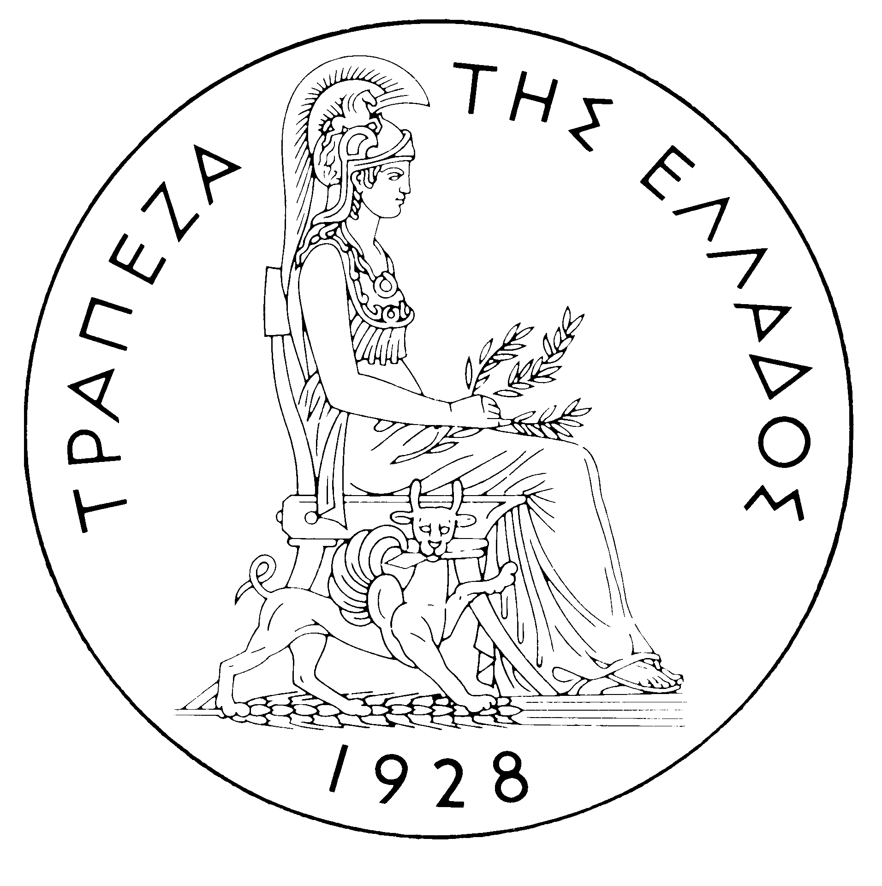
BANK OF GREECE

PRESS RELEASE

Athens, 19 July 2005

Re: Balance of payments MAY 2005

Current account balance

In May 2005, the current account deficit was €575 million, i.e. it fell by €138 million year-on-year. This development is mainly accounted for by a considerable increase in the transfers surplus and, secondarily, a widening of the services surplus. By contrast, the income account deficit grew, while the trade deficit was virtually unchanged.

Specifically, underlying the slight increase in the trade deficit was the growth of the trade deficit excluding oil and ships, while the rise in the oil deficit was almost fully offset by a rise in the surplus of the ships' balance. The services surplus increased in comparison with May 2004, mainly owing to a rise in net transport receipts and – to a lesser extent – in net travel receipts. The income account deficit grew mainly because interest payments on Greek Government bonds (on an accruals basis) rose year-on-year. It should be recalled that, as from April 2005, the methodology of recording interest on bonds in the balance of payments statistics changed, so that interest payments are recorded on an accruals basis, rather than on the basis of interest actually paid (as they had been until March 2005), and data are more accurate. However, to ensure comparability, the data on interest for the previous months back to (and including) January 2003 were also revised. Finally, the substantial year-on-year increase in the transfers surplus reflects exclusively a rise in net EU transfers to general government, while net transfers to the other sectors dropped.

In the January-May 2005 period, the current account deficit rose considerably (by €1,646 million) over the same period of 2004 and reached €6,006 million. This development mainly reflects an increase in the trade deficit and a narrowing of the transfers surplus; to a lesser extent, it reflects a rise in the income account deficit. By contrast, the services surplus grew slightly.

The overall trade deficit (which includes the oil and the ships' balances) increased by €1,047 million over the same period of 2004. Specifically, the non-oil balance has been affected considerably by purchases and sales of ocean-going vessels. In particular, in the first five months of 2005, net payments of €228 million for the purchase of ships were recorded, compared with net receipts of €300 million from sales of ships in the same period of 2004. This pushed up the trade deficit by €528 million during the same period. At the same time, the net oil import bill rose by €581 million. By contrast, the trade deficit excluding oil and ships fell slightly (by €62 million), as imports decreased more than exports (by €147 million and €85 million respectively).

The services surplus grew by €171 million, owing to a further rise in net transport (mainly shipping) receipts; these were higher by €312 million compared with the already high receipts recorded in the first five months of 2004. Gross travel receipts rose by €120 million (or 6.5%), but gross payments increased by €121.5 million (or 15.0%); as a result, net travel receipts remained unchanged. Furthermore, net payments for ‘‘other’’ services rose. During the same period, the income account deficit widened by €221 million owing to increased net interest, dividend and profit payments. Finally, a €548 million year-on-year decline in the transfers surplus is mainly accounted for by a €278 million decrease in net EU transfers to general government. Actually, while gross EU transfers to general government rose (by €230 million), gross general government payments to the EU increased (by €508 million). At the same time, the net receipts of the “other” sectors dropped by €270 million.

Financial account balance

In May 2005, net outflows under residents’ direct investment abroad reached €106 million. The most important investments abroad by residents concerned a €68 million outflow for the acquisition of credit institutions in Serbia and Bulgaria by Piraeus Bank, as well as a €21 million outflow for the acquisition of an insurance company in Turkey by EUROBANK. As regards non-residents’ direct investment in Greece, a small net outflow (of only €15 million) was observed, as gross inflows were more than offset by a €62 million gross outflow owing to the withdrawal of the French company DANONE from DELTA HOLDING. Under portfolio investment, a net inflow of €1,167 million was mainly accounted for by non-residents’ investment (of €2,540 million) in Greek government securities, half of which was, however, approximately offset by residents’ purchases of foreign bonds. As regards “other” investment, a substantial outflow of residents’ funds was observed, exclusively as a result of a rise in resident credit institutions’ deposits and repo holdings abroad, while a remarkable inflow of funds was recorded, mainly stemming from non-residents’ increased deposit and repo holdings in Greece.

In January-May 2005, direct investment showed a net outflow of €66 million (compared with a €439 million net inflow in the same period of 2004). This development is accounted for by the fact that residents’ net direct investment abroad came to €330 million, while non-residents’ net direct investment in Greece reached €264 million. During the same period, a net inflow of €6,926 million was recorded under portfolio investment, as the outflow of residents’ funds for investment abroad was offset by an approximately double inflow of non-residents’ funds for investment in Greece. Finally, a net outflow of €1,187 million under ‘‘other’’ investment is associated with substantial outflows of residents’ funds, mainly to deposits and repos abroad (of €14,093 million), which were largely offset by inflows of non-residents’ funds (of €12,906 million), mainly to deposits and repos in Greece.

At end-May 2005, Greece’s reserve assets came to €1.7 billion. (It should be recalled that since the first months of 2003 the Bank of Greece has started to diversify its portfolio, by reducing its non-euro area currency holdings, which are included in reserve assets, and increasing its assets which have higher yields and are mainly denominated in euro – predominantly bonds issued by euro area Member States, which are not included in reserve assets. It has been noted repeatedly that, since Greece joined the euro area in January 2001, reserve assets, as defined by the European Central Bank, include only monetary gold, the "reserve position" with the IMF, "Special Drawing Rights", and Bank of Greece claims in foreign currency on residents of non-euro area countries. Conversely, reserve assets do not include claims in euro on residents of non-euro area countries, claims in foreign currency and in euro on residents of euro area countries, and the Bank of Greece participation in the capital and the reserve assets of the ECB.)

Note: Balance of payments data for June 2005 will be released on 18 August 2005.

