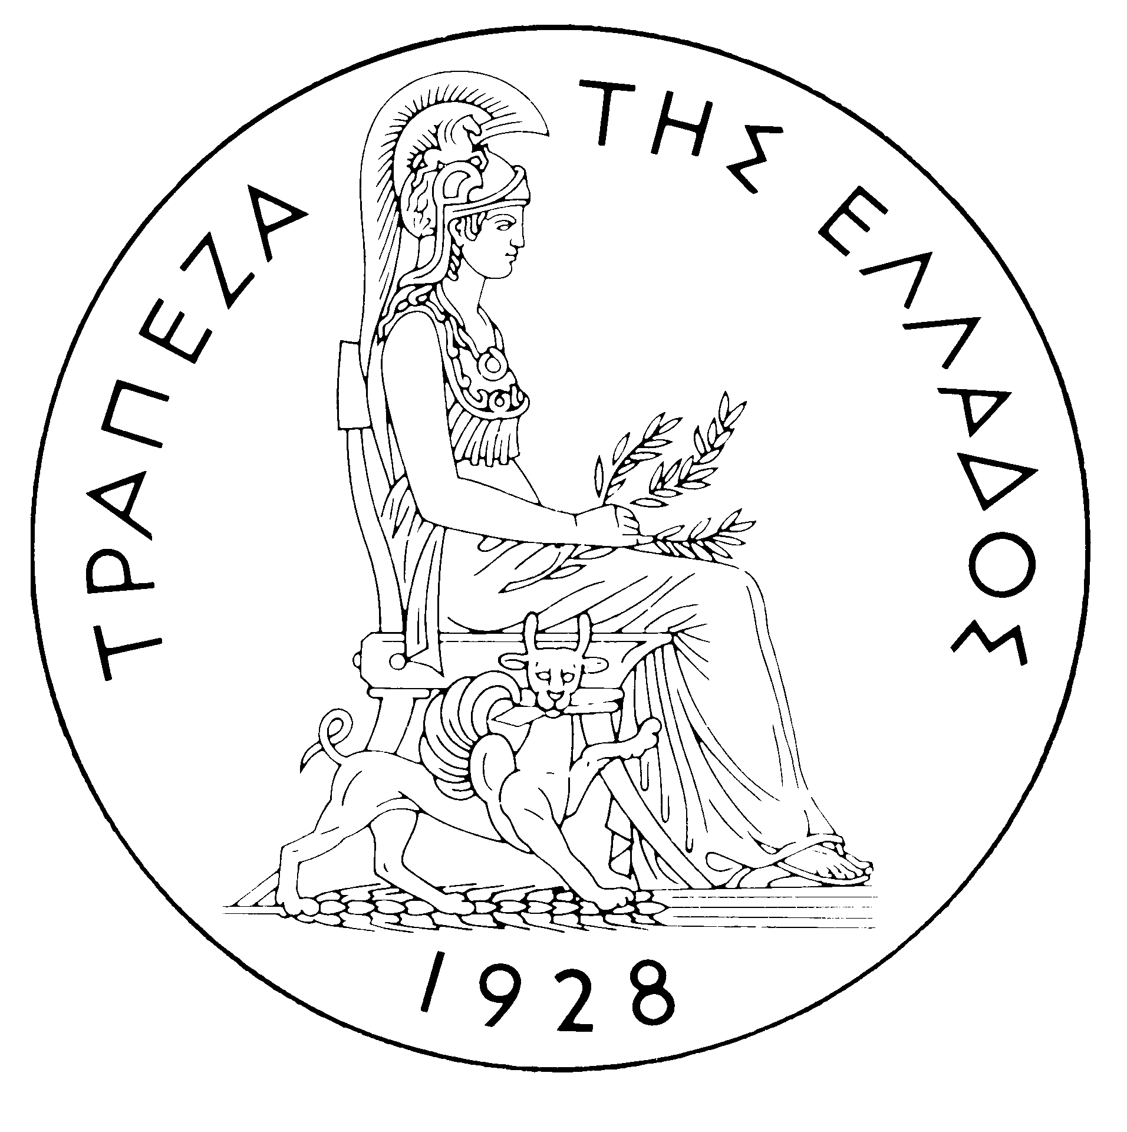
BANK OF GREECE

PRESS RELEASE

Athens, 18 August 2005

Re: Balance of payments JUNE 2005

Current account balance

In June 2005, the current account deficit narrowed by €145 million year-on-year and amounted to €729 million, compared with €874 million in June 2004. This development is mainly due to a considerable rise in the services surplus and, secondarily, to the combined effect of a decrease in the trade deficit and an increase in the transfers surplus, which more than offset the widening of the income account deficit.
In more detail, in June 2005 the overall trade deficit narrowed by €111 million year-on-year as the trade deficit excluding oil and ships contracted by an appreciable €284 million, whereas the net oil import bill rose by €80 million and net payments of €34 million were recorded in the ships' balance, compared with net receipts of €59 million in the corresponding month of 2004. The services surplus widened by €157 million year-on-year, owing to a rise in net transport and travel receipts (in June gross transport receipts grew by 4.4% and gross travel receipts – i.e. travel spending in Greece by non-residents -- rose by 5.5%). The transfers surplus also rose by €82 million year-on-year, exclusively because of a €122 million rise in net EU transfers to general government, while net transfers to the "other sectors" (emigrants’ remittances, etc.) declined. More specifically, gross EU transfers to general government grew by €287 million, thereby more than offsetting the €165 million increase in general government gross payments to the EU. By contrast, in June 2005 the income account deficit widened by €205 million year-on-year. Underlying this development was a €121 million rise (compared with June 2004) in dividend and profit payments, as well as a €40 million increase in interest payments (on an accruals basis) on Greek government
bonds held by non-residents. (It should be recalled that, as from April 2005, the methodology of recording interest on bonds in the balance of payments statistics changed, so that interest payments are recorded on an accruals basis, rather than on the basis of interest actually paid as they had been until March 2005. For comparability purposes, however, the monthly data going back to January 2003 have also been revised.)
In the first half of 2005, the current account deficit rose by €1,501 million over the corresponding period of 2004 and amounted to €6,735 million, mainly because net payments were recorded this year in the ships' balance (as opposed to net receipts having been recorded in the corresponding period of 2004), as well as because of the rise in the net oil import bill and the increase in general government gross payments to the EU and in net interest, dividend and profit payments. By contrast, the trade deficit excluding oil and ships decreased. Moreover, gross EU transfers to general government grew appreciably and the services surplus rose.
In particular, the overall trade deficit (which includes the oil and the ships' balances) widened by €936 million over the corresponding period in 2004. This reflects the fact that in the first half of 2005 net payments of €262 million were recorded in the ships' balance, compared with net receipts of €359 million in the same period of 2004. At the same time, the net oil import bill rose by €581 million. By contrast, the trade deficit excluding oil and ships narrowed by €346 million, as the decrease in imports was larger than the decrease in exports (-€555 million and -€208 million, respectively).
The services surplus widened considerably (by €328 million). Underlying this improvement was a further increase in net transport (mainly shipping) receipts (despite the continuing fall in freight rates in international markets, net shipping receipts were higher by €383 million, compared with the already very high receipts recorded in the first half of 2004). Gross travel receipts (travel spending in Greece by non-residents) rose by €189 million or 6.1%, while gross travel payments (travel spending abroad by Greek residents) grew by €127 million or 12.3%, thereby pushing up net travel receipts by €61 million only. By contrast, a rise was recorded in net payments for ‘‘other’’ services.
The income account deficit grew by €426 million during the same period, as interest, dividend and profit payments increased, mainly because of the continued rise in interest payments on Greek government paper held by non-residents.

Finally, the transfers surplus shrank by €467 million over the same period in 2004. This reduction was accounted for by a €310 million decrease in net transfers to "other sectors” (e.g. emigrants’ remittances, etc.) and a €156 million fall in net EU transfers to general government. Indeed, while in the first half of 2005 gross EU transfers to general government grew by €517 million or 15.2%, general government gross payments to the EU (particularly the contribution to the Community budget, etc.) soared by €673 million or 60.5%.

Financial account balance

In June 2005 net outflows under residents’ direct investment abroad stayed at low levels and amounted to €32 million. The most important outflows were a €13 million outflow from EUROBANK to increase its holdings of the BANKPOST’s (Romania) equity capital and participate in the capital increase of the latter, as well as a €20 million outflow for the acquisition of 69.3% of the equity capital of the Egyptian bank "ECB" by the Bank of Piraeus. As regards non-residents’ direct investment in Greece, a net inflow of €93 million was recorded (compared with a net outflow of €80 million in the same month a year earlier), owing to the net borrowing by affiliated companies located in Greece from their parent companies abroad. Under portfolio investment, a net outflow of €1,987 million was mainly accounted for by a €3.217 million outflow of residents’ funds for investments in foreign bonds and Treasury bills, around one-third of which was, however, offset by non-residents’ investments (of €1,138 million) in Greek government paper. As regards "other investment", a significant inflow of funds was recorded under residents' claims on non-residents, exclusively owing to the reduction in domestic credit institutions’ deposits and repo holdings abroad, while residents’ liabilities towards non-residents remained virtually unchanged (but for a small inflow of just €7 million), mainly because of a net increase in non-residents’ deposits and repo holdings in Greece, which was almost completely offset by the repayment of loans that had been granted to the private and the public sector by non-residents.
In January-June 2005, a net outflow of €5 million was recorded under direct investment (compared with a net inflow of €346 million in the same period of the previous year). This development is accounted for by the fact that residents’ net direct investment abroad came to €363 million, while, at the same time, non-residents' net
direct investment in Greece reached €357 million. Portfolio investment recorded a net inflow of €4,940 million during the same period, since the outflow of residents’ funds for investments abroad (mainly in bonds) was offset by the larger inflow of non-residents’ funds for investments primarily in Greek government paper. Finally, "other investment" recorded a net inflow of €1,845 million, reflecting the fact that the inflow of funds (€12,913 million) for non-residents’ investments in deposits and repos more than offset the outflow of residents’ funds (€11,068 million), mainly for investments in deposits and repos abroad.
At end-June 2005, Greece’s reserve assets came to €1.8 billion. (It should be recalled that since the first months of 2003 the Bank of Greece has started to diversify its portfolio, by reducing its non-euro area currency holdings, which are included in reserve assets, and increasing its assets which have higher yields and are mainly denominated in euro – predominantly bonds issued by euro area Member States, which are not included in reserve assets. It has been noted repeatedly that, since Greece joined the euro area in January 2001, reserve assets, as defined by the European Central Bank, include only monetary gold, the "reserve position" with the IMF, "Special Drawing Rights", and Bank of Greece claims in foreign currency on residents of non-euro area countries. Conversely, reserve assets do not include claims in euro on residents of non-euro area countries, claims in foreign currency and in euro on residents of euro area countries, and the Bank of Greece participation in the capital and the reserve assets of the ECB.)

Note: Balance of payments data for July 2005 will be released on 16 September 2005.

