5 August 2005
The Euro area bank lending survey
– JULY 2005 –

Overview of the results
This report presents the results of the ECB’s bank lending survey for the euro area that was conducted in July 2005. The cut-off date for receipt of data from the banks participating in this survey was 12 July 2005.
Overall, the results of the July 2005 bank lending survey showed a further and stronger relaxation of credit standards for loans to enterprises. At the same time, however, banks slightly tightened the credit standards applied to housing loans to households, while the relaxation of credit standards for consumer credit and other loans to households slowed down.

Loans or credit lines to enterprises
Credit standards. For the second quarter of 2005, banks reported a more pronounced net easing of credit standards for loans or credit lines to enterprises (-17%) than in the previous quarter (-10%). This is the fifth consecutive net easing of credit standards and is in line with the downward trend recorded since the launch of the bank lending survey (see Chart 1, first panel). The net easing in the second quarter of 2005 was also stronger than banks had expected for that period in April 2005 (0%).
Among the factors explaining changes in credit standards, competition from other banks contributed the most to the reported net easing (see Chart 1, fifth panel). At the same time, risk perceptions regarding general economic activity contributed more to a net tightening of credit standards than in the previous quarter (10% in the July 2005 survey, compared with 2% in April 2005). Costs related to banks’ capital position also weighed slightly towards a tightening of credit standards (see Chart 1, second panel). The net easing of the terms and conditions of credit was achieved primarily via a strong decline in margins on average loans (-34% in July, compared with -18% in April) and a lengthening of loan maturity (-13% in July, from -7% in April). Additionally, banks reported that loan covenants and collateral requirements became less stringent, while non-interest rate charges were eased and the average size of loans or credit lines was increased. Only margins on riskier loans tended to weigh somewhat towards a net tightening of credit standards, but considerably less so than in previous quarters.
In terms of borrowers’ size, banks continued to report a net easing of credit standards on loans to small and medium-sized enterprises (-14% in July, from -12% in April), as well as a significant increase in the net easing of credit standards on loans to large enterprises (-18% in July, from -5% in April).
Regarding the maturity of loans, the net easing of credit standards applied to both short-term and long-term loans, but was more pronounced for the former, also compared with the previous quarter.

General notes
The bank lending survey is addressed to senior loan officers of a representative sample of euro area banks, and its main purpose is to enhance the understanding of bank lending behaviour in the euro area.
The questions distinguish between three categories of loans: loans or credit lines to enterprises, loans to households for house purchase, and loans to households for consumer credit and other lending. For all categories, questions are posed on credit standards for approving loans, credit terms and conditions, as well as credit demand and the conditions affecting it.
The questions related to credit standards are analysed in this report by focusing on the difference (“net percentage”) between the share of banks reporting that credit standards have been tightened and those reporting that they have been eased. A positive net percentage indicates that a larger proportion of banks have tightened credit standards (“net tightening”), whereas a negative net percentage indicates that a larger proportion of banks have eased credit standards (“net easing”). Likewise, the term “net demand” refers to the difference between the share of banks reporting an increase in loan demand and those reporting a decline. Net demand will therefore be positive if a larger proportion of banks have reported an increase in loan demand, whereas a negative net demand would indicate that a larger proportion of banks have reported a decline in loan demand.
The survey questions are phrased in terms of changes over the past three months (in this case, the second quarter of 2005) or expectations of changes over the next three months (i.e. the third quarter of 2005).
A copy of the questionnaire can be found at http://www.ecb.int/stats/money/lend/html/index.en.html.

Chart 1. Changes in credit standards applied to the approval of loans or credit lines to enterprises
(net percentages of banks contributing to tightening standards)

Notes: The net percentage refers to the difference between the sum of the percentages for “tightened considerably” and “tightened somewhat” and the sum of the percentages for “eased somewhat” and “eased considerably”. “Realised” values refer to the period in which the survey was conducted. “Expected” values are the net percentages calculated from the responses given by the banks in the previous survey. For instance, “expected” values for 2005Q3 were reported in the July 2005 survey. The net percentages for the questions related to the factors are defined as the difference between the percentage of banks reporting that the given factor contributed to a tightening and to an easing.

Loan demand. In the second quarter of 2005, the overall net demand for loans or credit lines to enterprises remained in negative territory and declined slightly compared with the previous quarter (-5% in July, from -1% in April; see Chart 2, first panel). This result was heavily influenced by developments in one country. The decline in net demand affected loans both to small and medium-sized enterprises (0% in July, from 4% in April) and to large enterprises (-10% in July, from -6% in April) (see Chart 2, second and third panels). In terms of maturity structure, the overall decline in loan demand was due to a decline in demand for short-term loans, as net demand for long-term loans actually increased, albeit at a lower level than in the previous quarter (6% in July, from 11% in April).
The major factor contributing to the negative net demand for loans or credit lines to enterprises in the second quarter of 2005 was, according to responding banks, weak fixed investment (-20% in July, from -12% in April), followed by the use of alternative sources of finance, in particular the availability of internal finance for enterprises and the use of loans from other banks. However, banks reported that debt restructuring, mergers and acquisitions and corporate restructuring activities were important factors contributing to a net increase in corporate loan demand in the second quarter of 2005.

Chart 2. Changes in demand for loans or credit lines to enterprises
(net percentages of banks reporting a positive contribution to demand)
Notes: The net percentages for the questions on demand for loans are defined as the difference between the sum of the percentages for “increased considerably” and “increased somewhat” and the sum of the percentages for “decreased somewhat” and “decreased considerably”. “Realised” values refer to the period in which the survey was conducted. “Expected” values are the net percentages calculated from the responses given by the banks in the previous survey. For instance, “expected” values for 2005Q3 were reported in the July 2005 survey.

Expectations. For the third quarter of 2005, banks expect a stronger net easing of credit standards applied to the approval of loans or credit lines to enterprises (-9% in July, from 0% in April) (see Chart 1, first panel). For the period July-September 2005, banks expect a general continuation of the net easing of credit standards for all borrower sizes and for all loan maturities except for long-term loans. Regarding expected net demand for loans to enterprises in the third quarter of 2005, responding banks continue to report an increase (11% in July, compared with 16% in April) (see Chart 2, first panel). This expected positive net demand for loans to enterprises is more pronounced for small and medium-sized enterprises than for large enterprises, as well as being more pronounced for long-term loans than for short-term loans (see Chart 2, second to fifth panels).

Loans to households for house purchase
Credit standards. Banks reported a slight net tightening of credit standards applied to the approval of loans to households for house purchase in the second quarter of 2005 (2% in July, from -7% in April). This was the first time since the first quarter of 2004 that banks reported a net tightening of these credit standards and it contrasted with the net easing that they had expected in the April 2005 survey for the second quarter of 2005 (see Chart 3, first panel).
The slight net tightening reflected in particular banks’ growing perception of risk, particularly in terms of worsening housing market prospects (7% in July, from 6% in April) but also of expectations regarding general economic activity (3% in July, unchanged from April) (see Chart 3, third and second panels). At the same time, competition from other banks and non-banks contributed somewhat less to a net easing in the second quarter of 2005 than in previous quarters (see Chart 3, fourth panel).
Regarding the terms and conditions of credit, banks reported that the slight net tightening of credit standards was achieved predominantly via more stringent collateral requirements (3% in July, from 0% in April) and larger margins on riskier loans (2% in July, unchanged from April). All other factors contributed to a net easing, most significantly via a narrowing of margins on average loans, and to a lesser extent via a lengthening of the maturity of new loans.

Chart 3. Changes in credit standards applied to the approval of loans to households for house purchase (net percentages of banks contributing to tightening credit standards)
Notes: The net percentages for the questions on demand for loans are defined as the difference between the sum of the percentages for “increased considerably” and “increased somewhat” and the sum of the percentages for “decreased somewhat” and “decreased considerably”. “Realised” values refer to the period in which the survey was conducted. “Expected” values are the net percentages calculated from the responses given by the banks in the previous survey. For instance, “expected” values for 2005Q3 were reported in the July 2005 survey. The net percentages for the questions related to the factors are defined as the difference between the percentage of banks reporting that the given factor contributed to a tightening and to an easing.

Loan demand. The net demand for housing loans to households increased strongly in the second quarter of 2005 (29% in July, from -1% in April) (see Chart 4, first panel). This increase in net demand was considerably higher than banks had expected for the second quarter of 2005 in the April 2005 survey.
The main factor underpinning the increase in net demand was a more positive contribution from housing market prospects (10% in July, from 9% in April). Thus, borrowers of housing loans seemed more optimistic regarding housing market prospects than in the previous quarters. The increase in net demand for housing loans was further due to household savings (3% in July, from -4% in April) and a smaller contribution from worsening consumer confidence (-4% in July, from -13% in April).
Chart 4. Changes in demand for loans to households
(net percentages of banks reporting a positive contribution to demand)
Notes: The net percentages for the questions on demand for loans are defined as the difference between the sum of the percentages for “increased considerably” and “increased somewhat” and the sum of the percentages for “decreased somewhat” and “decreased considerably”. “Realised” values refer to the period in which the survey was conducted. “Expected” values are the net percentages calculated from the responses given by the banks in the previous survey. For instance, “expected” values for 2005Q3 were reported in the July 2005 survey.

Expectations. For the third quarter of 2005, respondent banks expect a slight net easing of credit standards for loans to households for house purchase (-3% in July, unchanged from April). This is the second time that banks have reported an expected net easing since the launch of the bank lending survey. At the same time, reporting banks continue to expect that net demand will increase again in the third quarter of 2005 (17% in July, from 7% in April) (see Chart 4, first panel).

Consumer credit and other lending to households
Credit standards. In the second quarter of 2005, banks reported a smaller net easing of credit standards applied to loans to households for consumer credit and other lending than in the previous quarter (-2% in July, from -7% in April) (see Chart 5, first panel), which contrasted with the net tightening reported for loans to households for house purchase.
The main factor contributing to the net easing of these credit standards was increased competition, both from other banks (-11% in July, from -16% in April) and from non-banks (-6%, from -10%) (see Chart 5, second and third panels). Expectations regarding general economic activity were somewhat less negative than in the previous quarter, but weighed in the direction of a net tightening of credit standards (1% in July, from 3% in April). An increase in the perception of risks on demanded collateral and higher risks stemming from lower creditworthiness of consumers contributed in particular to a net tightening of credit standards, in both cases to a larger extent than in the previous quarter. As regards terms and conditions for approving consumer credit and other lending to households, both price and non-price terms and conditions and, in particular, lower margins on average loans (-18% in July, compared with -19% in April) contributed to the net easing of credit standards.
Loan demand. Net demand for consumer credit and other lending to households increased slightly in the second quarter of 2005, after being basically unchanged in the first quarter of 2005 (5% in July, from 0% in April). The main factor contributing to this development was increased spending on durable consumer goods, which in the previous quarter contributed slightly to lower net demand (7% in July, from -1% in April), whereas reduced household savings (2% in July, from 1% in April) and competition from other banks contributed slightly to the higher net demand (1%, unchanged from the previous quarter). Furthermore, the decline in consumer confidence contributed less to lower net demand for consumer credit and other loans to households than in the first quarter of 2005 (-6% in July, from -15% in April).
Expectations. For the third quarter of 2005, responding banks expect a further net easing of credit standards for consumer credit and other lending to households (-7% in July, from -4% in April) (see Chart 5, first panel) as well as an increase in the net demand for these loans (13% in July, from 16% in April) (see Chart 4, second panel).

Chart 5. Changes in credit standards applied to the approval of consumer credit and other lending to households (net percentages of banks contributing to tightening credit standards)
Notes: The net percentages for the questions on demand for loans are defined as the difference between the sum of the percentages for “increased considerably” and “increased somewhat” and the sum of the percentages for “decreased somewhat” and “decreased considerably”. “Realised” values refer to the period in which the survey was conducted. “Expected” values are the net percentages calculated from the responses given by the banks in the previous survey. For instance, “expected” values for 2005Q3 were reported in the July 2005 survey. The net percentages for the questions related to the factors are defined as the difference between the percentage of banks reporting that the given factor contributed to a tightening and to an easing.

Results for the individual questions

I. Loans or credit lines to enterprises

Over the past three months, how have your bank’s credit standards as applied to the approval of loans or credit lines to enterprises changed?
Note: The net percentage is defined as the difference between the sum of the percentages for “tightened considerably” and “tightened somewhat”, and the sum of the percentages for “eased somewhat” and “eased considerably”.

Chart 6. Credit standards applied to the approval of loans or credit lines to enterprises
(net percentages of banks reporting tightening credit standards)
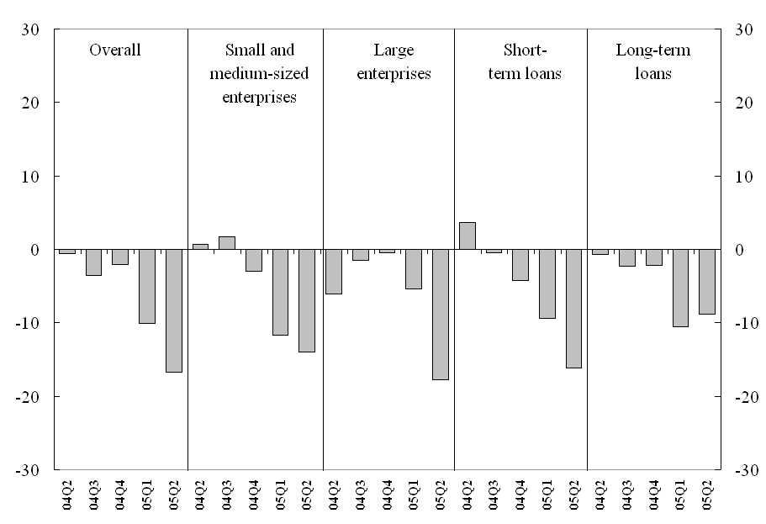

- Over the past three months, how have the following factors affected your bank’s credit standards as applied to the approval of loans or credit lines to enterprises?
NA = Not available; NetP = Net percentage
Note: The “Net percentage” column is defined as the difference between the sum of “- -” (contributed considerably to tightening) and “-” (contributed somewhat to tightening), and the sum of “+” (contributed somewhat to easing) and “+ +” (contributed considerably to easing). “°” means ”contributed to basically unchanged credit standards”.

Chart 7a. Factors affecting credit standards applied to the approval of loans or credit lines to enterprises
(net percentages of banks contributing to tightening standards)

Chart 7b. Factors affecting credit standards applied to the approval of loans or credit lines to enterprises
(net percentages of banks contributing to tightening standards)

Over the past three months, how have your bank’s conditions and terms for approving loans or credit lines to enterprises changed?
NA = Not available; NetP = Net percentage
Note: The “Net percentage” column is defined as the difference between the sum of “- -” (tightened considerably) and “-” (tightened somewhat), and the sum of “+” (eased somewhat) and “+ +” (eased considerably). “°” means “remained basically unchanged”.

Chart 8. Conditions and terms for approving loans or credit lines to enterprises
(net percentages of banks contributing to tightening standards)

Over the past three months, how has the demand for loans or credit lines to enterprises changed at your bank, apart from normal seasonal fluctuations?
Note: The net percentage is defined as the difference between the sum of the percentages for “increased considerably” and “increased somewhat”, and the sum of the percentages for “decreased somewhat” and “decreased considerably”.

Chart 9. Demand for loans and credit lines to enterprises
(net percentages of banks contributing to positive loan demand)
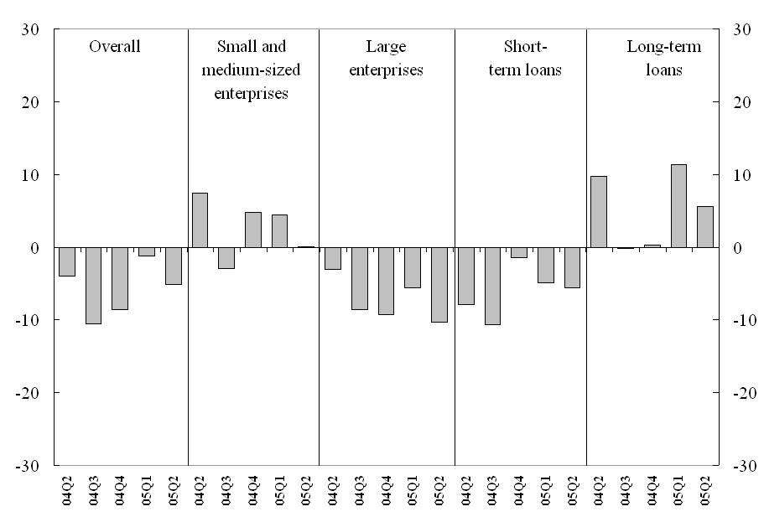

Over the past three months, how have the following factors affected the demand for loans or credit lines to enterprises?
NA = Not available; NetP = Net percentage
Note: The “Net percentage” column is defined as the difference between the sum of “+ +” (contributed considerably to higher demand) and “+” (contributed somewhat to higher demand), and the sum of “-” (contributed somewhat to lower demand) and “- -” (contributed considerably to lower demand).“°” means “contributed to basically unchanged demand”.

Chart 10a. Factors affecting demand for loans and credit lines to enterprises
(net percentages of banks reporting a positive contribution to demand)

Chart 10b. Factors affecting demand for loans and credit lines to enterprises
(net percentages of banks reporting a positive contribution to demand)

- Please indicate how you expect your bank’s credit standards as applied to the approval of loans or credit lines to enterprises to change over the next three months.
Note: The net percentage is defined as the difference between the sum of the percentages for “tighten considerably” and “tighten somewhat”, and the sum of the percentages for “ease somewhat” and “ease considerably”.

Chart 11. Expected credit standards for the approval of loans or credit lines to enterprises
(net percentages of banks reporting tightening credit standards)
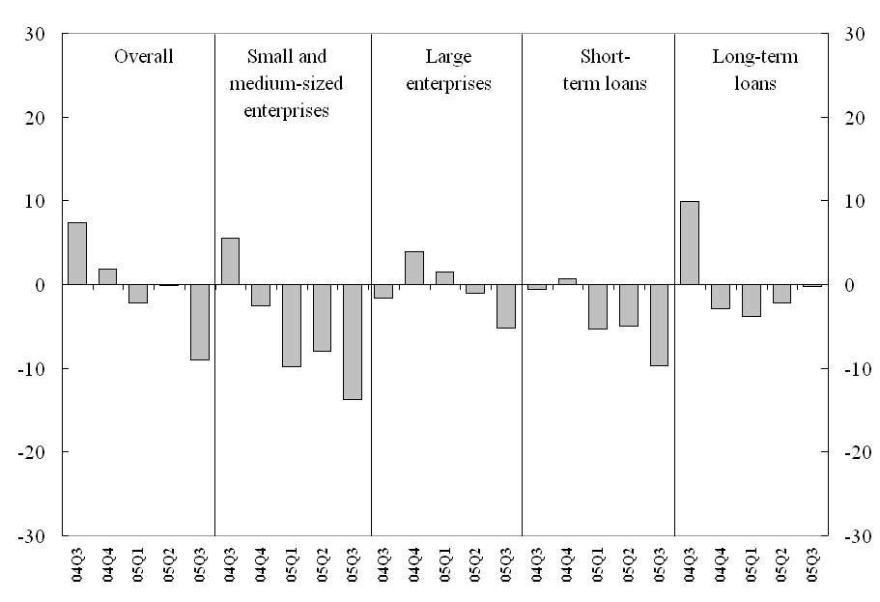

- Please indicate how you expect demand for loans or credit lines to enterprises to change at your bank over the next three months (apart from normal seasonal fluctuations).
Note: The net percentage is defined as the difference between the sum of the percentages for “increase considerably” and “increase somewhat”, and the sum of the percentages for “decrease somewhat” and “decrease considerably”.

Chart 12. Expected demand for loans and credit lines to enterprises
(net percentages of banks reporting a positive loan demand)
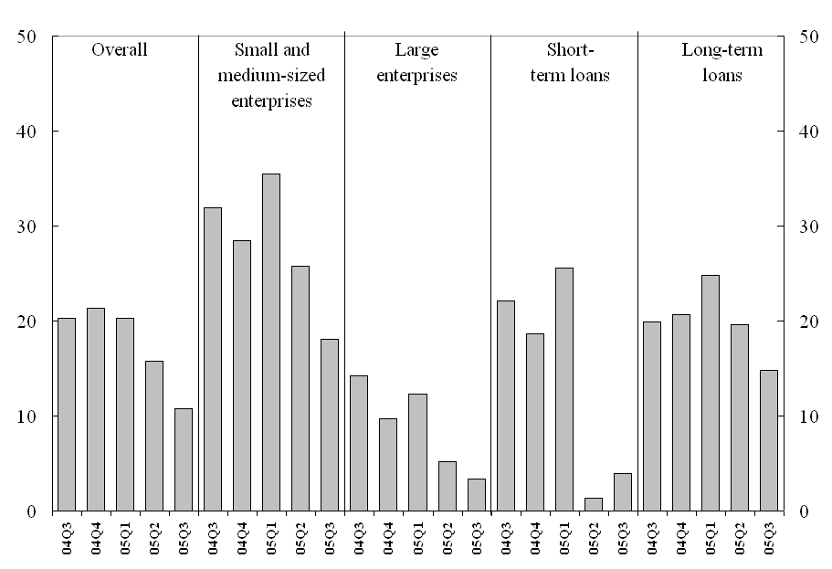
II. Loans to households
- Over the past three months, how have your bank’s credit standards as applied to the approval of loans to households changed?
Note: The net percentage is defined as the difference between the sum of the percentages for “tightened considerably” and “tightened somewhat”, and the sum of the percentages for “eased somewhat” and “eased considerably”.

Chart 13. Credit standards applied to the approval of loans to households
(net percentages of banks reporting tightening credit standards)
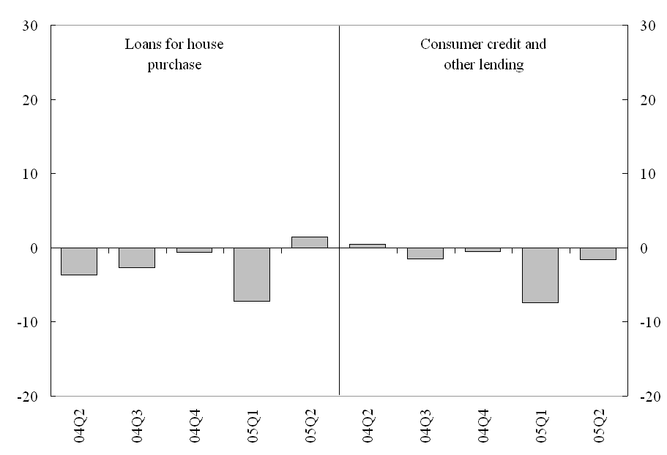

Over the past three months, how have the following factors affected your bank’s credit standards as applied to the approval of loans to households for house purchase?
NA = Not available; NetP = Net percentage
Note: The “Net percentage” column is defined as the difference between the sum of “- -” (contributed considerably to tightening) and “-” (contributed somewhat to tightening), and the sum of “+” (contributed somewhat to easing) and “+ +” (contributed considerably to easing). “°” means “contributed to basically unchanged credit standards”.

Chart 14. Factors affecting credit standards applied to the approval of loans to households for house purchase (net percentages of banks contributing to tightening standards)
- Over the past three months, how have your bank’s conditions and terms for approving loans to households for house purchase changed?
NA = Not available; NetP = Net percentage
Note: The “Net percentage” column is defined as the difference between the sum of “- -” (tightened considerably) and “-” (tightened somewhat), and the sum of “+” (eased somewhat) and “+ +” (eased considerably). “°” means “remained basically unchanged”..

Chart 15. Conditions and terms for approving loans to households for house purchase
(net percentages of banks contributing to tightening standards)

- Over the past three months, how have the following factors affected your bank’s credit standards as applied to the approval of consumer credit and other lending to households (as described in question 8)?
NA = Not available; NetP = Net percentage
Note: The “Net percentage” column is defined as the difference between the sum of “- -” (contributed considerably to tightening) and “-” (contributed somewhat to tightening), and the sum of “+” (contributed somewhat to easing) and “+ +” (contributed considerably to easing). “°” means “contributed to basically unchanged credit standards”.

Chart 16. Factors affecting credit standards applied to the approval of consumer credit and other lending to households (net percentages of banks contributing to tightening standards)

- Over the past three months, how have your bank’s conditions and terms for approving consumer credit and other lending to households changed?
NA = Not available; NetP = Net percentage
Note: The “Net percentage” column is defined as the difference between the sum of “- -” (tightened considerably) and “-” (tightened somewhat), and the sum of “+” (eased somewhat) and “+ +” (eased considerably). “°” means “remained basically unchanged”.

Chart 17. Conditions and terms for approving consumer credit and other loans to households
(net percentages of banks contributing to tightening standards)

- Over the past three months, how has the demand for loans to households changed at your bank, apart from normal seasonal fluctuations?
Note: The net percentage is defined as the difference between the sum of the percentages for “increased considerably” and “increased somewhat”, and the sum of the percentages for “decreased somewhat” and “decreased considerably”.

Chart 18. Demand for loans to households
(net percentages of banks contributing to positive loan demand)
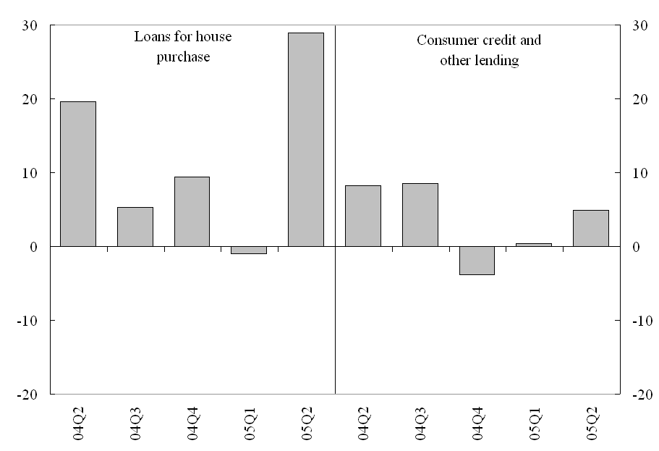
- Over the past three months, how have the following factors affected the demand for loans to households for house purchase (as described in question 13)?
NA = Not available; NetP = Net percentage
Note: The “Net percentage” column is defined as the difference between the sum of “+ +” (contributed considerably to higher demand) and “+” (contributed somewhat to higher demand), and the sum of “-” (contributed somewhat to lower demand) and “- -” (contributed considerably to lower demand). “°” means “contributed to basically unchanged demand”..

Chart 19. Factors affecting demand for loans to households for house purchase
(net percentages of banks reporting a positive contribution to demand)

- Over the past three months, how have the following factors affected the demand for consumer credit and other lending to households (as described in question 13)?
NA = Not available; NetP = Net percentage
Note: The “Net percentage” column is defined as the difference between the sum of “+ + ” (responsible for considerable increase) and “+” (responsible for increase), and the sum of “-” (responsible for decrease) and “- -” (responsible for considerable decrease). “°” means “responsible for neither a decrease nor an increase”.

Chart 20. Factors affecting demand for consumer credit and other lending to households (net percentages of banks reporting a positive contribution to demand)

- Please indicate how you expect your bank’s credit standards as applied to the approval of loans to households to change over the next three months.
Note: The net percentage is defined as the difference between the sum of the percentages for “tighten considerably” and “tighten somewhat”, and the sum of the percentages for “ease somewhat” and “ease considerably”.

Chart 21. Expected credit standards for loans to households
(net percentages of banks reporting tightening standards)
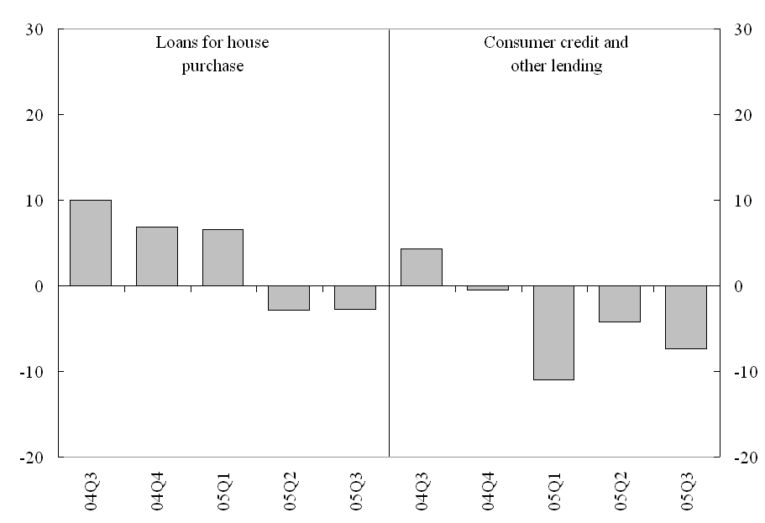
- Please indicate how you expect demand for loans to households to change over the next three months at your bank (apart from normal seasonal fluctuations).
Note: The net percentage is defined as the difference between the sum of the percentages for “increase considerably” and “increase somewhat”, and the sum of the percentages for “decrease somewhat” and “decrease considerably”.

Chart 22. Expected demand for loans to households for house purchase
(net percentages of banks reporting positive loan demand)
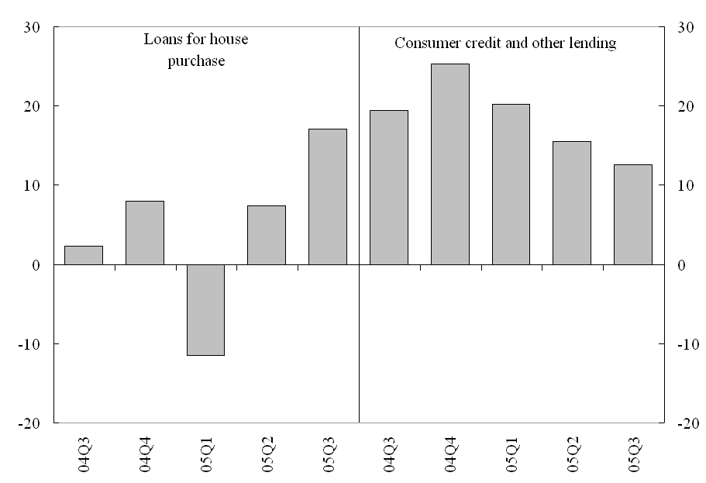

Annex: Glossary used in the survey
In order to assist the banks participating in the survey to fill out the questionnaire, a compilation guide has been developed containing the most important terms in the survey. The overview below shows the main terminology used.

Capital
This is defined in accordance with the Basel capital adequacy requirements; it includes both tier 1 capital (core capital) and tier 2 capital (supplementary capital).

Collateral
The security given by a borrower to a lender as a pledge for the repayment of a loan. This could include certain financial securities, such as equity or debt securities, real estate or compensating balances. A compensating balance is the minimum amount of a loan that the borrower is required to keep in an account at the bank.

Covenant
A covenant is an agreement or stipulation expressed in loan contracts, particularly contracts with enterprises, under which the borrower either pledges to take certain action (an affirmative covenant) or to refrain from taking certain action (a negative covenant), and is consequently part of the terms and conditions of a loan.

Credit line
A credit line is a facility with a stated maximum amount that an enterprise is entitled to borrow from a bank at any given time. In the survey, developments regarding credit lines should be interpreted as changes in the net amount drawn under either an existing or a new credit line.

Credit standards
Credit standards are the internal guidelines or criteria which reflect a bank’s loan policy. They are the written and unwritten criteria, or other practices related to this policy, which define the types of loan a bank considers desirable and undesirable, the designated geographic priorities, the collateral deemed acceptable and unacceptable, etc. In the survey, changes in written loan policies should be considered together with changes in their application.
Credit terms and conditions
The terms and conditions of a loan refer to the specific obligations agreed upon by the lender and the borrower. In the context of the bank lending survey, they consist of the direct price or interest rate, the maximum size of the loan and the access conditions, and other terms and conditions in the form of non-interest rate charges (i.e. fees), collateral requirements (including compensating balances), loan covenants and maturity (short versus long-term).

Enterprises
Enterprises refer to non-financial corporations, i.e. all private and public institutional units, whatever their size and legal form, which are not principally engaged in financial intermediation but rather in the production of goods and non-financial services.

Enterprise size
The distinction between large enterprises and small and medium-sized enterprises is based on annual sales. A firm is considered large if its annual net turnover is more than €50 million.

Households
Households are individuals or groups of individuals acting as consumers or as producers of goods and non-financial services exclusively intended for their own final consumption, as well as small-scale market producers.

Loans
The loans covered by the bank lending survey are those granted to euro area residents by domestic branches, including loans or credit lines to enterprises, loans to households for house purchase, and consumer credit and other lending to households.

Loan-to-value ratio
The ratio of the amount borrowed to the appraisal or market value of the underlying collateral, usually taken into consideration in relation to loans used for real estate financing.

Maturity
The concept of maturity used in the bank lending survey is original maturity, and only two different types are used, i.e. short-term and long-term. Short-term loans are loans with an original maturity of one year or less; long-term loans are consequently defined as loans that have an original maturity of more than one year.

Net balance (or percentage)
The net percentage is defined as the difference between the sum of the percentages for “tightened considerably” and “tightened somewhat”, and the sum of the percentages for “eased somewhat” and “eased considerably”. For questions related to demand for loans, the net percentage is defined as the difference between the sum of the percentages for “increase considerably” and “increase somewhat”, and the sum of the percentages for “decrease somewhat” and “decrease considerably”.

Non-banks
In general, these consist of non-monetary financial corporations. More specifically, they include insurance corporations and pension funds, financial auxiliaries and other financial intermediaries.

Non-interest rate charges
These are various kinds of fees which can be part of the pricing of a loan, such as commitment fees on revolving loans, administration fees (e.g. document preparation costs), and charges for enquiries, guarantees and credit insurance.

The sample group of banks participating in the survey comprises 86 banks, representing all euro area countries, and takes into account the characteristics of their respective national banking structures. Since the banks differ considerably in size, the survey results are weighted according to the national shares in the total amount outstanding of euro area lending to euro area residents. In the January 2005 survey, all 86 banks participated.
For further information on the bank lending survey please see the ECB press release of 21 November 2002, Bank lending survey for the euro area, the April 2003 Monthly Bulletin article entitled “A bank lending survey for the euro area”, and Berg J. et al. (2005) The bank lending survey for the euro area, ECB Occasional Paper No 23.

