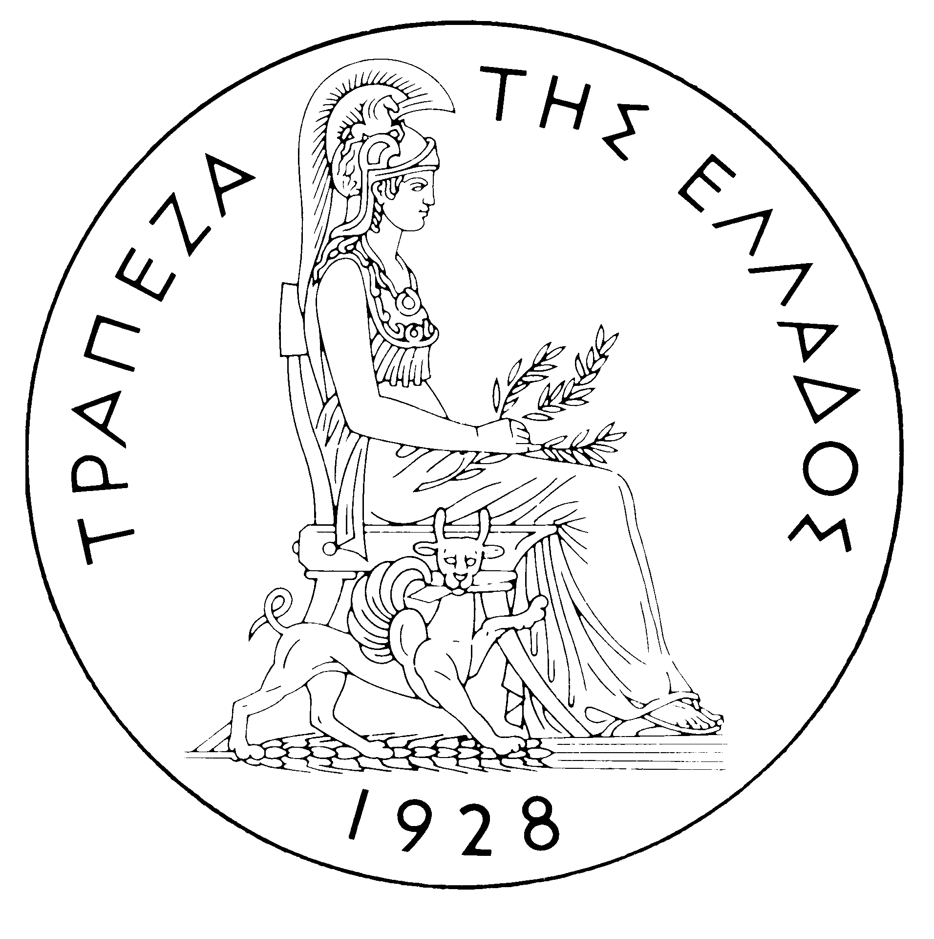
BANK OF GREECE

PRESS RELEASE

Athens, 16 September 2005

Re: Balance of payments JULY 2005

Current account balance

New presentation of the balance of payments. The availability of detailed data that cover a sufficient time span makes possible the presentation of balance of payments figures that refer to July 2005 and onwards according to a breakdown in line with the prevailing international practice. Specifically, as from this month, transfer payments and receipts are broken down into current and capital transfer payments and receipts. The criterion for this breakdown is the final purpose of the transfer payment, i.e. whether it is aimed at increasing the recipient's income (current transfer) or increasing – directly or indirectly – the recipient's stock of capital (capital transfer). On the basis of this breakdown, the transfers balance is now divided into two parts: the current transfers balance, which is classified under the current account, and the capital transfers balance, which is a separate section. Thus, the new current account balance now includes the trade balance, the services balance, the income account balance and the current transfers balance, while the capital transfers balance is an independent part of the balance of payments. Therefore, in this new presentation of the balance of payments, the algebraic sum of the current account balance and the capital transfers balance corresponds to the current account balance as presented until recently ( i.e. regarding data up to and including June 2005).

In July 2005, the current account according to the new presentation showed a deficit of €411 million, i.e. it grew by €179 million year-on-year. Underlying this widening of the deficit is a considerable increase in the income account deficit, as well as a rise in the trade deficit and a decrease in the current transfers surplus, which more than offset a relatively large increase in the services surplus.

In more detail, the overall trade deficit widened, although the trade deficit excluding oil and ships contracted by €175 million. The growth of the overall trade deficit is attributable to a €193 million increase in the net oil import bill and a considerable decrease (of €89 million) in the surplus of the ships' balance. By contrast, the services balance improved, as its surplus grew by €237 million year-on-year. This development is largely accounted for by a rise in net travel receipts (gross travel receipts – i.e. travel spending in Greece by non-residents – grew by €287 million or 16.8%, while gross payments – i.e. travel spending by residents abroad – rose by €70 million or 38.9%). Furthermore, a small increase was observed in the surplus of the transportation services balance. The income account deficit widened, mainly because of the year-on-year rise in dividend and profit payments, as well as in interest payments (on an accruals basis) on Greek government bonds held by non-residents. (It should be recalled that, as from April 2005, the methodology of recording interest on bonds in the balance of payments statistics changed, so that interest payments are recorded on an accruals basis, rather than on the basis of interest actually paid, as they had been up to and including March 2005. Thus, data are recorded more accurately. For comparability purposes, the monthly data going back to January 2003 have also been revised.) Finally, in July 2005, the current transfers surplus fell by €61 million year-on-year. Specifically, net EU current transfers to general government dropped by €21 million and net current transfers to the other sectors (emigrants’ remittances, etc.) declined by €40 million. (Current EU transfers mainly include receipts from the Guarantee Section of the European Agricultural Guidance and Guarantee Fund-EAGGF in the context of the Common Agricultural Policy, as well as Greece’s payments to the Community Budget.)

In January-July 2005, the current account deficit widened by €1,655 million over the same period of 2004 and reached €8,194 million, reflecting a rise in the trade deficit and – to a lesser extent – an increase in the income account deficit and a fall in the current transfers surplus. By contrast, the services surplus showed a considerable rise, which, however, was not enough to offset the above developments.

The €1,043 million growth of the overall trade deficit (including oil and ships) over the same period of 2004 reflects a €678 million increase in total export receipts and a €1,721 million rise in the total import bill. Specifically, the net oil import bill grew by €855 million, while the ships’ balance showed a deficit of €247 million, compared with a surplus of €567 million in the corresponding period of 2004. These developments more than offset the favourable out-turn of the trade deficit excluding oil and ships, which decreased by €626 million.

The services surplus widened considerably (by €565 million or 11.1%), reflecting an increase in net transportation and travel receipts. Specifically, net transportation (mainly shipping) receipts were higher by €400 million, compared with the already very high receipts recorded in the corresponding period of 2004, despite the continuing drop in freight rates in international markets. Gross travel receipts rose by €476 million or 9.9%, while gross travel payments grew by €197 million or 16.3%, thereby pushing up net travel receipts by a €279 million over the corresponding period of 2004.

The income account deficit grew by €674 million during the same period, as interest, dividend and profit payments increased, mainly because of a continuing rise in non-residents’ holdings of old and new issues of government bonds.

Finally, a €504 million year-or-year fall in the current transfers surplus is mainly attributable to a €341 million decrease in net current transfers to "other" sectors (excluding general government) and, secondarily, a €162 million decline in net EU current transfers to general government. Specifically, while in the January-July 2005 period gross EU current transfers to general government grew by €509 million, general government gross current payments to the EU rose by €670 million.

Capital transfers balance

In July 2005, the capital transfer account balance showed a deficit of €22 million, compared with a surplus of €267 million in July 2004. In more detail, net EU capital transfers to general government fell to €20 million, from €270 million in July 2004, while net capital transfers to non-residents by the other sectors of the economy rose to €42 million, from a mere €3 million in July 2004. (EU capital transfers mainly include receipts from the Structural Funds and the Cohesion Fund under the Community Support Framework).

In January-July 2005, the capital transfer account balance showed a surplus of €1,025 million, i.e. lower by €313 million than in the corresponding period of 2004. This mainly reflects a €265 million decrease in net EU capital transfers to general government.

Combined current account and capital transfers account balance (according to the old method of presentation)

The combined current account and capital transfers balances (on the basis of the old method of presentation) showed a deficit of €433 million in July 2005, compared with a surplus of €35 million in July 2004. Overall, in January-July 2005, the deficit amounted to €7,168 million, compared with €5,200 million in the same period of 2004.

Financial account balance

In July 2005, residents’ direct investment abroad was relatively high, reaching €196 million. It notably included, on the one hand, a €120 million outflow for the participation of COSMOTE in the share capital increase of COSMOROM (Romania) and, on the other hand, a €35 million outflow for the participation of the National Bank of Greece in the capital increase of its Cairo branch. As regards non-residents’ direct investment in Greece, a relatively small net inflow of €41 million was observed (compared with a net inflow of €178 million in the same month a year earlier), which mainly reflects borrowing by affiliated companies located in Greece from their parent companies abroad. Under portfolio investment, underlying a net inflow of €3,210 million were mainly non-residents’ purchases of Greek government paper, Greek corporate bonds (of COSMOTE) and equities, as well as a decrease in residents’ holdings of foreign bonds. "Other" investment showed a substantial net outflow of €2,735, because, on the one hand, residents’ foreign assets rose (notably domestic credit institutions’ deposits and repo holdings abroad) and, on the other hand, residents’ foreign liabilities declined slightly (reflecting, inter alia, the repayment of loans granted by non-residents to the private and the public sector).

In January-July 2005, direct investment showed a net outflow of €160 million (compared with a net inflow of €435 million in the corresponding period of the previous year). This development is accounted for by the fact that residents’ direct investment abroad came to €558 million, while, at the same time, non-residents' direct investment in Greece reached €398 million. Portfolio investment recorded a net inflow of €8,149 million during the same period, since the inflow of non-residents’ funds for investment, primarily in Greek government paper, was much larger than the outflow of residents’ funds for investment abroad (mainly in bonds) . Finally, under "other" investment, a net outflow of €891 million reflects the fact that the outflow of funds (€13,583 million), mainly for residents’ investment in deposits and repos abroad, more than offset the inflow of non-residents’ funds (€12,693 million), mainly for investment in deposits and repos in Greece.

At end-July 2005, Greece’s reserve assets came to €1.9 billion. (It should be recalled that, since Greece joined the euro area in January 2001, reserve assets, as defined by the European Central Bank, include only monetary gold, the "reserve position" with the IMF, "Special Drawing Rights", and Bank of Greece claims in foreign currency on residents of non-euro area countries. Conversely, reserve assets do not include claims in euro on residents of non-euro area countries, claims in foreign currency and in euro on residents of euro area countries, and the Bank of Greece participation in the capital and the reserve assets of the ECB.)

Note: Balance of payments data for August 2005 will be released on 20 October 2005.

