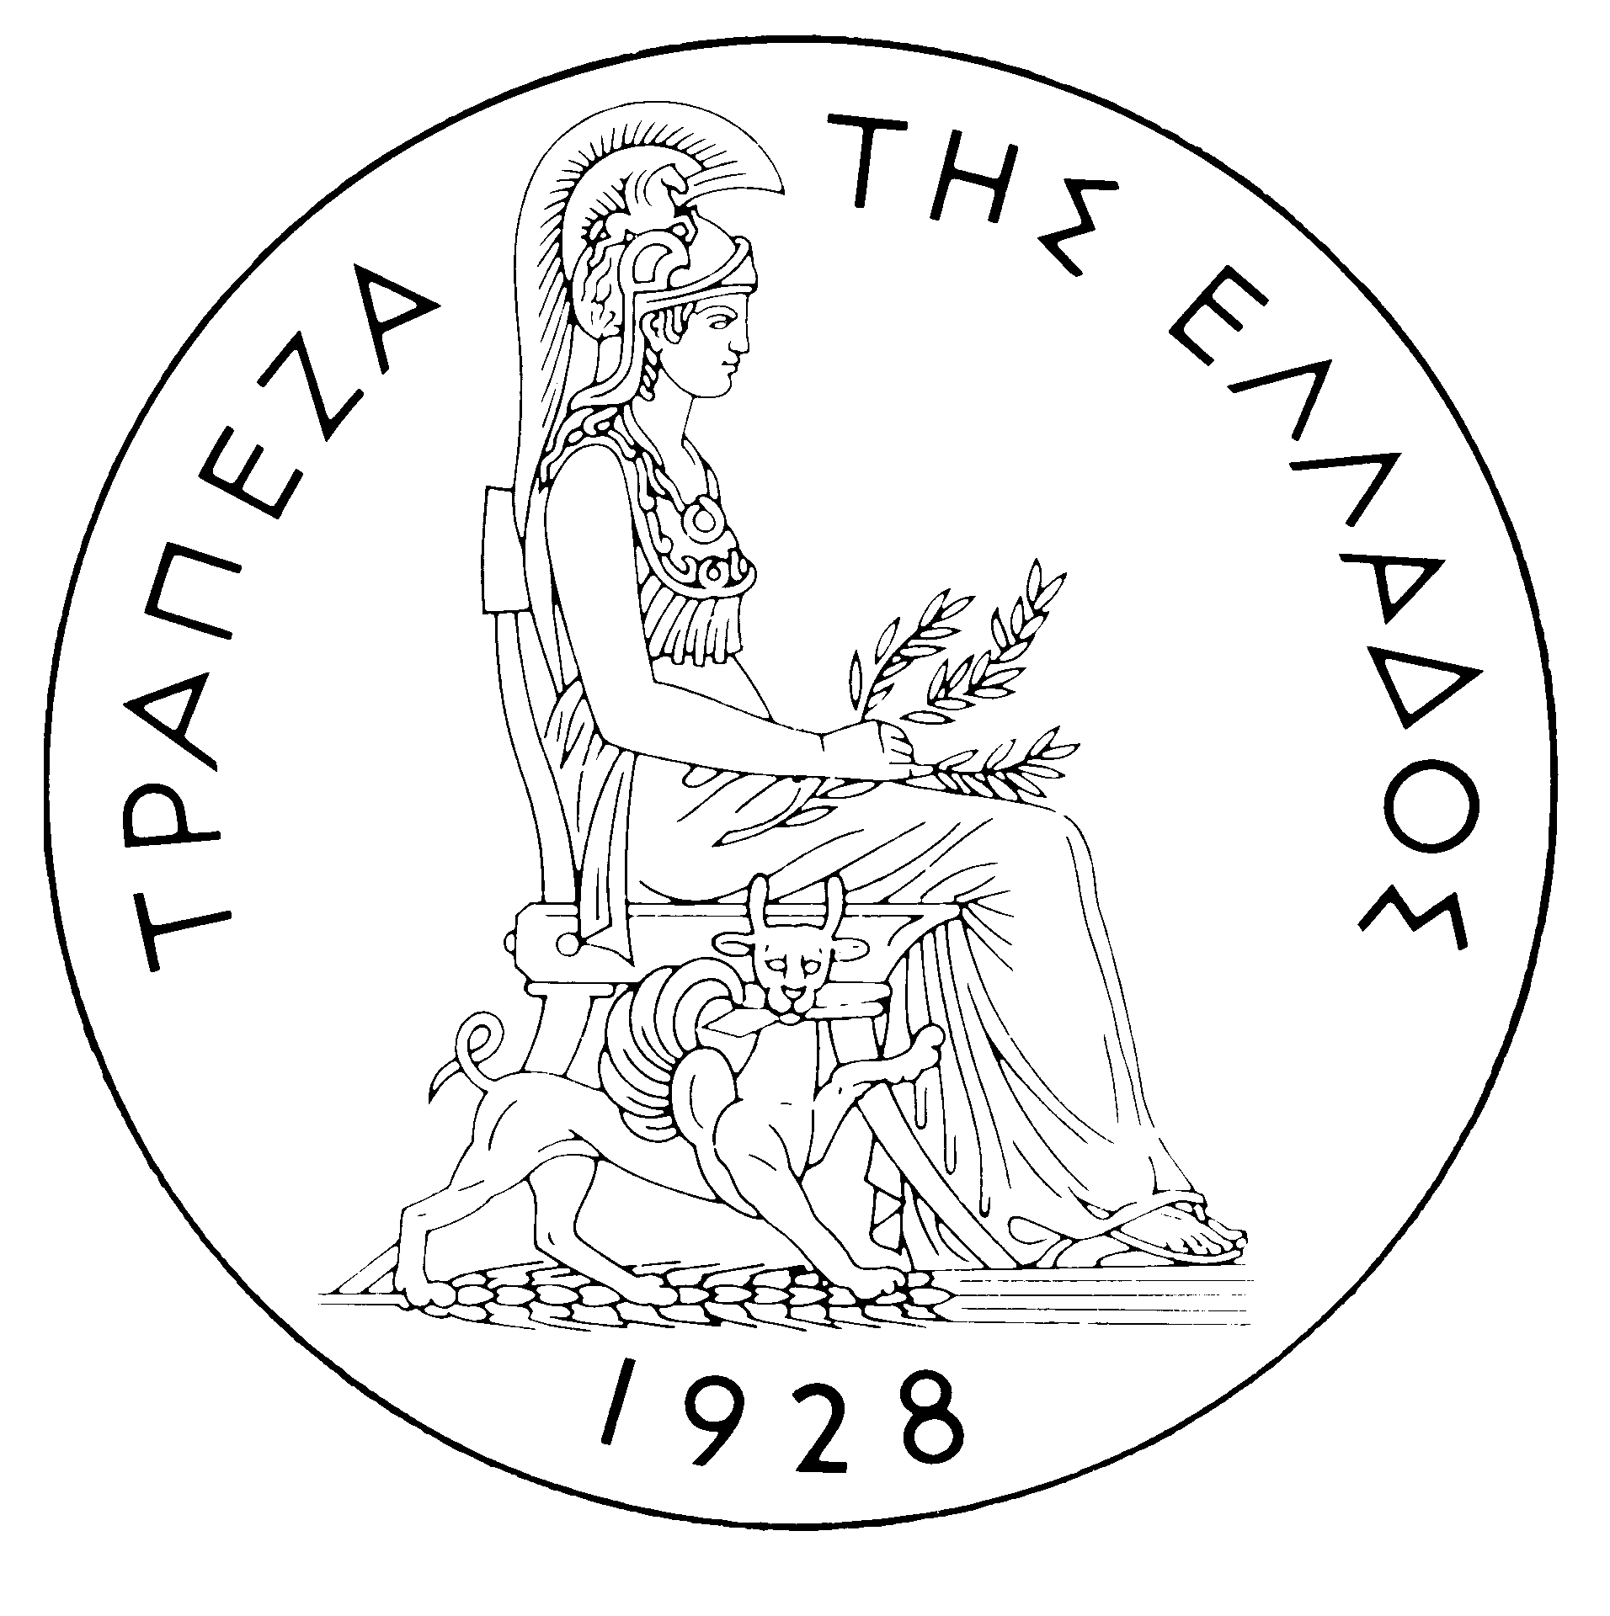
BANK OF GREECE

PRESS RELEASE

Athens, 20 October 2005

Re: Balance of payments: AUGUST 2005

Current account balance
New presentation of the balance of payments. As noted in the previous balance of payments press release (16 September 2005), the availability of detailed data that cover a sufficient time span makes possible the presentation of balance of payments figures that refer to July 2005 and onwards according to a breakdown in line with the prevailing international practice. Specifically, as from July 2005, transfer payments and receipts are broken down into current and capital transfer payments and receipts. The criterion for this breakdown is the final purpose of the transfer payment, i.e. whether it is aimed at increasing the recipient's income (current transfer) or increasing – directly or indirectly – the recipient's stock of capital (capital transfer). On the basis of this breakdown, the transfers balance is now divided into two parts: the current transfers balance, which is classified under the current account, and the capital transfers balance, which is a separate section. Thus, the new current account balance now includes the trade balance, the services balance, the income account balance and the current transfers balance, while the capital transfers balance is an independent part of the balance of payments. Therefore, in this new presentation of the balance of payments, the algebraic sum of the current account balance and the capital transfers balance corresponds to the current account balance as presented until recently (i.e. regarding data up to and including June 2005).

In August 2005, the current account according to the new presentation showed a surplus of €656 million, which was lower by €377 million than in August 2004. Underlying this narrowing of the overall surplus was mainly a decrease in the current transfers surplus and, secondarily, an increase in the trade deficit, while both the services surplus and the income account deficit remained virtually unchanged.
In more detail, an €86 million rise in the trade deficit is attributable mainly to the increase in the trade deficit excluding oil and ships, less to the increase in the deficit of the ships' balance and, finally, marginally to the outturn of the net oil bill. Although the surplus of both the travel services balance and the transportation services balance grew (by €76 and €32 million respectively), the overall surplus of the services balance remained at the same level as in August 2004. This is accounted for by a considerable drop in receipts from “other services”, which was to be expected, taking into account the one-off receipts in August 2004 owing to the Olympic Games. It should be noted that gross travel receipts (i.e. travel spending in Greece by non-residents) grew by €84 million or 3.2% over the already high level recorded in August 2004. Gross transportation receipts also rose by €112 million or 10.5%.
The income account deficit was unchanged, mainly reflecting the fact that interest, dividend and profit receipts grew by €35 million and the corresponding payments rose by €33 million. However, it should be noted that the latter increase was a result of a €100 million rise in interest payments on Greek government bonds held by non-residents, which was partly offset by a €56 million fall in interest payments on non-residents’ loans and deposits and a €12 million decline in dividend and profit payments. (It should be recalled that, as from April 2005, the methodology of recording interest on bonds in the balance of payments statistics changed, so that interest payments are recorded on an accruals basis, rather than on the basis of interest actually paid, as they had been up to and including March 2005. Thus, data are recorded more accurately. For comparability purposes, the monthly data going back to January 2003 have also been revised.)
Finally, the current transfers surplus fell by €296 million year-on-year, because a €322 million decline in net EU current transfers to general government was offset only to a small extent by a €26 million rise in net current transfers to the other sectors (emigrants’ remittances, etc.). (Current EU transfers mainly include receipts from the Guarantee Section of the European Agricultural Guidance and Guarantee Fund-EAGGF in the context of the Common Agricultural Policy, receipts from the European Social Fund and Greece’s payments to the Community Budget.)
In January-August 2005, the current account deficit widened by €2,032 million over the same period of 2004 and reached €7,537 million, reflecting a rise in the trade deficit, a fall in the current transfers surplus and an increase in the income account deficit. The increase of the services surplus only partly offset the above developments.
The €1,129 million increase in the overall trade deficit (including oil and ships) is due to the growth of the net oil import bill by €862 million, while the ships’ balance showed a deficit of €310 million, compared with a surplus of €526 million in the corresponding period of 2004. These developments more than offset the favourable outturn of the trade deficit excluding oil and ships, which narrowed by €569 million.
The services surplus widened considerably (by €568 million or 5.2%), reflecting an increase in net transportation and travel receipts. Specifically, net transportation (mainly shipping) receipts were higher by €432 million, compared with the already very high receipts recorded in the corresponding period of 2004, despite the continuing drop in freight rates in international markets. Gross travel receipts rose by €560 million or 7.5%, while gross travel payments grew by €205 million or 14.2%, thereby pushing up net travel receipts by €354 million over the corresponding period of 2004.
The income account deficit grew by €671 million during the same period, as net interest, dividend and profit payments increased, mainly because of a continuing rise in non-residents’ holdings of old and new issues of Greek Government bonds.
Finally, the €800 million year-or-year fall in the current transfers surplus is attributable on the one hand to a €484 million decrease in net EU current transfers to general government and, on the other hand, a €316 million drop in net current transfers to the "other" sectors (excluding general government). Specifically, while in the January-August 2005 period general government current payments to the EU rose by €665 million year-on-year, EU current transfers to general government only grew by €181 million.
Capital transfers balance
In August 2005, the capital transfer account balance showed a surplus of €57 million, compared with a surplus of €105 million in August 2004. In more detail, net EU capital transfers to general government fell to €59 million, from €106 million in August 2004. (EU capital transfers mainly include receipts from the Structural Funds – except for the European Social Fund – and the Cohesion Fund under the Community Support Framework).
In January-August 2005, the capital transfer account balance showed a surplus of €1,083 million, i.e. lower by €361 million than in the corresponding period of 2004. This mainly reflects a €312 million decrease in net EU capital transfers to general government.
Combined current account and capital transfers account balance (according to the old method of presentation)
The combined current account and capital transfers balances (on the basis of the old method of presentation) showed a surplus of €713 million in August 2005, compared with a surplus of €1,138 million in August 2004. Overall, in January-August 2005, the deficit amounted to €6,455 million, compared with €4,062 million in the same period of 2004.
Financial account balance
In August 2005, both non-residents’ direct investment in Greece and residents’ direct investment abroad were very low. Under portfolio investment, underlying a net outflow of €847 million were mainly residents’ purchases of foreign bonds and Treasury bills of €1,548 million and a €1,098 million outflow for the repayment of a convertible bond loan of the Hellenic Telecommunications Organisation (OTE), which were only partly offset by an inflow of €2,000 million for non-residents’ purchases of Greek Government bonds. "Other" investment showed a net inflow of €680 million, because, on the one hand, residents’ external assets declined and, on the other hand, residents’ external liabilities rose.
In January-August 2005, direct investment showed a net outflow of €148 million (compared with a net inflow of €600 million in the corresponding period of the previous year). This development is accounted for by the fact that residents’ direct investment abroad came to €561 million, while, at the same time, non-residents' direct investment in Greece reached €414 million. Portfolio investment recorded a net inflow of €7,302 million during the same period, since the outflow of residents’ funds for investment abroad (mainly in bonds) was more than offset by the inflow of non-residents’ funds for investment primarily in Greek government paper. Finally, under "other" investment, a net outflow of €211 million reflects the fact that the outflow of funds (€13,087 million), mainly for residents’ investment in deposits and repos abroad, more than offset the inflow of non-residents’ funds (€12,876 million), mainly for similar investment in Greece.
At end-August 2005, Greece’s reserve assets came to €1.9 billion. (It should be recalled that, since Greece joined the euro area in January 2001, reserve assets, as defined by the European Central Bank, include only monetary gold, the "reserve position" with the IMF, "Special Drawing Rights", and Bank of Greece claims in foreign currency on residents of non-euro area countries. Conversely, reserve assets do not include claims in euro on residents of non-euro area countries, claims in foreign currency and in euro on residents of euro area countries, and the Bank of Greece participation in the capital and the reserve assets of the ECB.)
Note: Balance of payments data for September 2005 will be released on 22 November 2005.

