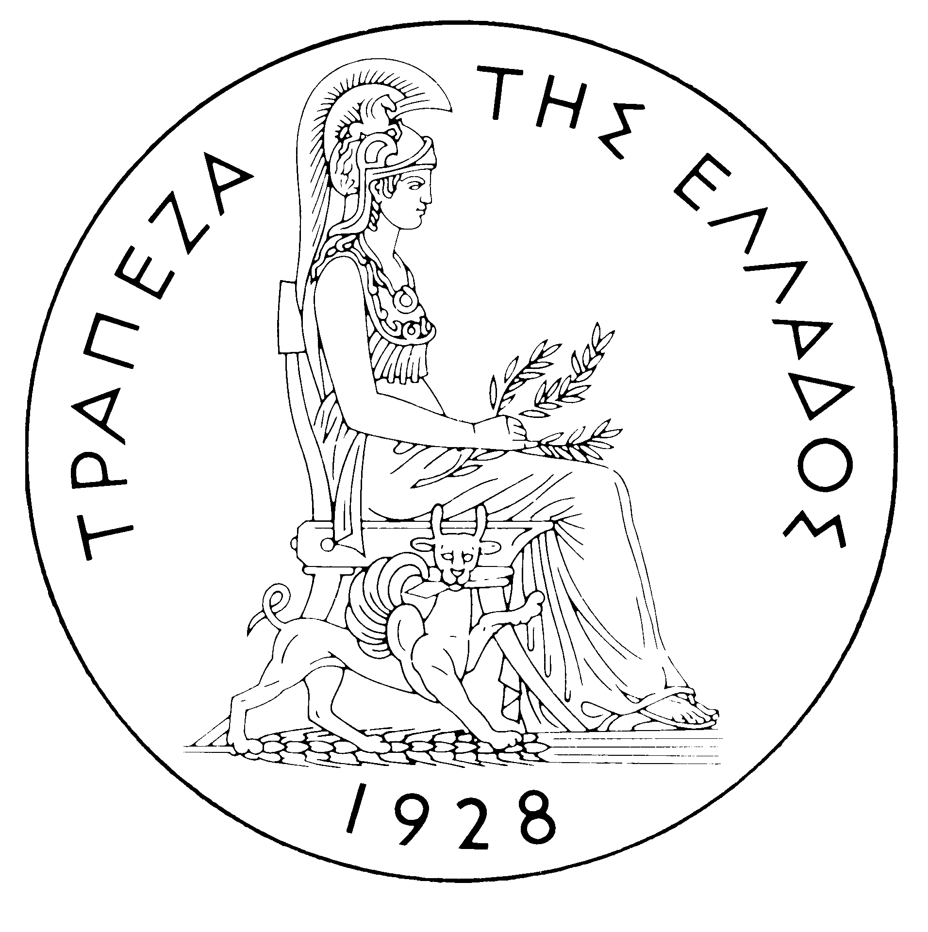
BANK OF GREECE

PRESS RELEASE

Athens, 22 November 2005

Re: Balance of payments: SEPTEMBER 2005

Current account balance
In September 2005, the current account according to the new presentation showed a deficit of €592 million, which was higher by €281 million than in September 2004. This development is attributable almost equally to a widening of the trade deficit, an increase in the income account deficit and a decline in the services surplus, which more than offset the growth of the current transfers surplus. (It should be recalled that, according to the new presentation, the transfers balance is now divided into two parts: the current transfers balance, which is classified under the current account, and the capital transfers balance, which is a separate section. Thus, the new current account balance now includes the trade balance, the services balance, the income account balance and the current transfers balance, while the capital transfers balance is an independent part of the balance of payments. Therefore, in this new presentation of the balance of payments, the algebraic sum of the current account balance and the capital transfers balance corresponds to the current account balance as presented until recently, i.e. regarding data up to and including June 2005.)
The trade deficit (excluding oil and ships) narrowed in September by €102 million, but its decrease was more than offset by the €163 million and €61 million increases, respectively, in the deficits of the oil balance and the ships' balance.
The overall surplus of the services balance dropped by €117 million year-on-year. Specifically, the surplus of the travel services balance grew by €157 million, reflecting a €114 million (or 7.5%) increase in gross receipts (i.e. travel spending in Greece by non-residents) over the relatively high level recorded in September 2004 and a €43 million (or 20.7%) decline in gross payments (i.e. travel spending abroad by residents). By contrast, the surplus of the transport services balance narrowed by €87 million, reflecting a small drop in gross receipts (of €24 million or 2.2%) and an appreciable rise in gross payments (of €63 million or 13.3%). Finally, as it was to be expected, the “other services” balance showed a deficit of €73 million, compared with a surplus of €115 million in September 2004 which is attributable to one-off receipts owing to the Olympic Games.
The €124 million increase in the income account deficit mainly reflects the fact that interest payments on Greek government bonds held by non-residents rose by €110 million. (It should be recalled that, as from April 2005, the methodology of recording interest on bonds in the balance of payments statistics changed, so that interest payments are recorded on an accruals basis, rather than on a cash basis, as they had been up to and including March 2005. Thus, data are recorded more accurately. For comparability purposes, the monthly data going back to January 2003 have also been revised.)
Finally, the current transfers surplus grew by €81 million year-on-year, as a €122 million rise in EU current transfers to general government overshot a €33 million rise in general government payments to the EU. (Current EU transfers mainly include receipts from the Guarantee Section of the European Agricultural Guidance and Guarantee Fund – EAGGF in the context of the Common Agricultural Policy, receipts from the European Social Fund and Greece’s payments to the Community Budget.)
In January-September 2005, the current account deficit widened by €2,313 million over the same period of 2004 and reached €8,130 million, reflecting mainly a rise in the trade deficit and, secondarily, an increase in the income account deficit and a drop in the current transfers surplus. The increase in the services surplus only partly offset the above developments.
The €1,251 million increase in the overall trade deficit (including oil and ships) is due to the growth of the net oil import bill by €1,025 million and the fact that the ships’ balance showed a deficit of €376 million, compared with a surplus of €522 million in the corresponding period of 2004. These developments more than offset the favourable outturn of the trade deficit excluding oil and ships, which narrowed by €671 million, because exports (excluding oil and ships) grew by €100 million, while the corresponding imports declined by €571 million in comparison with their very high level in the same period of 2004.
The services surplus widened considerably (by €451 million), reflecting an increase in net transport and travel receipts. Specifically, gross transport (mainly shipping) receipts were higher by €679 million or 6.9%, compared with the already very high receipts recorded in the corresponding period of 2004, despite the continuing drop in freight rates in international markets. Since gross transport payments rose by €334 million or 7.9%, net transport receipts grew by €345 million. Gross travel receipts rose by €674 million or 7.5%, while gross travel payments increased by €162 million or 9.8%, thereby pushing up net travel receipts by €511 million over the corresponding period of 2004.
The income account deficit grew by €795 million during the same period, as net interest, dividend and profit payments increased, mainly because of a continuing rise in non-residents’ holdings of old and new issues of Greek Government bonds.
Finally, the €718 million year-or-year fall in the current transfers surplus is attributable on the one hand to a €395 million decrease in net EU current transfers to general government and, on the other hand, a €323 million drop in net current transfers to the "other" sectors (excluding general government). Specifically, in the January-September 2005 period EU current transfers to general government grew by €303 million or 9.0%, but general government current payments to the EU rose by €698 million or 44.6% year-on-year.
Capital transfers balance
In September 2005, the capital transfers balance showed a surplus of €264 million, which was slightly smaller than in September 2004 (€284 million). (EU capital transfers mainly include receipts from the Structural Funds – except for the European Social Fund – and the Cohesion Fund under the Community Support Framework).
In January-September 2005, the capital transfers balance showed a surplus of €1,346 million, i.e. smaller by €382 million than in the corresponding period of 2004. This mainly reflects a €330 million decrease in net EU capital transfers to general government.
Combined current account and capital transfers balance (according to the old method of presentation)
The combined current account and capital transfers balances (on the basis of the old method of presentation) showed a deficit of €329 million in September 2005, compared with a deficit of only €27 million in September 2004. Overall, in January-September 2005, the deficit amounted to €6,783 million, compared with €4,089 million in the same period of 2004.
Financial account balance
In September 2005, direct investment in Greece showed a substantial net outflow of €712 million, which mainly reflects a considerable net outflow of €592 million under non-residents’ investment in Greece and, secondarily, an outflow of €121 million for residents’ investment abroad. As regards non-residents’ investment in Greece, the outflow is accounted for by the fact that the Dutch company ARAMCO withdrew from the share capital of MOTOR OIL HELLAS S.A., while the Luxembourg company MOTOR OIL HOLDING S.A. sold its stake in the share capital of the said company. However, the shares sold by MOTOR OIL HOLDING S.A., worth €318 million, were purchased by other non-residents (mainly institutional investors); as a result, this transaction is recorded as an inflow under portfolio investment and the overall financial account balance is not affected thereby. Investment abroad by residents in September 2005 mainly reflects the expansion of Greek banks in the Balkans, with, specifically, ALPHA BANK participating in the capital increase of its subsidiary ALPHA BANK ROMANIA and EUROBANK acquiring the Serbian bank NATIONALNA STEDIONICA BANKA. Under portfolio investment, a net inflow of €1,985 million reflects inflows of non-residents’ funds amounting to €3,769 million, mainly for the purchase of Greek Government bonds and shares, which were partly offset by an outflow of €1,783 million for purchases of foreign bonds and, secondarily, Treasury bills and shares by residents. "Other" investment showed a net outflow of €645 million, because residents’ external liabilities fell more than residents’ external assets.
In January-September 2005, direct investment showed a net outflow of €860 million (compared with a net inflow of €626 million in the corresponding period of the previous year). This development is accounted for mainly by a net outflow of €682 million for residents’ direct investment abroad and, secondarily, by a net outflow of €178 million under non-residents' investment in Greece. Portfolio investment recorded a net inflow of €9,288 million during the same period, since the outflow of residents’ funds for investment abroad (mainly in bonds) was more than offset by the inflow of non-residents’ funds for investment primarily in Greek government paper and – to an appreciable degree – shares of Greek firms. Finally, under "other" investment, a net outflow of €856 million reflects the fact that the outflow of funds (€12,185 million), mainly for residents’ investment in deposits and repos abroad, more than offset the inflow of non-residents’ funds (€11,329 million), mainly for similar investment in Greece.
At end-September 2005, Greece’s reserve assets came to €2.0 billion. (It should be recalled that, since Greece joined the euro area in January 2001, reserve assets, as defined by the European Central Bank, include only monetary gold, the "reserve position" with the IMF, "Special Drawing Rights", and Bank of Greece claims in foreign currency on residents of non-euro area countries. Conversely, reserve assets do not include claims in euro on residents of non-euro area countries, claims in foreign currency and in euro on residents of euro area countries, and the Bank of Greece participation in the capital and the reserve assets of the ECB.)
Note: Balance of payments data for October 2005 will be released on 20 December 2005.

