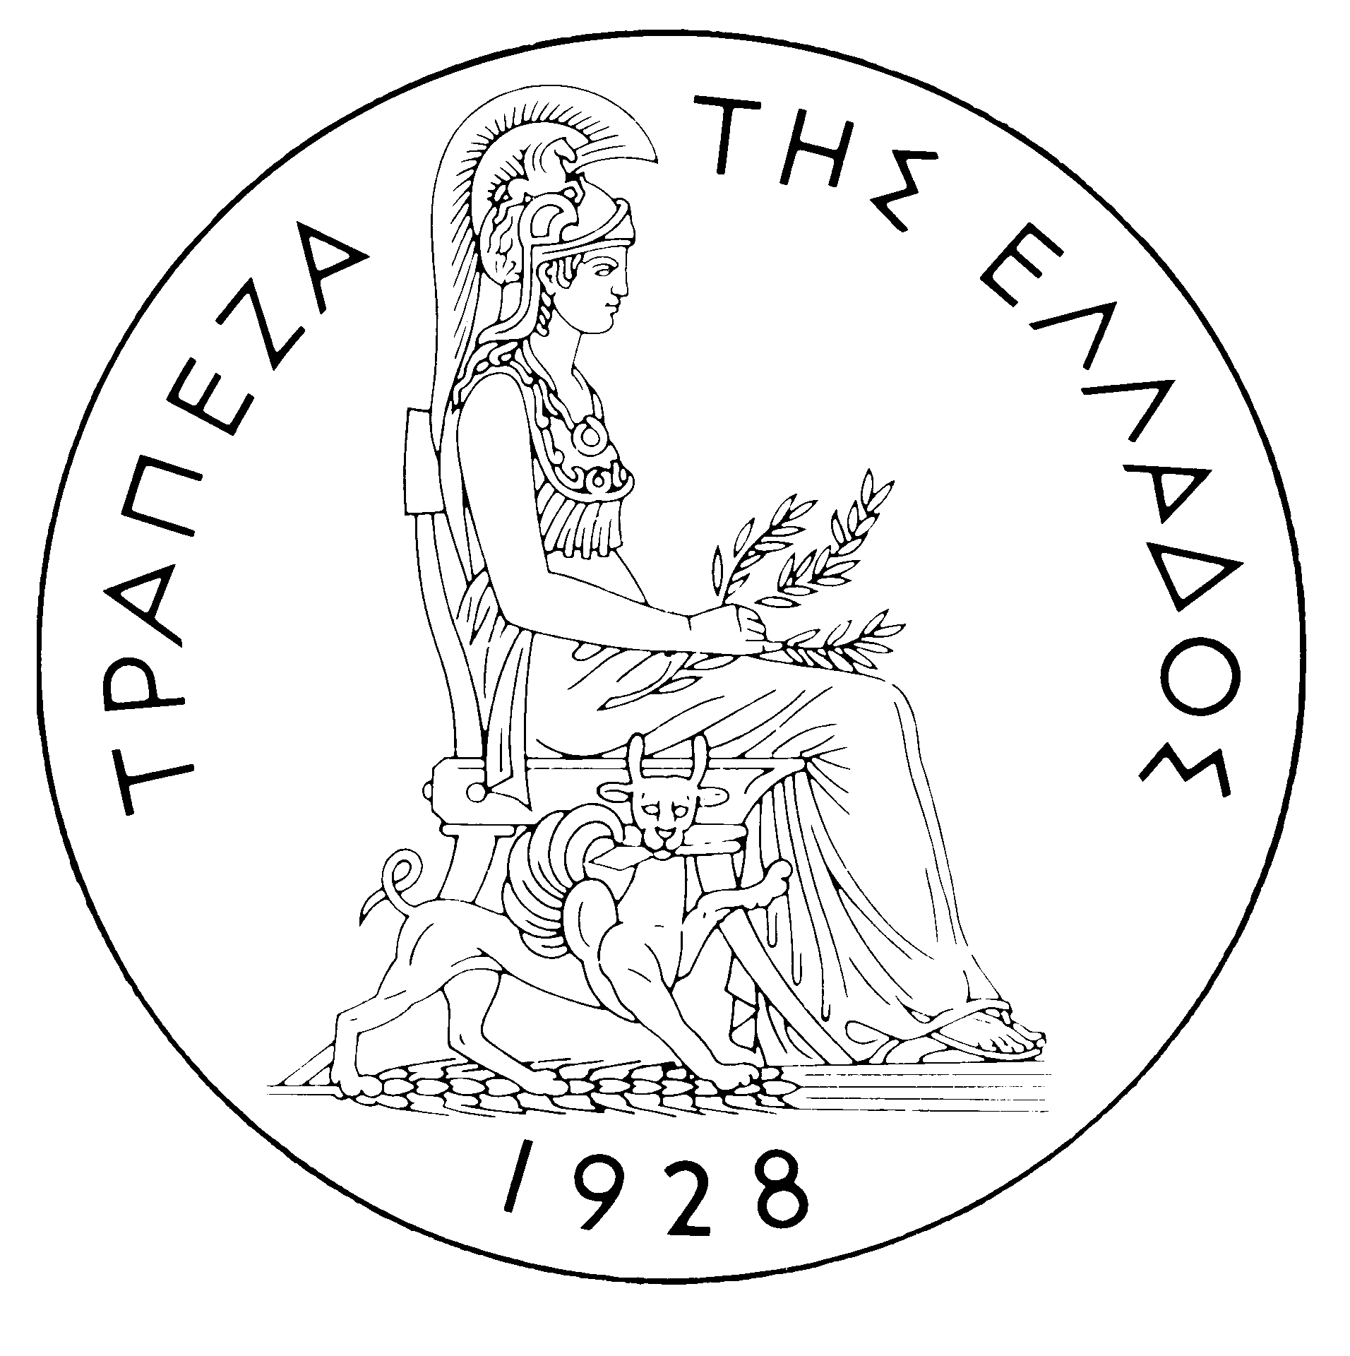
BANK OF GREECE

PRESS RELEASE

Athens, 20 December 2005

Re: Balance of payments: OCTOBER 2005

Current account balance
In October 2005, the current account showed a deficit of €1,285 million, €408 million higher than in October 2004. This development is mainly attributable to a widening of the trade deficit and, secondarily, to a decline in the services surplus and an increase in the income account deficit. By contrast, the current transfers surplus grew. (It should be recalled that, according to the new presentation, the transfers balance is now divided into two parts: the current transfers balance, which is classified under the current account, and the capital transfers balance, which is a separate section. Thus, the new current account balance now comprises the trade balance, the services balance, the income account balance and the current transfers balance, while the capital transfers balance is an independent part of the balance of payments. Therefore, in this new presentation of the balance of payments, the algebraic sum of the current account balance and the capital transfers balance corresponds to the current account balance as presented until recently, i.e. regarding data up to and including June 2005).)
The trade deficit (excluding oil and ships) increased only slightly in October (by €34 million). Given that the deficit of the ships’ balance (sales minus purchases) showed a small decline, the widening of the overall trade balance is mainly accounted for by a rise (of €317 million) in the oil balance.
The overall surplus of the services balance dropped by €88 million year-on-year. Specifically, the surplus of the travel services balance grew by €39 million, while, by contrast, the surplus of the transport services balance narrowed by €113 million and the “other services” deficit widened slightly.
The €91 million increase in the income account deficit mainly reflects the fact that interest payments on Greek government bonds held by non-residents rose. (It should be recalled that, as from April 2005, the methodology of recording interest on bonds in the balance of payments statistics changed, so that interest payments are recorded on an accruals basis, rather than on a cash basis, as they had been up to and including March 2005. Thus, data are recorded more accurately. For comparability purposes, the monthly data going back to January 2003 have also been revised.)
Finally, the current transfers surplus grew by €106 million year-on-year, as a €144 million rise in EU gross current transfers to general government by far overshot a €29 million rise in general government payments to the EU. (Current transfers from or to the EU mainly include receipts from the Guarantee Section of the European Agricultural Guidance and Guarantee Fund – EAGGF – in the context of the Common Agricultural Policy, receipts from the European Social Fund and Greece’s contributions to the Community Budget.)
In January-October 2005, the current account deficit widened by €2,721 million over the same period of 2004 and reached €9,415 million, reflecting mainly a rise in the trade deficit and, secondarily, an increase in the income account deficit and a drop in the current transfers surplus. The increase in the services surplus only partly offset the above developments.
The €1,587 million rise in the overall trade deficit (including oil and ships) is mainly due to the growth of the net oil import bill by €1,341 million and, secondarily, to the fact that the ships’ balance showed a deficit of €409 million, compared with a surplus of €474 million in the corresponding period of 2004. These developments more than offset the favourable outturn of the trade deficit excluding oil and ships, which narrowed by €637 million, because exports (excluding oil and ships) grew by €223 million, while the corresponding imports declined by €414 million in comparison with their very high levels in the same period of 2004.
The services surplus widened considerably (by €363 million), reflecting an increase in net travel and transport receipts. Specifically, gross travel receipts (i.e. travel spending in Greece by non-residents) grew by €682 million (or 6.9%), while gross payments (i.e. travel spending abroad by residents) rose by €132 million or 7.1%, thereby pushing up net travel receipts by €550 million year-on-year. Gross transport (mainly shipping) receipts were higher by €578 million or 5.3%, compared with the already very high receipts recorded in the corresponding period of 2004, despite the continuing drop in freight rates in international markets. As gross transport payments rose by €345 million or 7.3%, net transport receipts increased by €233 million.
The income account deficit grew by €885 million during the same period, as net interest, dividend and profit payments increased, mainly because of a continuing rise in non-residents’ holdings of old and new issues of Greek Government bonds.
Finally, the €612 million year-or-year fall in the current transfers surplus is attributable on the one hand to a €279 million decrease in net EU current transfers to general government and, on the other hand, to a €333 million drop in net current transfers to the "other" sectors (excluding general government). Specifically, while in the January-October 2005 period general government gross current receipts from the EU rose by €447 million or 12.7% year-on-year, general government gross current payments to the EU grew by €726 million or 41.6%.
Capital transfers balance
In October 2005, the capital transfers balance showed a surplus of €42 million, compared with a small deficit in October 2004. (EU capital transfers mainly include receipts from the Structural Funds – except for the European Social Fund – and the Cohesion Fund under the Community Support Framework).
In January-October 2005, the capital transfers balance showed a surplus of €1,388 million, i.e. smaller by €336 million than in the corresponding period of 2004. This mainly reflects a €290 million decrease in net EU capital transfers to general government.
Combined current account and capital transfers balance (according to the old method of presentation)
The combined current account and capital transfers balances (on the basis of the old method of presentation) showed a deficit of €1,244 million in October 2005, compared with a deficit of €881 million in October 2004. Overall, in January-October 2005, the deficit amounted to €8,027 million, compared with €4,969 million in the same period of 2004.
Financial account balance
In October 2005, no significant flows were observed under direct investment. Under portfolio investment, a net outflow of €2,108 million reflects a €1,684 outflow of residents’ funds, mainly for purchases of foreign bonds, and, secondarily, an outflow of non-residents’ funds owing to sales of Greek bonds. "Other" investment showed a net inflow of €3,382 million, which is primarily attributable to an increase in non-residents’ repo and deposit holdings in Greece and, to a lesser extent, a decline in the corresponding holdings abroad by residents.
In January-October 2005, direct investment showed a net outflow of €920 million (compared with a net inflow of €613 million in the corresponding period of the previous year). This development is accounted for mainly by a net outflow of €695 million for residents’ direct investment abroad and, secondarily, by a net outflow of €226 million under non-residents' investment in Greece. Portfolio investment recorded a net inflow of €7,180 million during the same period, since the outflow of residents’ funds for investment abroad (mainly in bonds) was more than offset by the inflow of non-residents’ funds for investment primarily in Greek government paper and – to a considerable extent – shares of Greek firms. Finally, under "other" investment, a net inflow of €2,525 million reflects the fact that the inflow of funds (€14,128 million), mainly for non-residents’ investment in deposits and repos in Greece, more than offset the outflow of residents’ funds (€11,602 million), almost exclusively for similar investment abroad.
At end-October 2005, Greece’s reserve assets came to €2.0 billion. (It should be recalled that, since Greece joined the euro area in January 2001, reserve assets, as defined by the European Central Bank, include only monetary gold, the "reserve position" with the IMF, "Special Drawing Rights", and Bank of Greece claims in foreign currency on residents of non-euro area countries. Conversely, reserve assets do not include claims in euro on residents of non-euro area countries, claims in foreign currency and in euro on residents of euro area countries, and the Bank of Greece participation in the capital and the reserve assets of the ECB.)
Note: Balance of payments data for November 2005 will be released on 20 January 2006.

