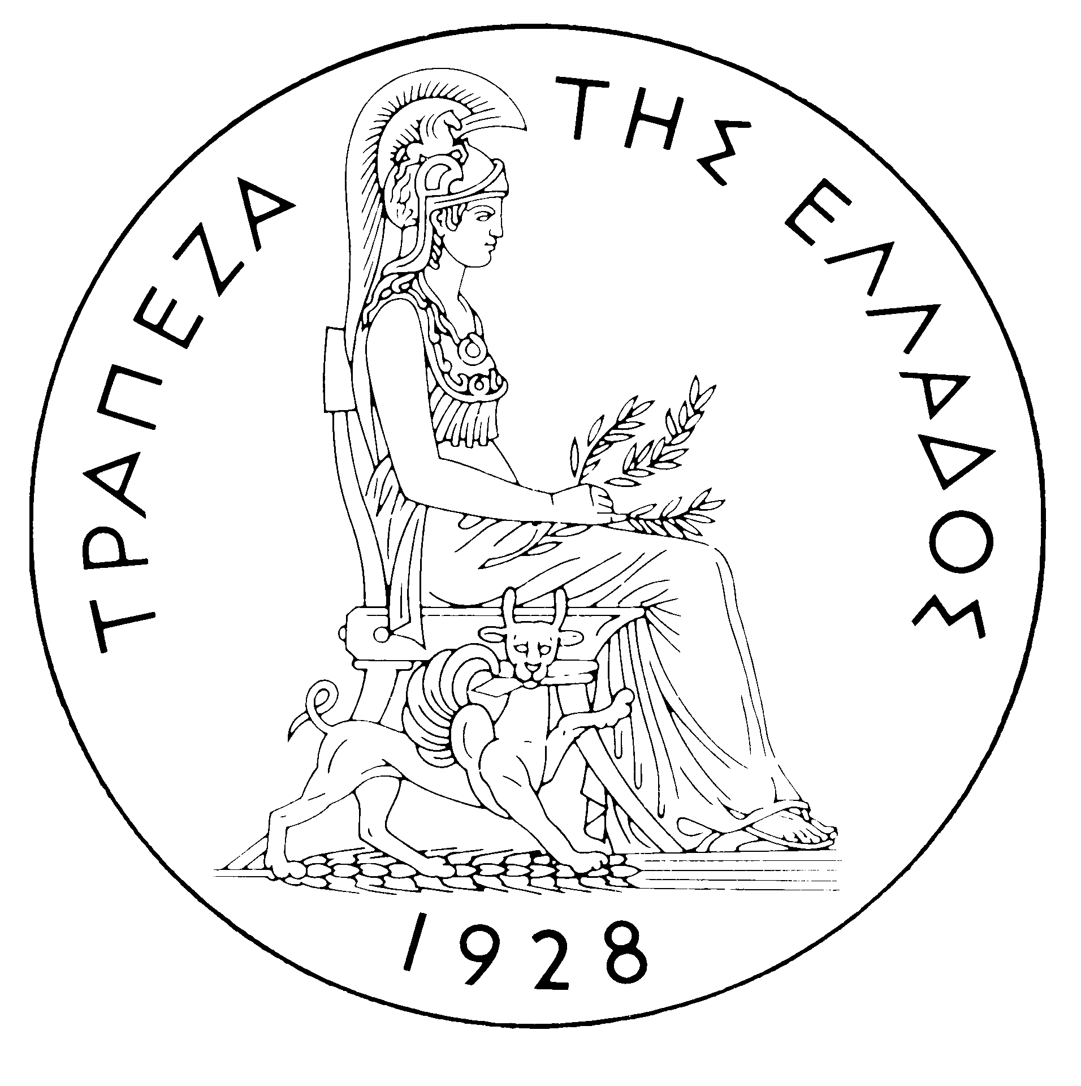
BANK OF GREECE

PRESS RELEASE

Athens, 20 January 2006

Re: Balance of payments: NOVEMBER 2005

Current account balance
In November 2005, the current account showed a deficit of €2,137 million, €197 million higher than in November 2004. This development is attributable to a relatively large increase in the income account deficit, a decline in the services surplus and a widening of the trade deficit. By contrast, the current transfers surplus grew considerably. (It should be recalled that, according to the new presentation, the transfers balance is now divided into two parts: the current transfers balance, which is classified under the current account, and the capital transfers balance, which is a separate section. Thus, the new current account balance now comprises the trade balance, the services balance, the income account balance and the current transfers balance, while the capital transfers balance is an independent part of the balance of payments. Therefore, in this new presentation of the balance of payments, the algebraic sum of the current account balance and the capital transfers balance corresponds to the current account balance as presented until recently, i.e. regarding data up to and including June 2005.)
The trade deficit (excluding oil and ships) shrank by €102 million in November. However, since the net oil import bill rose by €140 million and the deficit of the ships’ balance (sales minus purchases) also grew – to a lesser extent – by €35 million, the overall trade deficit widened by €72 million.
The overall surplus of the services balance dropped by €79 million year-on-year, reflecting a €105 million decline in the surplus of the transport services balance, while the surplus of the travel services balance showed a small increase and the “other services” deficit narrowed slightly.
The €161 million increase in the income account deficit is mainly attributable to a €129 million rise in interest payments on Greek government bonds held by non-residents. (It should be recalled that, as from April 2005, the methodology of recording interest on bonds in the balance of payments statistics changed, so that interest payments are recorded on an accruals basis, rather than on a cash basis, as they had been up to and including March 2005. Thus, data are recorded more accurately. For comparability purposes, the monthly data going back to January 2003 have also been revised.)
Finally, the current transfers surplus grew by €114 million year-on-year, as a €130 million rise in EU gross current transfers to general government by far overshot a €29 million rise in general government payments to the EU. (Current transfers from the EU mainly include receipts from the Guarantee Section of the European Agricultural Guidance and Guarantee Fund – EAGGF – in the context of the Common Agricultural Policy and receipts from the European Social Fund, while current transfers to the EU include Greece’s contributions to the Community Budget.)
In January-November 2005, the current account deficit widened by €2,919 million over the same period of 2004 and reached €11,551 million, reflecting mainly a rise in the trade deficit and the income account deficit and, secondarily, a drop in the current transfers surplus. The increase in the services surplus only partly offset the above developments.
The €1,659 million rise in the overall trade deficit (including oil and ships) is mainly due to the growth of the net oil import bill by €1,481 million and, secondarily, to the fact that the ships’ balance showed a deficit of €528 million, compared with a surplus of €389 million in the corresponding period of 2004. These developments more than offset the favourable outturn of the trade deficit excluding oil and ships, which narrowed by €740 million, because exports (excluding oil and ships) grew by €390 million, while the corresponding imports declined by €350 million in comparison with their very high levels in the same period of 2004.
The services surplus widened (by €284 million), as a result of an increase in net travel and transport receipts. Specifically, gross travel receipts (i.e. travel spending in Greece by non-residents) grew by €688 million (or 6.8%), while gross payments (i.e. travel spending abroad by residents) rose by €127 million or 6.1%, thereby pushing up net travel receipts by €561 million year-on-year. Gross transport (mainly shipping) receipts were higher by €497 million or 4.1%, compared with the already very high receipts recorded in the corresponding period of 2004, despite the continuing drop in freight rates in international markets. As gross transport payments rose by €370 million or 7.1%, net transport receipts increased by €127 million. By contrast, net payments for “other” services rose by €403 million.
The income account deficit grew by €1,046 million during the same period, as net interest, dividend and profit payments increased, mainly because of a continuing rise in non-residents’ holdings of old and new issues of Greek Government bonds.
Finally, the €498 million year-or-year fall in the current transfers surplus is attributable mainly to a €318 million drop in net current transfers to the "other" sectors (excluding general government) and, secondarily, to a €180 million decrease in net (mainly EU) current transfers to general government. However, it should be stressed that gross current transfers to general government (mainly from the EU) rose by €576 million or 15.7%, but general government gross current payments to the EU grew by €756 million or 38.4%.
Capital transfers balance
In November 2005, the capital transfers balance showed a surplus of €299 million, €89 million smaller than in November 2004. (EU capital transfers mainly include receipts from the Structural Funds – except for the European Social Fund – and the Cohesion Fund under the Community Support Framework).
In January-November 2005, the capital transfers balance showed a surplus of €1,687 million, i.e. smaller by €425 million than in the corresponding period of 2004. This mainly reflects a €421 million decrease in capital transfers to general government from the EU.
Combined current account and capital transfers balance (according to the old method of presentation)
The combined current account and capital transfers balances (on the basis of the old method of presentation) showed a deficit of €1,838 million in November 2005, compared with a deficit of €1,552 million in November 2004. Overall, in January-November 2005, the deficit amounted to €9,865 million, compared with €6,521 million in the same period of 2004.
Financial account balance
In November 2005, no significant flows were observed under direct investment. Under portfolio investment, a net inflow of €356 million reflects a €1,610 million inflow of non-residents’ funds, mainly for purchases of Greek government bonds, and, secondarily, shares. However, this inflow was largely offset by a €1,255 million outflow of residents’ funds for corresponding purchases abroad. "Other" investment showed a net inflow of €1,264 million, which is attributable to the fact that the increase in non-residents’ repo and deposit holdings in Greece overshot the rise in the corresponding holdings abroad by residents.
In January-November 2005, direct investment showed a net outflow of €1,002 million (compared with a net inflow of €564 million in the corresponding period of the previous year). This development is accounted for mainly by a net outflow of €709 million for residents’ direct investment abroad and, secondarily, by a net outflow of €293 million under non-residents' investment in Greece. Portfolio investment recorded a net inflow of €7,535 million during the same period, since the €17.3 billion outflow of residents’ funds for investment abroad (mainly in bonds) was more than offset by a €24.8 billion inflow of non-residents’ funds for investment primarily in Greek government paper and – to a considerable extent – shares of Greek firms. Finally, under "other" investment, a net inflow of €3,790 million reflects the fact that the inflow of funds (€16,898 million), mainly for non-residents’ investment in deposits and repos in Greece, was largely offset by the outflow of residents’ funds (€13,108 million), primarily for similar investment abroad.
At end-November 2005, Greece’s reserve assets came to €2.0 billion. (It should be recalled that, since Greece joined the euro area in January 2001, reserve assets, as defined by the European Central Bank, include only monetary gold, the "reserve position" with the IMF, "Special Drawing Rights", and Bank of Greece claims in foreign currency on residents of non-euro area countries. Conversely, reserve assets do not include claims in euro on residents of non-euro area countries, claims in foreign currency and in euro on residents of euro area countries, and the Bank of Greece participation in the capital and the reserve assets of the ECB.)
Note: Balance of payments data for December 2005 will be released on 20 February 2006.

