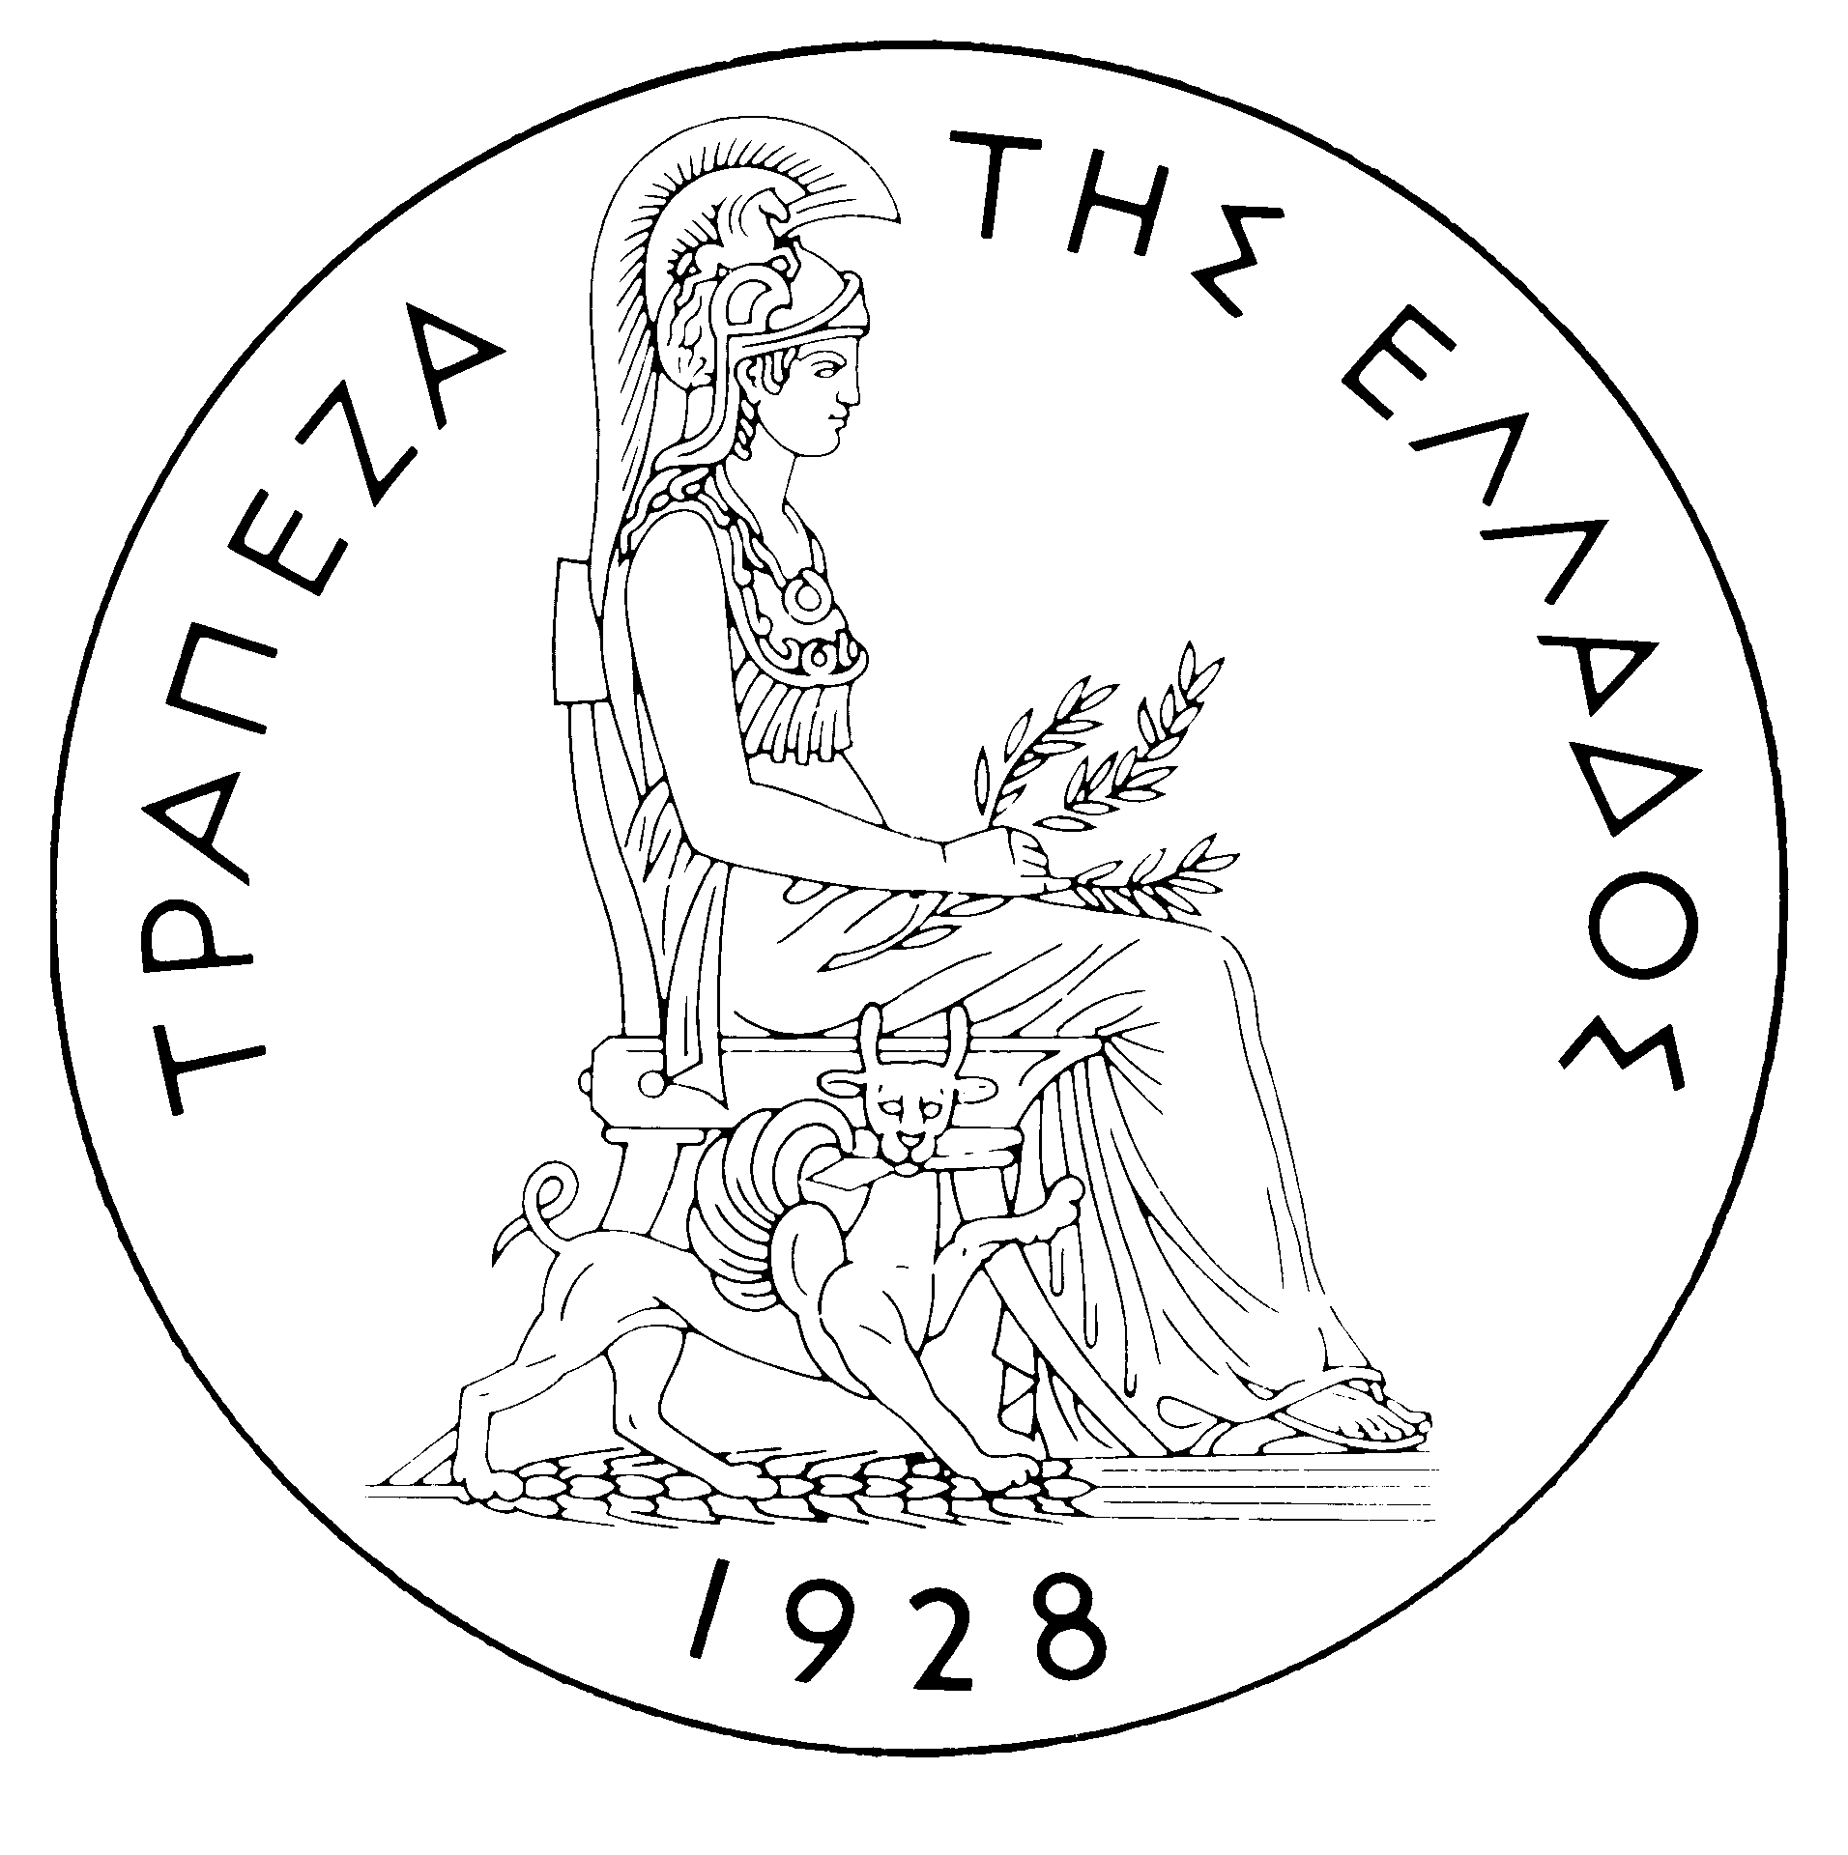
BANK OF GREECE
PRESS RELEASE
Athens, January 5 2006

Subject: Developments in the Greek government bond market – December 2005

On international markets government bond performance was generally positive in December, with the exception of short-term Euro-zone bonds. The yields on those securities increased in line with the increase in interest rates decided by the European Central Bank (ECB) on December 1. The ECB increased the refinancing rate by 25 basis points (bps) to 2.25% (from the level of 2%, unchanged since June 2003). On December 13, also the Federal Reserve increased official interest rates by 25 bps to 4.25%. Overall, the impact of these policy moves on international markets was muted as they had been anticipated by investors. In addition, an interesting factor that occurred in the US bond market was the moderate inversion of the yield curve (short-term yields exceeding long-term ones) during the last days of 2005. This left investors wondering about the future implications of such a development, weather it hints at a possible future slowdown of the US economy or it reflects ample savings in the world economy.
In the Greek electronic secondary securities market (HDAT) bond yields declined in December, with the exception of the 3-year yield, in line with the rest of the Euro-zone markets. Moreover, medium to long-term government bond yields ended the year at lower levels than at the end of 2004 while short-term (3 and 5-year) yields were higher. The 3-year yield rose by 6 bps to 3.00% on December 30 from 2.94% at the end of November and compared to 2.69% on December 31, 2004. The 10-year yield declined by 12 bps to 3.51% at the end of December from 3.63% on November 30 and compared to 3.80% at the end of 2004. Finally, the 32-year yield declined by 20 bps to 3.92% at the end of December from 4.12% on November 30. As a result, the yield curve became significantly flatter in December, with the 3 to 32-year yield gap narrowing to 92 bps, compared to 118 bps in November and 130 bps in October. The average monthly spread between the Greek and the German 10-year benchmark bond yields was 20 bps as in the previous two months.
Benchmark bond prices rose in the range of 7-375 bps, with the exception of the 3-year bond price that fell by 14 bps. The largest gain was recorded by the 32-year bond and the smallest by the 5-year bond. The 3-year bond price fell to 99.74 on December 30, compared to 99.88 at the end of November. The 10-year and the 32-year bond prices rose respectively to 101.46 and 110.31 at the end of December, compared to 100.48 and 106.56 at the end of November.
Trading volume on HDAT in December was EUR 41.87 billion worth of transactions compared to EUR 74.68 billion in November, while the daily average turnover was EUR 1.99 billion compared to EUR 3.39 billion respectively. Trading activity was mainly focused on bonds with remaining maturity between 7 and 10 years, which absorbed EUR 26.49 billion or 63% of the overall traded volume. The most actively traded bond was the 10-year benchmark that recorded EUR 15.65 billion worth of transactions followed by the 15-year bond maturing on 11/1/2014 with EUR 4.30 billion. Of the 7,529 orders executed on HDAT 51.82% were “buy” orders and 48.18% “sell” orders.

