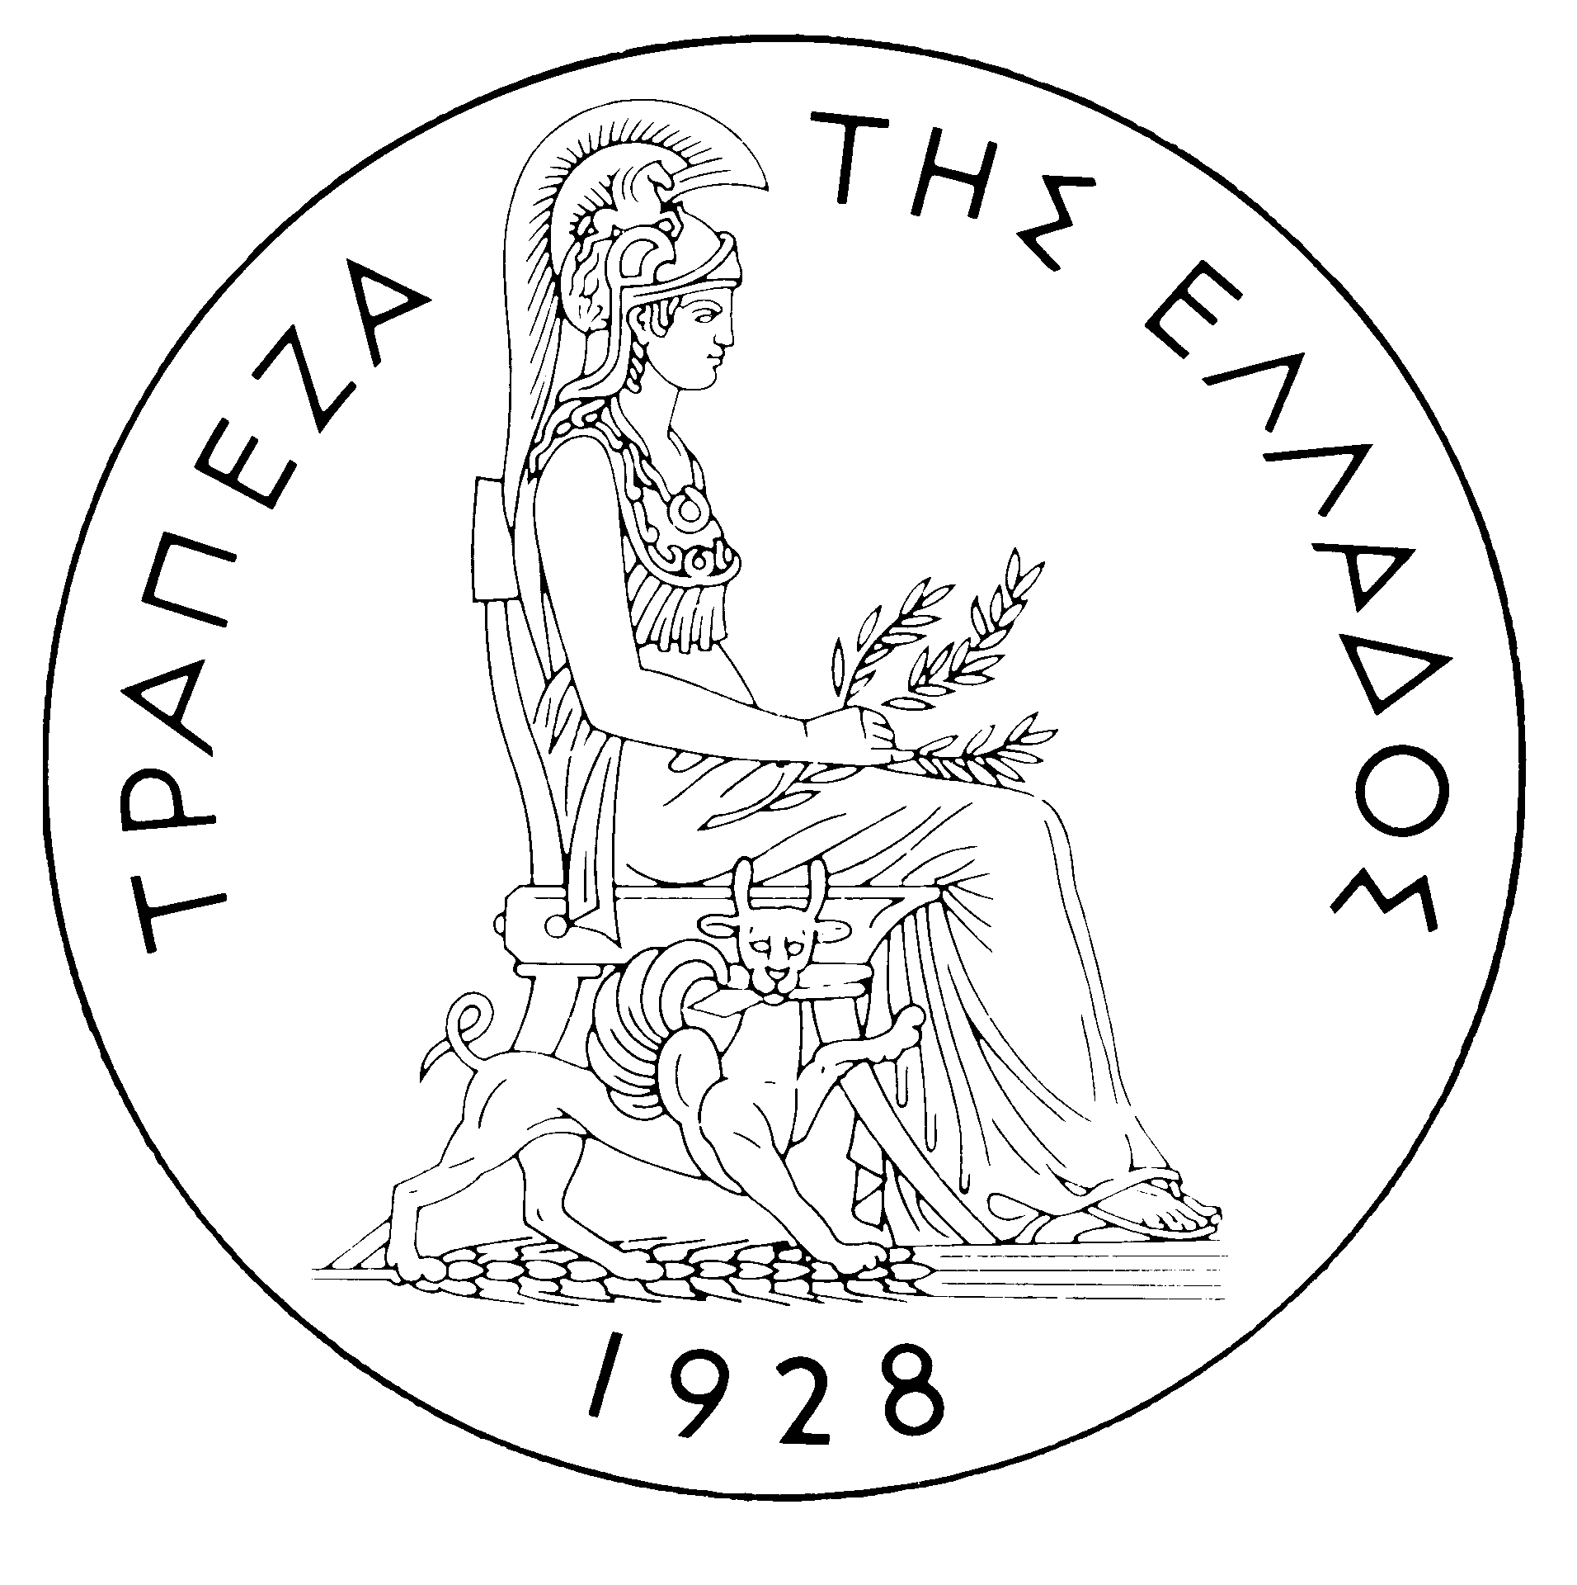
BANK OF GREECE

PRESS RELEASE

Athens, 20 February 2006

Re: Balance of payments: DECEMBER 2005

Current account balance
In December 2005, the current account showed a deficit of €2,496 million, €676 million higher than in December 2004. This development is attributable to increases in the trade and income account deficits and a decline in the services surplus. By contrast, the current transfers surplus showed a small rise. (It should be recalled that, according to the new presentation, the transfers balance is now divided into two parts: the current transfers balance, which is classified under the current account, and the capital transfers balance, which is a separate section. Thus, the new current account balance comprises the trade balance, the services balance, the income account balance and the current transfers balance, while the capital transfers balance is an independent part of the balance of payments. Therefore, in this new presentation of the balance of payments, the algebraic sum of the current account balance and the capital transfers balance corresponds to the current account balance as presented until recently, i.e. regarding data up to and including June 2005.)
The trade deficit excluding oil and ships shrank by €125 million in December and the deficit of the ships’ balance (sales minus purchases) dropped by €60 million (year-on-year). However, since the deficit of the oil balance rose by €637 million, the overall trade deficit eventually widened by €452 million year-on-year.
The overall surplus of the services balance dropped by €53 million year-on-year, mainly reflecting a €72 million decline in the surplus of the transport services balance. Furthermore, the travel services balance showed a small deficit (as in December 2004), which was €7 million larger year-on-year. By contrast, the “other services” deficit narrowed by €26 million.
The €216 million increase in the income account deficit is mainly attributable to a rise in interest payments on Greek government bonds held by non-residents. (It should be recalled that, as from April 2005, the methodology of recording interest on bonds in the balance of payments statistics changed, so that interest payments are recorded on an accruals basis, rather than on a cash basis, as they had been up to and including March 2005. Thus, data are recorded more accurately. For comparability purposes, the monthly data going back to January 2003 have also been revised.)
Finally, the current transfers surplus grew by €46 million year-on-year. Specifically, net current transfers from the EU rose by €10 million in comparison with December 2004. (Current transfers from the EU mainly include receipts from the Guarantee Section of the European Agricultural Guidance and Guarantee Fund – EAGGF – in the context of the Common Agricultural Policy and receipts from the European Social Fund, while current transfers to the EU include Greece’s contributions to the Community Budget.)
In 2005 (January-December), the current account deficit widened by €3,594 million in comparison with 2004 and reached €14,047 million, reflecting mainly a rise in the trade deficit and the income account deficit and, secondarily, a drop in the current transfers surplus. The small increase in the services surplus only partly offset the above developments.
The €2,111 million rise in the overall trade deficit (including oil and ships) is mainly due to the growth of the net oil import bill by €2,118 million and, secondarily, to the fact that the ships’ balance showed a deficit of €722 million, compared with a surplus of €136 million in 2004. (This outturn of the ships’ balance mainly reflects a considerable increase in payments for purchases of new sea-going ships from abroad.) These developments more than offset the favourable outturn of the trade deficit excluding oil and ships, which narrowed by €865 million, because exports (excluding oil and ships) grew by €524 million, while the corresponding imports declined by €341 million in comparison with 2004.
The services surplus widened by €231 million, as a result of an increase in net travel and transport receipts. Specifically, gross travel receipts (i.e. travel spending in Greece by non-residents) grew by €689 million (or 6.7%), while gross payments (i.e. travel spending abroad by residents) rose by €135 million or 5.9%, thereby pushing up net travel receipts by €553 million year-on-year. Net transport receipts increased only by €55 million, as a considerable rise (of €564 million) in gross transport (mainly shipping) receipts, despite the continuing drop in freight rates in international markets, was largely offset by the growth of gross transport payments (by €509 million). Finally, net payments for “other” services rose by €377 million.
In 2005, the income account deficit grew by €1,263 million, as net interest, dividend and profit payments increased. The deficit increase is mainly attributable to a continuing rise in non-residents’ holdings of old and new issues of Greek Government bonds.
Finally, the €452 million fall in the current transfers surplus in comparison with 2004 is attributable mainly to a €282 million drop in net current transfers to the "other" sectors (excluding general government) and, secondarily, to a €169 million decrease in net current transfers to general government (mainly from the EU). However, it should be stressed that gross current transfers to general government (mainly from the EU) rose by €535 million or 13.1%, but in the end net transfers dropped, as general government gross current payments to the EU grew by €705 million or 31.8%.
Capital transfers balance
In December 2005, the capital transfers balance showed a surplus of €362 million, €87 million larger than in December 2004. (Capital transfers from the EU mainly include receipts from the Structural Funds – except for the European Social Fund – and the Cohesion Fund under the Community Support Framework).
In 2005, the capital transfers balance showed a surplus of €2,049 million, i.e. smaller by €337 million than in 2004. This mainly reflects a €327 million decrease in capital transfers to general government from the EU.
Combined current account and capital transfers balance (according to the old method of presentation)
The combined current account and capital transfers balances (on the basis of the old method of presentation) showed a deficit of €2,134 million in December 2005, compared with a deficit of €1,546 million in December 2004. Overall, in 2005, the deficit amounted to €11,999 million, compared with €8,067 million in 2004.
Financial account balance
In December 2005, no significant flows were observed under direct investment, except for an inflow of €69 million representing Crédit Agricole’s participation in Emporiki Bank’s share capital increase. Under portfolio investment, a net outflow of €212 million was observed, as the €964 million inflow of non-residents’ funds, for purchases of, mainly, Greek government bonds, and, secondarily, shares, was more than offset by a €1,177 million outflow of residents’ funds for corresponding purchases abroad. "Other" investment showed a net inflow of €2,124 million, which is attributable to the fact that the decline in residents’ repo and deposit holdings abroad overshot the decrease in the corresponding holdings in Greece by non-residents.
In 2005, direct investment showed a net outflow of €979 million (compared with a net inflow of €600 million in the previous year). This development is accounted for mainly by a net outflow of €767 million for residents’ direct investment abroad and, secondarily, by a net outflow of €212 million under non-residents' investment in Greece. Portfolio investment recorded a net inflow of €7,323 million, since the outflow of residents’ funds for investment abroad (mainly in bonds) was more than offset by a €20.7 billion inflow of non-residents’ funds for investment primarily in Greek government paper and – to a considerable extent – shares of Greek firms (€5.1 billion). Finally, under "other" investment, a net inflow of €5,914 million reflects the fact that the inflow of funds (€12,215 million), mainly for non-residents’ investment in deposits and repos in Greece, was largely offset by the outflow of residents’ funds (€6,301 million), primarily for similar investment abroad.
At end-2005, Greece’s reserve assets came to €1.9 billion. (It should be recalled that, since Greece joined the euro area in January 2001, reserve assets, as defined by the European Central Bank, include only monetary gold, the "reserve position" with the IMF, "Special Drawing Rights", and Bank of Greece claims in foreign currency on residents of non-euro area countries. Conversely, reserve assets do not include claims in euro on residents of non-euro area countries, claims in foreign currency and in euro on residents of euro area countries, and the Bank of Greece participation in the capital and the reserve assets of the ECB.)
Note: Balance of payments data for January 2006 will be released on 21 March 2006.

