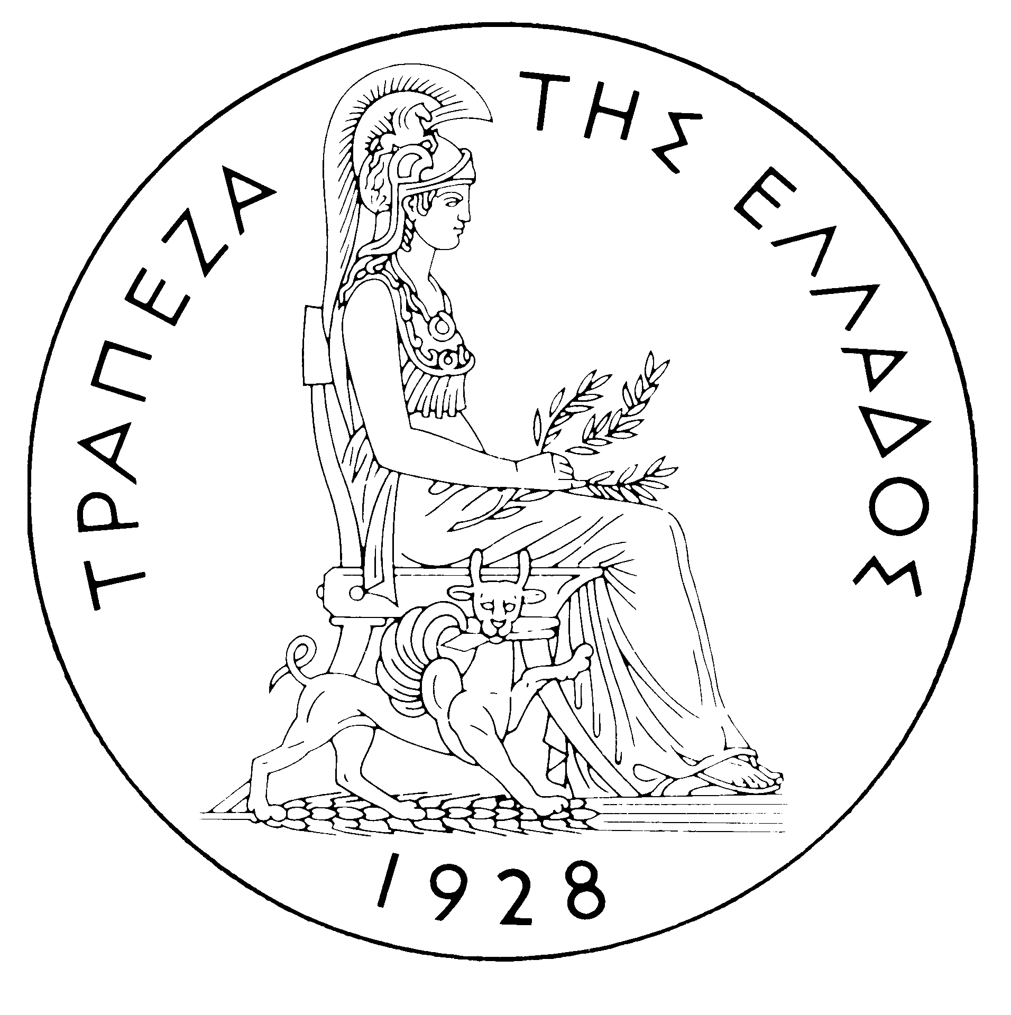
BANK OF GREECE

PRESS RELEASE

Athens, 21 March 2006

Re: Balance of payments: JANUARY 2006

Current account balance
In January 2006, the current account deficit was €348 million higher than in January 2005. This development is attributable to a deterioration in all balances, except for the current transfers balance, the surplus of which grew considerably.
Specifically, the widening of the trade deficit by €409 million is accounted for by a €202 million rise in the net oil import bill and a €215 million increase in the trade deficit excluding oil and ships, while the ships’ balance did not show any considerable change. Underlying a €179 million decline in the surplus of the services balance was mainly a €88 million drop in net transport services. However, gross transport (mainly shipping) receipts grew by €36 million (or 3.2%) year-on-year. At the same time, the travel services balance showed a small deficit, compared with a small surplus in January 2005, and net payments for “other services” rose. The income account deficit grew as a result of an increase in interest payments on loans and on Greek government bonds in comparison with January 2005. Finally, a considerable rise in the current transfers surplus year-on-year is mainly attributable to a hike in net transfers to general government (mainly from the EU) and, secondarily, a rise in net transfers to the other sectors. (It should be recalled that current transfers from the EU mainly include receipts from the Guarantee Section of the European Agricultural Guidance and Guarantee Fund – EAGGF – in the context of the Common Agricultural Policy and receipts from the European Social Fund, while current transfers to the EU include Greece’s contributions to the Community Budget.)

Capital transfers balance
In January 2006, the capital transfers balance showed a surplus of €36 million, compared with a mere €2 million in January 2005. (It should be recalled that capital transfers from the EU mainly include receipts from the Structural Funds – except for the European Social Fund – and the Cohesion Fund under the Community Support Framework.)
Combined current account and capital transfers balance (according to the old method of presentation)
The combined current account and capital transfers balances showed a deficit of €2,139 million in January 2006, compared with a deficit of €1,825 million in January 2005.
Financial account balance
In January 2006, financial flows under residents’ direct investment abroad reached €123 million, while non-residents’ direct investment in Greece came to €257 million. The most important investments abroad by residents concerned the acquisition of a further 20% (worth €69 million) in the share capital of the Turkish company INTELTECK by INTRALOT and the participation of the National Bank of Greece (to the amount of €63 million) in the capital increase of BANCA ROMANESCA S.A. in Romania. On the other hand, non-residents’ investment in Greece included notably the acquisition (to the amount of €298 million) of Q-TELECOMMUNICATIONS S.A. by the US investment company APAX AND TEXAS PACIFIC.
At this point it should be noted that the Bank of Greece, in the context of its full harmonisation with the relevant international methodology, calculated and incorporated into the balance of payments, as from January 2006, the data concerning reinvested (undistributed) earnings from non-residents’ direct investment in Greece and residents’ investment abroad. Specifically, reinvested (undistributed) earnings from non-residents’ direct investment in Greece are recorded in the income account as an outflow (payment) of income from direct investment and, at the same time, in the financial account as an inflow (increase) in non-residents’ direct investment in Greece. Correspondingly, reinvested (undistributed) earnings from residents’ direct investment abroad are recorded in the income account as an inflow (receipt) of income from direct investment and, at the same time, in the financial account as an outflow (increase) in residents’ direct investment abroad.
Reinvested (undistributed) earnings from direct investment are calculated on the basis of data collected by the Bank of Greece directly from firms that operate in Greece and either have made direct investments abroad or in which direct investments have been made by non-residents. The data are collected on an annual basis and the resulting total of reinvested (undistributed) earnings is allocated equally across the months of the year. To ensure comparability, reinvested (undistributed) earnings were also calculated for the years 2003, 2004 and 2005 and the relevant figures of the balance of payments were adjusted accordingly. The data for the years 2003 and 2004 are final, while those for the years 2005 and 2006 are provisional and are based on the assumption that both the profitability and the dividend policy of firms in 2004 will be maintained in 2005 and 2006. (In October of every year the data of the previous year will be finalised.)
Under portfolio investment, a net outflow of €993 million was observed in residents’ external assets, mainly reflecting residents’ investment in bonds issued by non-residents (of €704 million), while in liabilities a net inflow of €3,742 million was recorded, representing non-residents’ investment mainly in Greek government bonds or Treasury bills (of €3,220 million) and, secondarily, shares of Greek firms (€522 million). Finally, "other" investment showed a substantial inflow (of €3,192 million) of non-residents’ funds, mainly to deposits and repos. This inflow was more than offset mainly by an outflow of domestic credit institutions’ and institutional investors’ funds to deposits and repos abroad.
At end-January 2006, Greece’s reserve assets came to €1.9 billion. (It should be recalled that, since Greece joined the euro area in January 2001, reserve assets, as defined by the European Central Bank, include only monetary gold, the "reserve position" with the IMF, "Special Drawing Rights", and Bank of Greece claims in foreign currency on residents of non-euro area countries. Conversely, reserve assets do not include claims in euro on residents of non-euro area countries, claims in foreign currency and in euro on residents of euro area countries, and the Bank of Greece participation in the capital and the reserve assets of the ECB.)
Note: Balance of payments data for February 2006 will be released on 18 April 2006.

