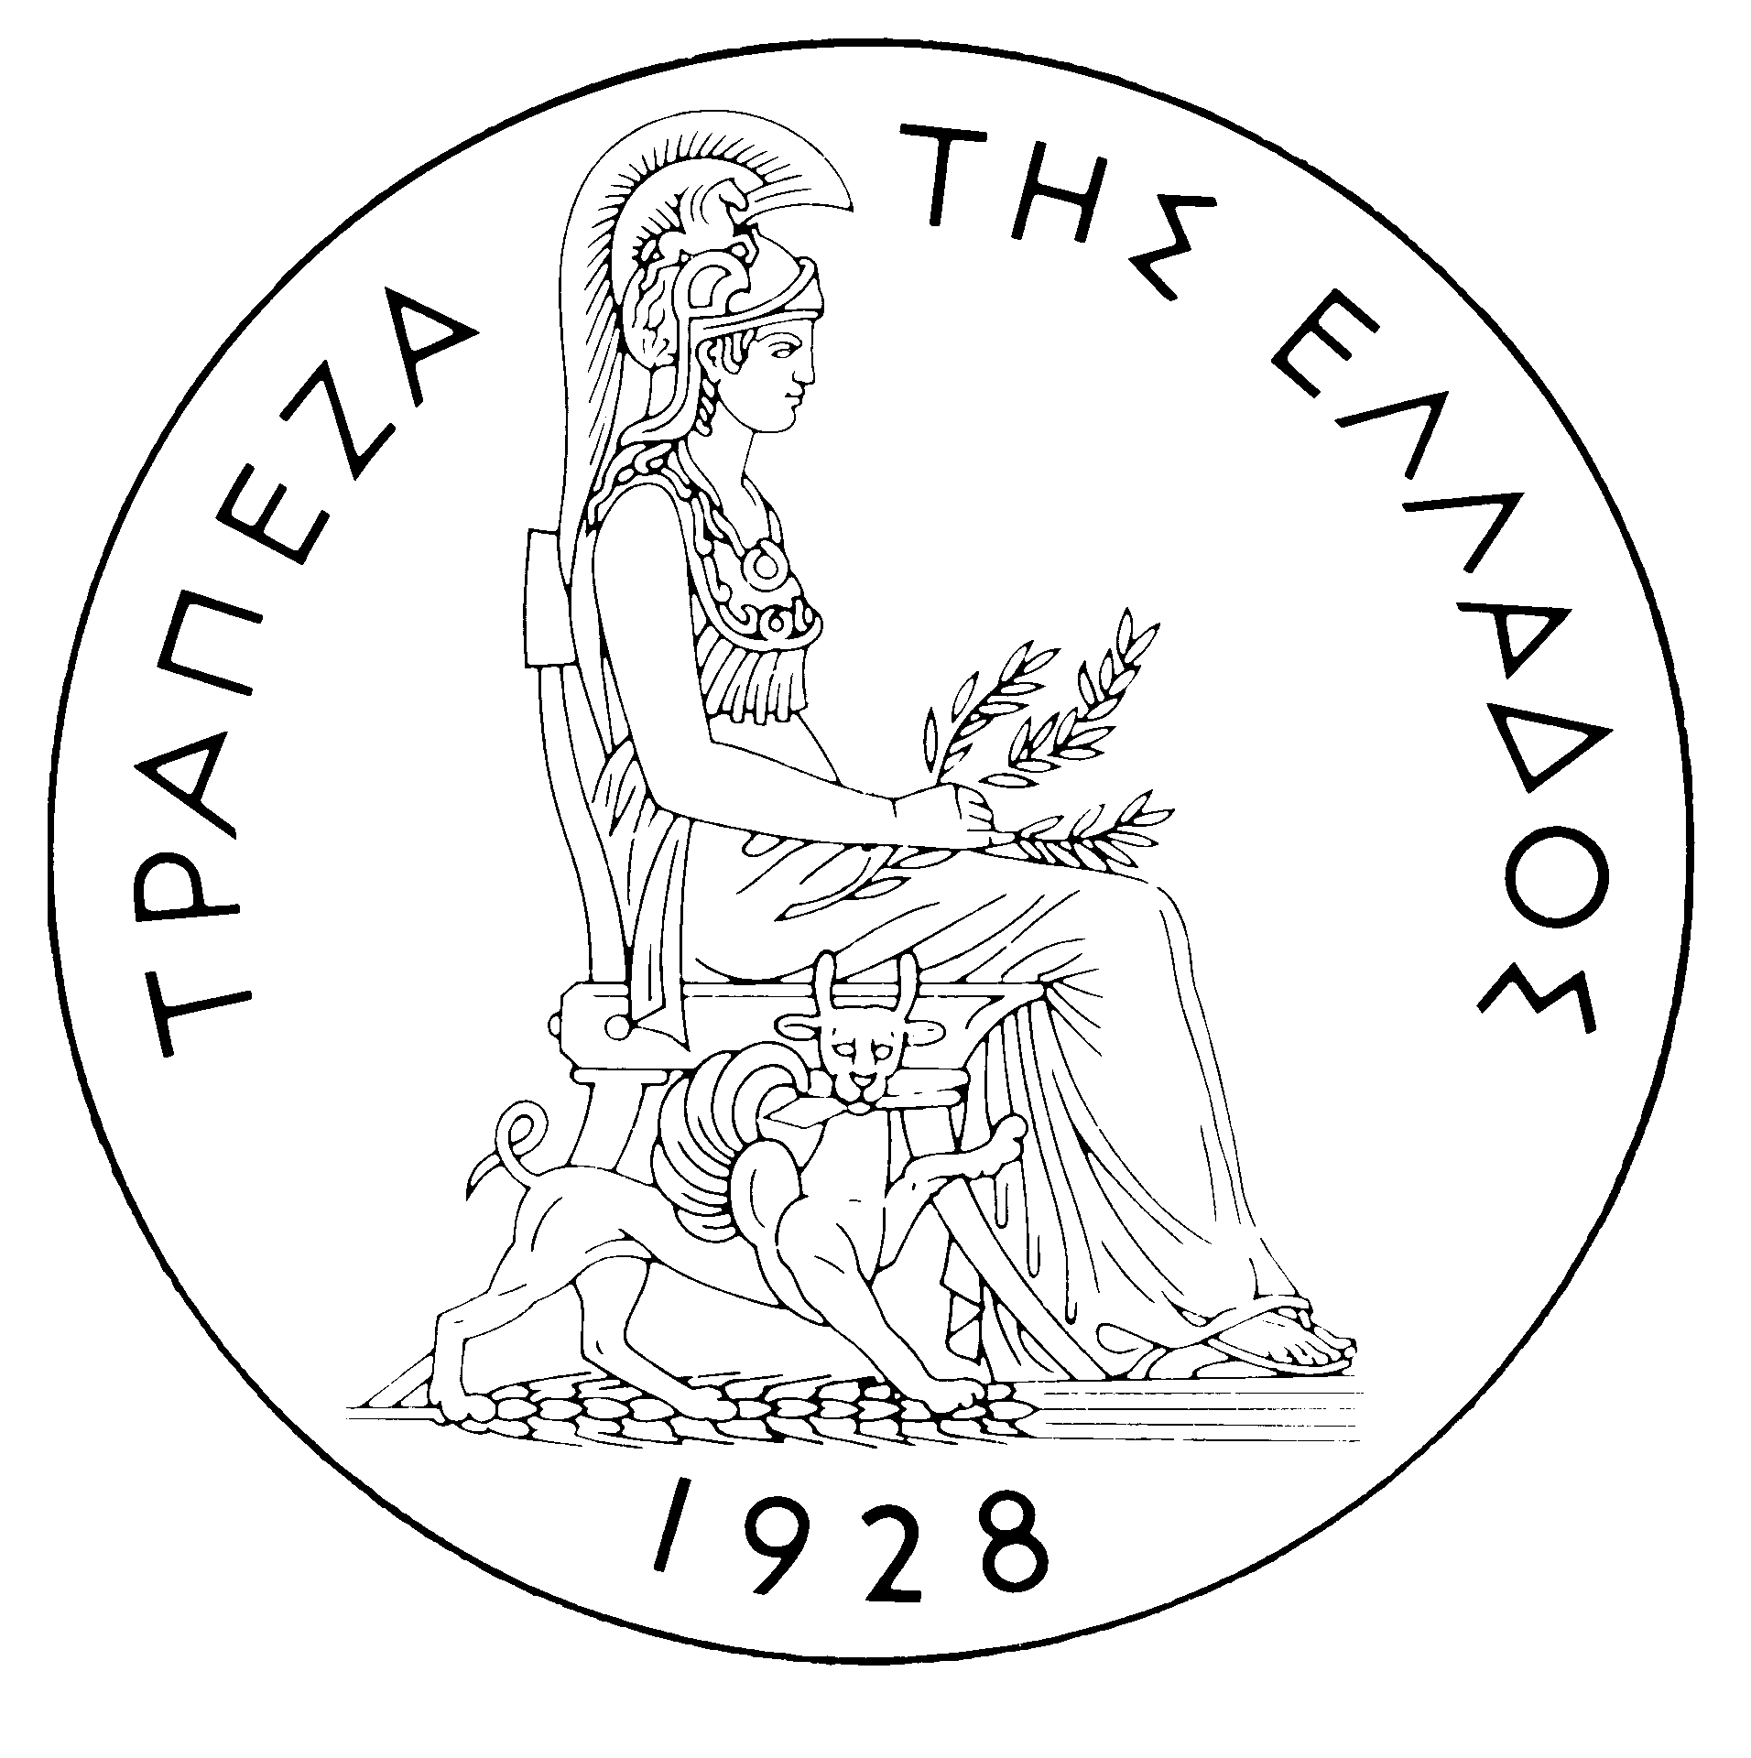
BANK OF GREECE
PRESS RELEASE
Athens, April 5 2006

Subject: Developments in the Greek government bond market – March 2006

On international markets government bonds recorded strong losses in March following the release of strong economic data in all main regions, the tightening of monetary policy in the Euro-zone and the US and the end of monetary quantitative easing in Japan. Bond yields increased significantly, particularly at the long end of the curve leading to a re-steepening of the yield curve in the Euro-zone and the US. Bond markets sentiment started deteriorating at the beginning of the month after the European Central Bank (ECB) increased interest rates by 25 basis points (bps), on March 2, to 2.50%, while revising upwards its projections for economic growth and inflation for 2006 and 2007. A week later, the Bank of Japan announced the end of its five-year old monetary policy approach called “quantitative easing”. Finally, at the end of the month (March 28) the Federal Reserve increased official interest rates by 25 bps to 4.75%. These monetary policy moves had been anticipated by investors. However, successive statements released by ECB and FED officials and evidence of a strengthening of global growth led investors to revise upwards their expectations of future interest rates.
In the Greek electronic secondary securities market (HDAT) bond yields increased considerably along the whole maturity spectrum, in line with the performance seen in the rest of the Euro-zone markets. Bond yields rose by around 28 bps on medium to long-term maturities, with the 30-year yield reaching 4.41% on March 31 from 4.13% at the end of February and the 10-year yield 4.07% from 3.80%. On the short end of the curve, the yield on the new 3-year bond, issued on March 14, rose to 3.54% at the end of March from 3.42% on its first day of trading. The 3 to 30-year yield gap narrowed to 87 bps at the end of March compared to 97 bps a month earlier, however the narrowing was due to the issuance of the new 3-year benchmark. Finally, the average monthly spread between the Greek and the German 10-year benchmark bond yields rose to 29 bps in March from 28 bps in February.
Benchmark bond prices fell significantly, particularly on long-term bonds. The 30-year bond price fell to 101.46 at the end of March from 106.32 a month earlier and the 10-year bond price to 96.01 from 98.27 respectively. The new 3-year bond price fell to 99.57 at the end of March from 99.92 on its first day of trading on March 14.
Trading volume on HDAT reached EUR 64.40 billion worth of transactions in March, compared to EUR 64.91 billion in February and EUR 56.06 billion in March 2005. The daily average turnover was EUR 2.93 billion after EUR 3.25 billion in February. Trading activity was mainly focused on bonds with remaining maturity between 7 and 15 years, which absorbed EUR 44.9 billion, or 70%, of the overall traded volume. The most actively traded bond was the 10-year benchmark with EUR 22.31 billion worth of transactions followed by the 10-year bond, maturing on 20/7/2015, with EUR 10.34 billion. Of the 11,487 orders executed on HDAT, 47.67% were “buy” orders and 52.33% “sell” orders.

