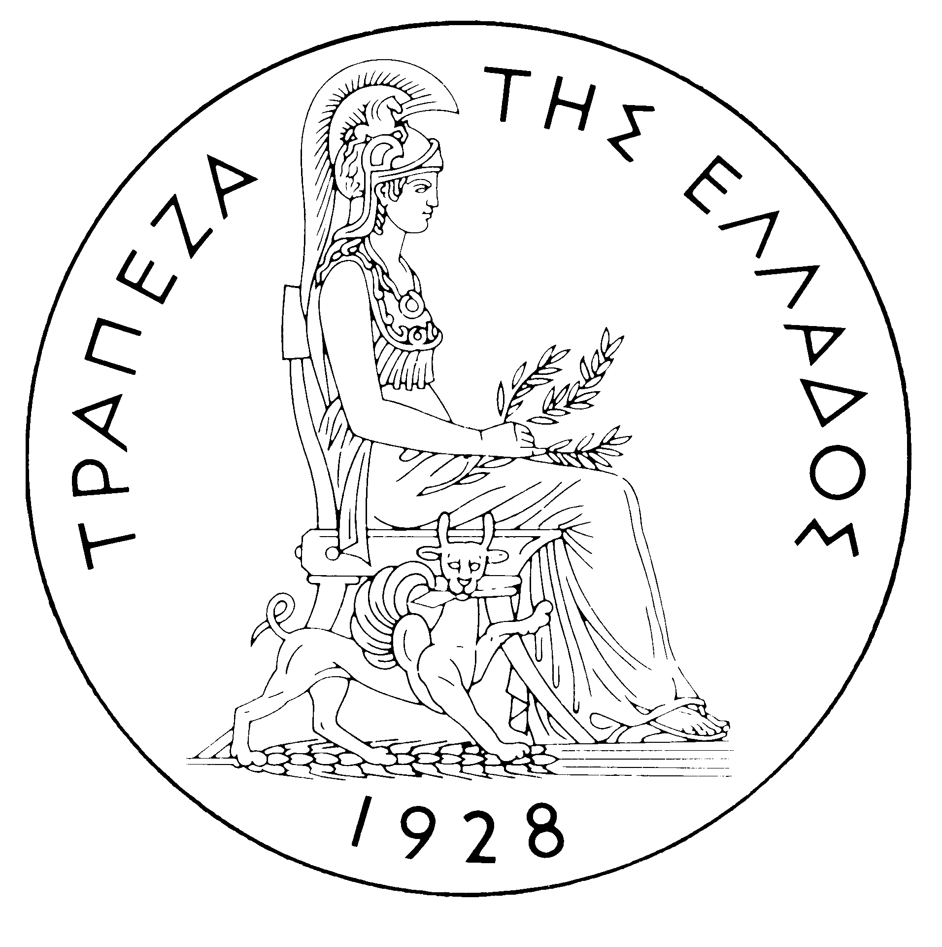
BANK OF GREECE

PRESS RELEASE

Athens, 24 May 2006

Re: Balance of payments: MARCH 2006

Current account balance
In March 2006, the current account deficit rose considerably year-on-year to €3,281 million. This development is attributable mainly to a substantial increase in the trade deficit and, secondarily, to the widening of the income account deficit and the narrowing of the services surplus. The current transfers surplus remained virtually unchanged.
Underlying a sizeable rise (of €1,370 million) in the overall trade deficit in March were hikes (of €613 million, €555 million and €202 million respectively) in the trade deficit excluding oil and ships, the net oil import bill and the deficit of the ships’ balance (sales minus purchases).
The overall surplus of the services balance declined by €82 million in comparison with March 2005, mainly as a result of a €52 million decrease in net transport receipts and a €90 million rise in net payments for “other” services. By contrast, net travel receipts grew (by €60 million).
A €208 million rise in the income account deficit was mainly accounted for by a €215 million increase in interest payments on Greek government bonds held by non-residents.
The current transfers surplus remained virtually unchanged year-on-year. Specifically, net current transfers from the EU were reduced by €16 million, while net receipts from transfers to other sectors of the economy grew by €25 million. It should be recalled that gross current transfers from the EU mainly include receipts from the Guarantee Section of the European Agricultural Guidance and Guarantee Fund (EAGGF) in the context of the Common Agricultural Policy and receipts from the European Social Fund, while current transfers to the EU include Greece’s contributions to the Community Budget.
In January-March 2006, the current account deficit widened by €3,412 million over the same period of 2005 and reached €8,000 million, reflecting mainly a rise in the trade deficit. The growth of the current account deficit is also accounted for (albeit to a much lesser extent) by a narrowing of the services surplus and the current transfers surplus and the growth of the income account deficit.
Almost half of the €2,394 million rise in the overall trade deficit (including oil and ships) is due to a €1,184 million increase in the net oil import bill, while the widening of the deficit excluding oil and ships and of the deficit of the ships’ balance contributed by €980 million and €230 million respectively. However, it should be pointed out that receipts from goods exports (excluding oil and ships) showed a remarkable increase (of €433 million or 18.8%), which, however, was more than offset by a rise (of €1,411 million or 19.2%) in the corresponding import bill.
The services surplus narrowed by €312 million, as a result of a drop in net transport receipts (because gross transport receipts rose by €89 million, but gross transport payments increased by €270 million at the same time) and a hike in net payments for “other” services. Finally, net travel receipts (in absolute terms) showed a small rise, because payments dropped faster than receipts.
The income account deficit grew by €403 million, as net interest, dividend and profit payments increased, mainly owing to the growth of net interest payments, as a result of a continuing rise in non-residents’ holdings of old and new issues of Greek Government bonds.
Finally, a €304 million fall in the current transfers surplus is exclusively attributable to a €418 million drop in net (mainly EU) current transfers to general government, while net current transfers to the other sectors (excluding general government) grew by €114 million.
Capital transfers balance
In March 2006, the capital transfers balance showed a surplus of €629 million, €505 million higher than in March 2005. (Capital transfers from the EU mainly include receipts from the Structural Funds – except for the European Social Fund – and the Cohesion Fund under the Community Support Framework.)
In January-March 2006, the capital transfers balance recorded a surplus of €738 million, €74 million down year-on-year. This reflects almost exclusively a decline in EU capital transfers to general government.
Combined current account and capital transfers balance (according to the old method of presentation)
The combined current account and capital transfers balances (according to the old method of presentation) showed a deficit of €2,651 million in March 2006, compared with a deficit of €1,506 million in March 2005. In January-March 2006, this deficit reached €7,262 million, compared with €3,777 million in the same period of 2005.
Financial account balance
In March 2006, a net inflow of €59 million was observed under direct investment. Residents’ investment abroad showed a small outflow of €79 million, associated with the completion of the acquisition of the bank EFG EUROBANK S.A. POLSKA (Poland) by EUROBANK ERGASIAS S.A., worth €77 million. Under non-residents’ direct investment in Greece, an inflow of €138 million was recorded. The most important investments under this category concerned an inflow of €114 million for the participation of the parent company SARA LEE in the capital increase of its subsidiary SARA LEE HELLAS, as well as an inflow of €36 million for the increase of the participation of PANEUROPEAN OIL AND INDUSTRIAL HOLDINGS S.A. (Luxembourg) in the capital of HELLENIC PETROLEUM S.A. Under portfolio investment, a net inflow of €1,672 million was observed, reflecting a €3,093 million rise in non-residents’ purchases of, principally, Greek government bonds and, secondarily, shares of Greek firms, which, however, was partly offset by a €1,421 million increase in residents’ investment, chiefly in bonds and, secondarily, in shares and Treasury bills issued by non-residents. "Other" investment showed a net inflow of €1,684 million, mainly as a result of the growth of non-residents’ deposit and repo holdings in Greece and the decline of residents’ deposit and repo holdings abroad.
In January-March 2006, direct investment showed a net inflow of €423 million (compared with a net inflow of €45 million in the previous year). This development is mainly accounted for by a net inflow of €566 million for non-residents’ direct investment in Greece. Under portfolio investment, a net inflow of €1,009 million was recorded, as the inflow of non-residents’ funds, mainly to Greek government bonds, more than offset residents’ outflows for investment abroad (mainly in bonds). Finally, under “other” investment, a net inflow of €6,337 million is attributable to non-residents’ inflows (of €9,519 million), primarily to deposits and repos.
At end-March 2006, Greece’s reserve assets came to €2.2 billion. (It should be recalled that, since Greece joined the euro area in January 2001, reserve assets, as defined by the European Central Bank, include only monetary gold, the "reserve position" with the IMF, "Special Drawing Rights", and Bank of Greece claims in foreign currency on residents of non-euro area countries. Conversely, reserve assets do not include claims in euro on residents of non-euro area countries, claims in foreign currency and in euro on residents of euro area countries, and the Bank of Greece participation in the capital and the reserve assets of the ECB.)
Note: Balance of payments data for April 2006 will be released on 21 June 2006.

