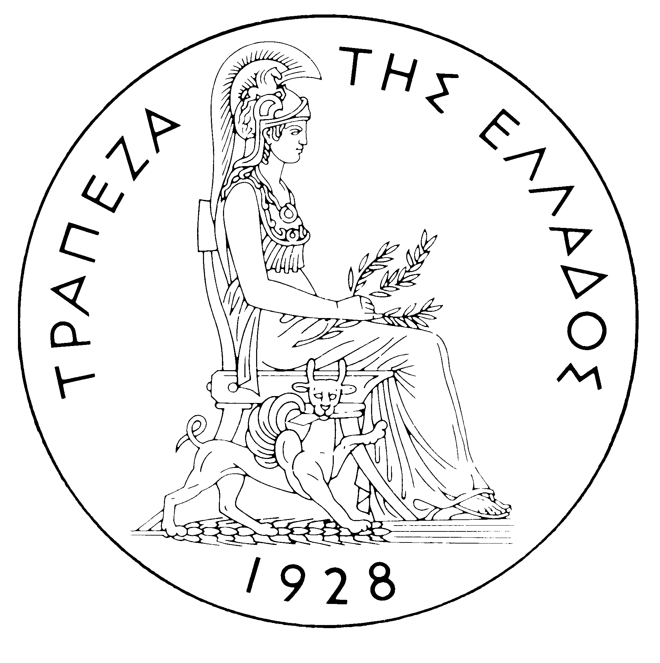
BANK OF GREECE
PRESS RELEASE
Athens, May 10 2006

Subject: Developments in the Greek government bond market – April 2006

Negative sentiment continued to dominate international government bond markets in April after the strong losses recorded in March. The economic data released during the month confirmed the existing robust growth outlook in the US and the ongoing recovery in the Euro-zone. In addition, oil prices traded above USD 70 per barrel, both in London and N.Y. markets while spot gold prices reached a 25-year high of USD 655 an ounce at the end of April. All the above factors enhanced fears of future inflationary pressures and reinforced investors’ expectations of further monetary policy tightening by the European Central Bank and the Federal Reserves in the coming months. As a consequence, bond yields recorded a significant increase and the yield curve steepened considerably particularly in the US.
In the Greek electronic secondary securities market (HDAT) bond yields increased strongly, in line with the performance seen in the rest of the Euro-zone markets, with longer-dated maturities underperforming the shorter ones. Benchmark bond yields rose by 17 to 25 basis points (bps), with the 3-year yield reaching 3.71% at the end of April from 3.54% a month earlier, the 10-year yield 4.32% from 4.07% and the 30-year yield 4.66% from 4.41%. The 3 to 30-year yield gap, therefore, widened to 95 bps from 87 bps at the end of March. Finally, the average monthly spread between the Greek and the German 10-year benchmark bond yields rose to 32 bps in April compared to 29 bps in March.
Benchmark bond prices fell significantly, in the range of 50 – 410 bps, with long-term bonds recording the highest losses. The 30-year bond price fell below parity to 97.36 at the end of April from 101.46 at the end of March and the 10-year bond price to 94.11 from 96.01 respectively. On the short end of the curve, the 3-year bond price fell to 99.07 on April 28 from 99.57 at the end of March.
Trading volume on HDAT was EUR 42.42 billion worth of transactions in April, compared to EUR 64.40 billion in March and to EUR 46.83 billion in April 2005. The daily average turnover recorded EUR 2.36 billion after EUR 2.93 billion in March. Trading activity was mainly focused on bonds with remaining maturity between 7 and 15 years, which absorbed EUR 29.2 billion, or 69%, of the overall traded volume. The most actively traded bond was the 10-year benchmark with EUR 12.33 billion worth of transactions followed by the 10-year bond, maturing on 20/7/2015, with EUR 8.72 billion. Of the 7,432 orders executed on HDAT, 51.24% were “buy” orders and 48.76% “sell” orders.

