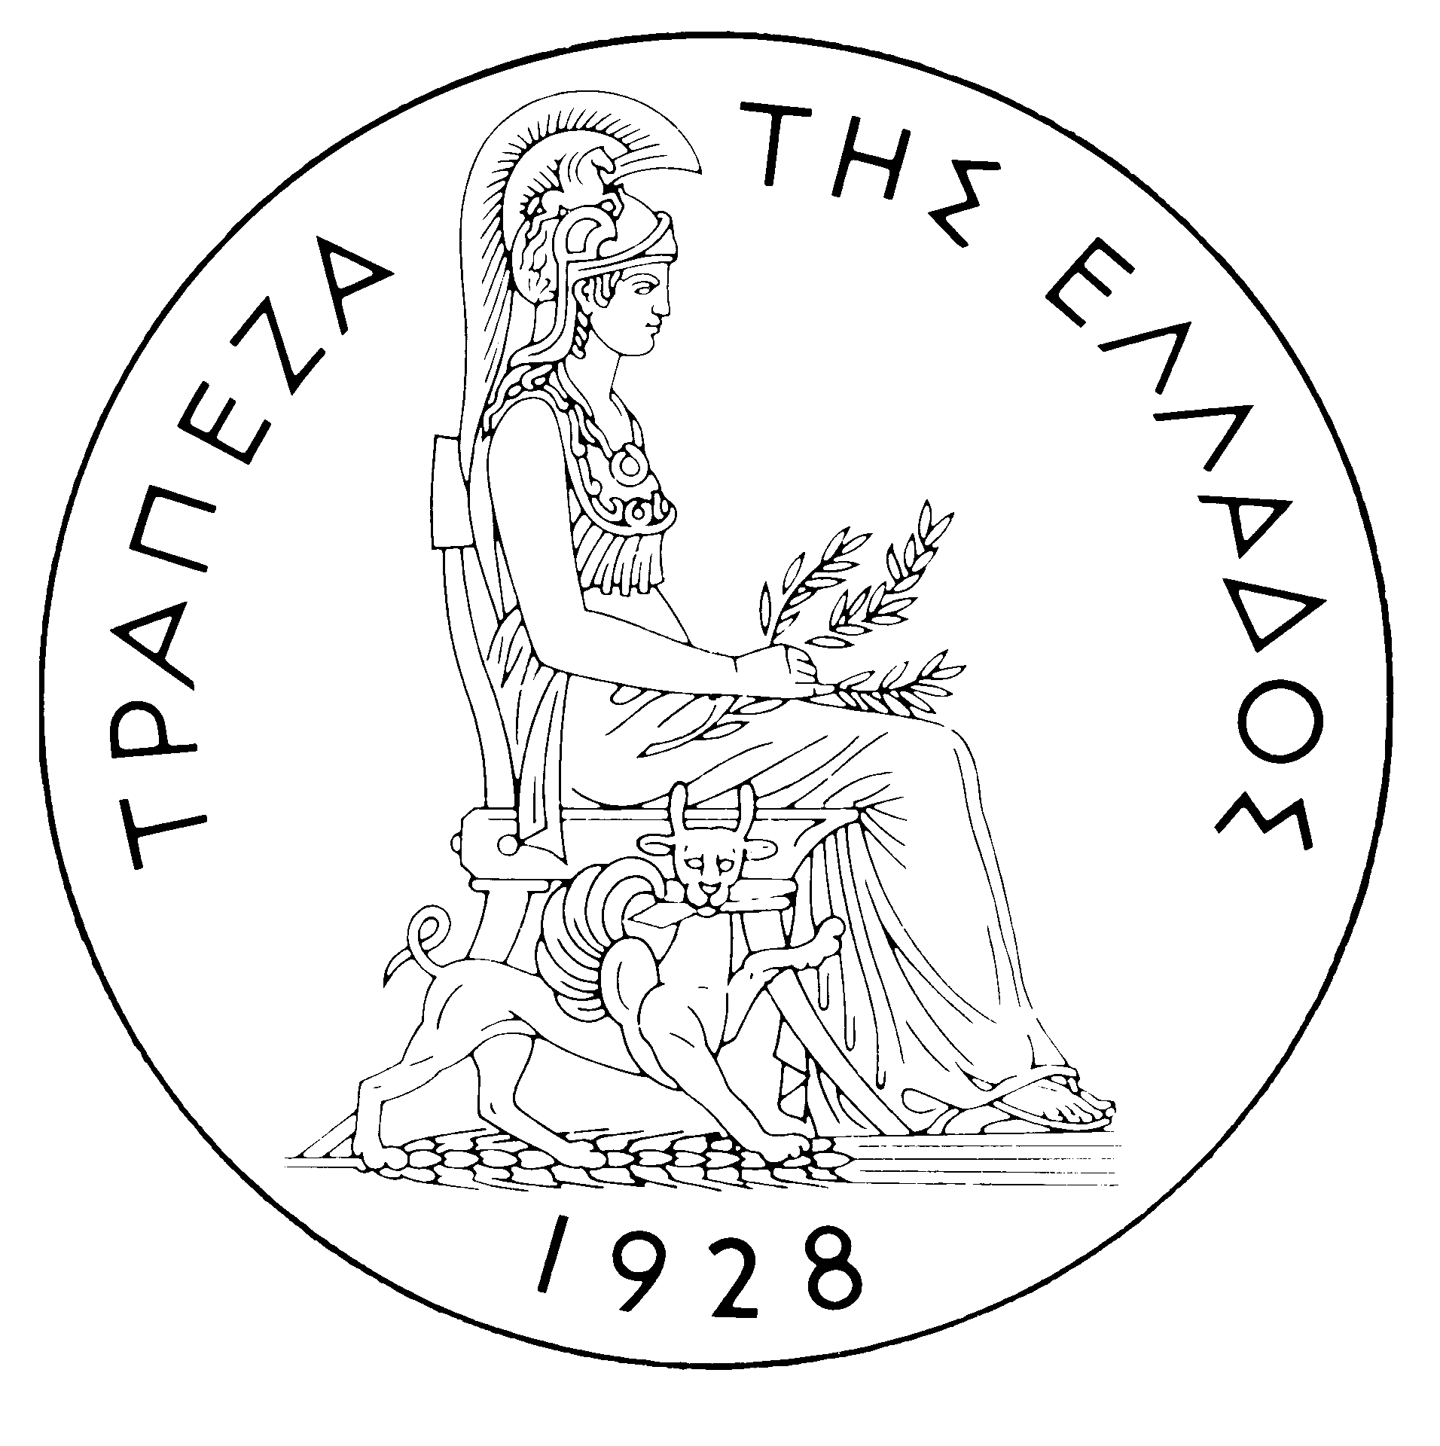
BANK OF GREECE

PRESS RELEASE

Athens, 21 June 2006

Re: Balance of payments: APRIL 2006

Current account balance
In April 2006, the current account deficit rose by €313 million year-on-year to €2,178 million. This development is attributable mainly to a €427 million deficit in the ships’ balance (compared with a small surplus of €6 million in April 2005) and, secondarily, to the widening of the income account deficit (by €143 million) and the oil deficit (by €103 million) and the narrowing of the services surplus (by €83 million). By contrast, the current transfers surplus surged (by €366 million) and the trade deficit excluding oil and ships declined by €82 million, partly offsetting the above changes.
It should be noted that the decrease in the surplus of the services balance reflects a €130 million drop in net transport receipts, while net travel receipts showed a small increase of €25 million (gross receipts, i.e. travel spending by non-residents in Greece, grew by €55 million or 14.9%) and net payments for “other” services fell by €22 million. The rise in the income account deficit was mainly accounted for by the increase in interest payments on Greek government bonds held by non-residents. Finally, the growth of the current transfers surplus reflects a €385 million rise in net current transfers from the EU, while net receipts from transfers to the other sectors of the economy declined by €19 million. It should be recalled that gross current transfers from the EU mainly include receipts from the Guarantee Section of the European Agricultural Guidance and Guarantee Fund (EAGGF) in the context of the Common Agricultural Policy and receipts from the European Social Fund, while current transfers to the EU include Greece’s contributions (payments) to the Community Budget.
In January-April 2006, the current account deficit widened by €3,725 million over the same period of 2005 and reached €10,178 million, reflecting mainly a rise in the trade deficit (both in the oil and the ships deficit and in the other goods deficit). The growth of the current account deficit is also accounted for (albeit to a much lesser extent) by an increase in the income account deficit and a narrowing of the services surplus. The current transfers surplus showed a small rise.
Almost half of the €2,847 million rise in the overall trade deficit (including oil and ships) is due to a €1,287 million increase in the net oil import bill, while the widening of the deficit excluding oil and ships and the increase in net payments for purchases of ships contributed by €863 million and €697 million, respectively. However, it should be pointed out that receipts from goods exports (excluding oil and ships) showed a remarkable rise (of €513 million or 16.9%), which, however, was more than offset by an increase (of €1,409 million or 14.3%) in the corresponding import bill.
The services surplus narrowed by €394 million, as a result of a drop in net transport receipts (because gross transport receipts declined by €21 million, while gross transport payments increased by €290 million at the same time) and a hike in net payments for “other” services. Finally, net travel receipts showed a small rise, because payments, i.e. travel spending abroad by residents, dropped more than receipts, i.e. travel spending in Greece by non-residents (by €46 million and €7 million, respectively).
The income account deficit grew by €546 million, as net interest, dividend and profit payments increased, mainly owing to the growth of net interest payments as a result of a continuing rise in non-residents’ holdings of Greek Government bonds.
Finally, a €62 million rise in the current transfers surplus is exclusively attributable to a €95 million increase in net current transfers to the other sectors (excluding general government). By contrast, net (mainly EU) current transfers to general government dropped by €33 million.
Capital transfers balance
In April 2006, the capital transfers balance showed a surplus of €434 million, €324 million higher than in April 2005. (Capital transfers from the EU mainly include receipts from the Structural Funds – except for the European Social Fund – and the Cohesion Fund under the Community Support Framework.)
In January-April 2006, the capital transfers balance recorded a surplus of €1,172 million, €250 million up year-on-year. This reflects almost exclusively a rise capital transfers to general government from the EU.
Combined current account and capital transfers balance (according to the old method of presentation)
The combined current account and capital transfers balances (according to the old method of presentation) showed a deficit of €1,743 million in April 2006, slightly lower (by €11 million) than in April 2005. Overall, in January-April 2006, this deficit reached €9,006 million, compared with €5,531 million in the corresponding period of 2005.
Financial account balance
In April 2006, a net outflow of €49 million was observed under direct investment. Specifically, residents’ investment abroad showed a net outflow of €84 million, while non-residents’ investment in Greece showed a net inflow of €35 million. These developments are not associated with any particular important investment. Under portfolio investment, a net outflow of €254 million was observed, reflecting residents’ investment of €301 million, mainly in foreign derivatives and shares, which, however, were offset only to a small extent by the inflow of non-residents’ funds for investment in Greek government bonds (which dropped to €100 million, compared with €6.5 billion in April 2005) and by residents’ sales of bonds issued by non-residents. "Other" investment showed a net inflow of €1,892 million, mainly as a result of the growth of non-residents’ deposit and repo holdings in Greece, which were offset only to a very small extent by a rise in residents’ deposit and repo holdings abroad.
In January-April 2006, direct investment showed a net inflow of €374 million (compared with a net inflow of €155 million in the corresponding period of 2005). This development is mainly accounted for by a net inflow of €601 million for non-residents’ direct investment in Greece, which was partly offset by a net outflow of €227 million for residents’ investment abroad. Under portfolio investment, a net inflow of €755 million was recorded, as the inflow of non-residents’ funds, mainly to Greek government bonds, more than offset residents’ outflows for investment abroad (mainly in bonds). Finally, under “other” investment, a net inflow of €8,228 million is attributable to the inflow of non-residents’ funds (of €11,498 million), primarily to deposits and repos in Greece.
At end-April 2006, Greece’s reserve assets came to €2.1 billion. (It should be recalled that, since Greece joined the euro area in January 2001, reserve assets, as defined by the European Central Bank, include only monetary gold, the "reserve position" with the IMF, "Special Drawing Rights", and Bank of Greece claims in foreign currency on residents of non-euro area countries. Conversely, reserve assets do not include claims in euro on residents of non-euro area countries, claims in foreign currency and in euro on residents of euro area countries, and the Bank of Greece participation in the capital and the reserve assets of the ECB.)
Note: Balance of payments data for May 2006 will be released on 20 July 2006.

