` 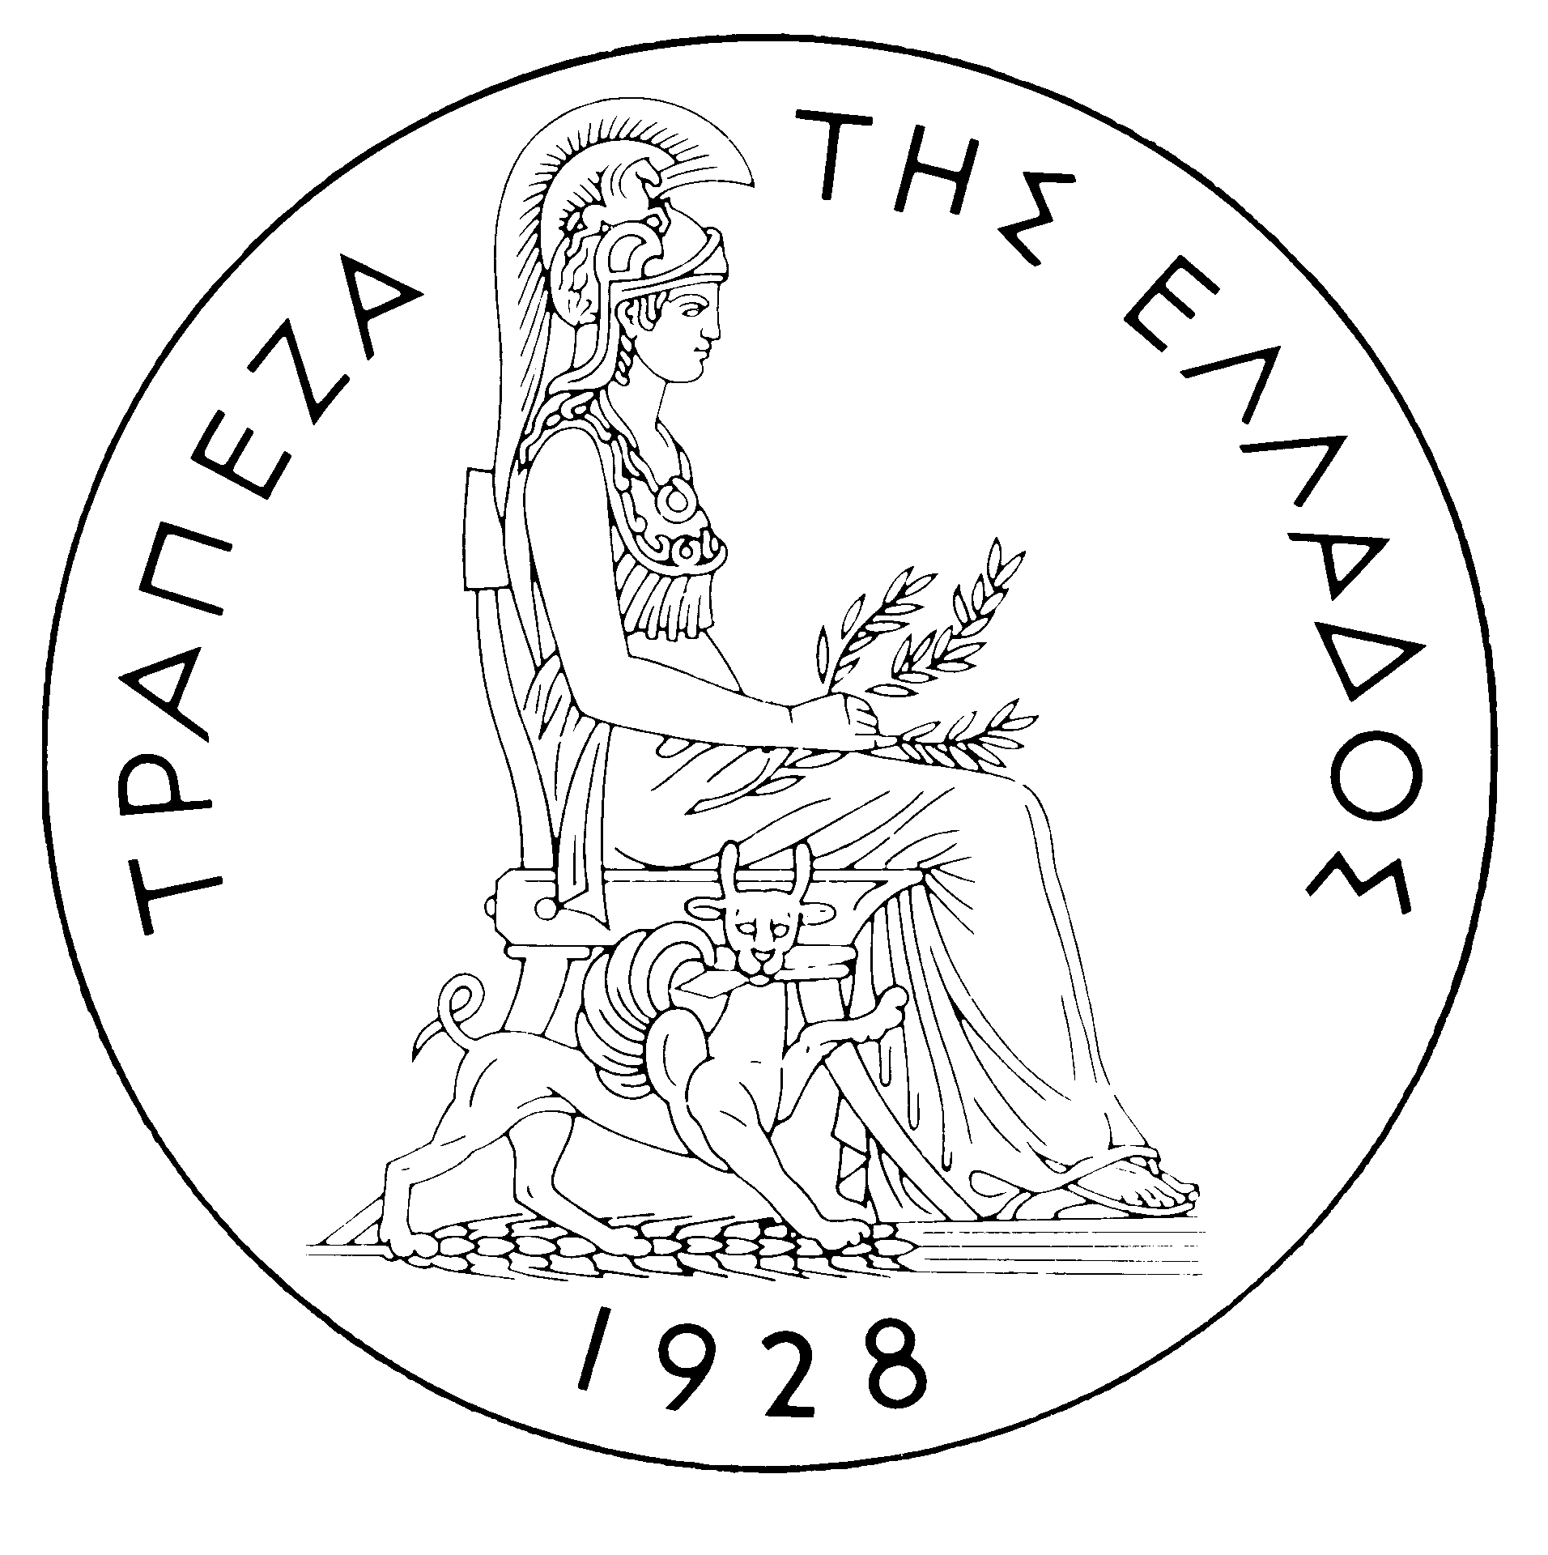
BANK OF GREECE

PRESS RELEASE

Athens, 18 August 2006

Re: Balance of payments: JUNE 2006

Current account balance
In June 2006, the current account deficit came to €2,081 million, compared with €777 million in the same month of 2005. This development is attributable mainly to a €1,098 million increase in the trade deficit, which almost equally stemmed from the deficits of the oil, ships and other goods balances. The widening of the current account deficit is also accounted for, to a much smaller extent, by the growth of the income account deficit (by €172 million) and the narrowing of the current transfers surplus (by €30 million). Finally, the surplus of the services balance remained virtually unchanged year-on-year.
The outturn of the surplus of the services balance firstly reflects a €205 million rise in net travel receipts, which is attributable to a €176 million (or 13.3%) hike in receipts (i.e. travel spending in Greece by non-residents) and a €28 million (or 12.4%) decline in payments (i.e. travel spending abroad by residents). However, the growth of net travel receipts was offset on the one hand by a €116 million drop in net receipts from transport (mainly shipping) services and, on the other hand, the fact that “other” services recorded net payments of €76 million, compared with net receipts of €17 million in June 2005. Besides, the rise in the income account deficit mainly reflects higher (by €112 million) net dividend and profit payments and, to a lesser extent, higher net interest payments. Finally, the drop in the current transfers surplus reflects the fact that current transfers from the EU to general government recorded net payments of €42 million (compared with net receipts of €3 million in June 2005), while net receipts from transfers to the other sectors of the economy grew by €15 million. It should be recalled that gross current transfers from the EU mainly include receipts from the Guarantee Section of the European Agricultural Guidance and Guarantee Fund (EAGGF) in the context of the Common Agricultural Policy and receipts from the European Social Fund, while current transfers to the EU include Greece’s contributions (payments) to the Community Budget.
In January-June 2006, the current account deficit widened by €6,344 million over the same period of 2005 and reached €14,277 million, reflecting mainly a rise in the trade deficit and, to a much lesser extent, an increase in the income account deficit and a narrowing of the services surplus. The current transfers surplus also recorded a decrease, albeit small.
The overall trade deficit (including oil and ships) showed an increase of €4,623 million, which almost equally stemmed from rises in the deficit excluding oil and ships, in the net oil import bill and in net payments for purchases of ships (of €1,628, €1,614 and €1,381 million respectively). It should be pointed out that receipts from goods exports (excluding oil and ships) showed a remarkable rise (of €666 million or 13.5%), which, however, was more than offset by a hike (of €2,321 million or 15.5%) in the corresponding import bill.
The services surplus narrowed by €683 million, as a result of, mainly, a €546 million drop in net transport receipts (because transport receipts declined by €82 million, while transport payments increased by €464 million) and, secondarily, a €284 million rise in net payments for “other” services. By contrast, net travel receipts grew by €146 million (as receipts rose by €99 million and payments declined by €47 million).
The income account deficit grew by €1,004 million, almost exclusively owing to higher net interest, dividend and profit payments. The widening of the deficit is mainly accounted for by an increase in net interest payments as a result of a continuing rise in non-residents’ holdings of old and new issues of Greek Government bonds.
Finally, the current transfers surplus narrowed slightly (by €34 million), as the decrease in net (mainly EU) current transfers to general government more than offset a rise in net current transfers to the other sectors (excluding general government).
Capital transfers balance
In June 2006, the capital transfers balance showed a surplus of €57 million, €35 million up year-on-year. (Capital transfers from the EU mainly include receipts from the Structural Funds – except for the European Social Fund – and the Cohesion Fund under the Community Support Framework.)
In January-June 2006, the capital transfers balance showed a surplus of €1,508 million, €461 million higher than in the same period of 2005. This reflects almost exclusively a rise in EU capital transfers to general government.
Combined current account and capital transfers balance (according to the old method of presentation)
The combined current account and capital transfers balances (according to the old method of presentation) showed a deficit of €2,024 million in June 2006, €1,270 million up year-on-year. Overall, in January-June 2006, this deficit reached €12,769 million, compared with €6,885 million in the same period of 2005.
Financial account balance
In June 2006, a net inflow of €117 million was observed under direct investment. Specifically, residents’ investment abroad showed a net outflow of €61 million, while there was a net inflow of €178 million under non-residents’ investment in Greece, chiefly featuring an inflow of €31 million for the participation of SOGEN HOLDING in the share capital increase of HSG CONSUMER FINANCE. Under portfolio investment, there was a net outflow of €3,971 million, as a result of non-residents’ disinvestment in Greek government securities, which was only partly offset by non-residents’ higher purchases of Greek firms’ shares (including €356 million in connection with the sale of 20% of the share capital of the Postal Savings Bank to institutional investors) and residents’ lower investment in securities issued by non-residents. "Other" investment showed a net inflow of €6,169 million, mainly reflecting a decline in resident credit institutions’ and institutional investors’ deposit and repo holdings abroad, which far outweighed a decrease in non-residents’ deposit and repo holdings in Greece.
In January-June 2006, direct investment showed a net inflow of €1,010 million (compared with a net inflow of €145 million in the same period of 2005). This development is mainly accounted for by a net inflow of €1,351 million for non-residents’ direct investment in Greece, which was partly offset by a net outflow of €342 million for residents’ direct investment abroad. Under portfolio investment, a net inflow of €2,114 million was recorded, as the inflow of non-residents’ funds for investment in Greece (mainly in Greek government securities and shares of Greek firms, of €4,825 and €2,420 million respectively) more than offset residents’ outflows for investment abroad (mainly in bonds and shares of foreign firms). Finally, under “other” investment, a net inflow of €10,386 million is mainly attributable to non-residents’ inflows (of €10,190 million) to deposits and repos in Greece, while resident credit institutions’ and institutional investors’ deposit and repo holdings abroad dropped.
At end-June 2006, Greece’s reserve assets reached €2.2 billion. (It should be recalled that, since Greece joined the euro area in January 2001, reserve assets, as defined by the European Central Bank, include only monetary gold, the "reserve position" with the IMF, "Special Drawing Rights", and Bank of Greece claims in foreign currency on residents of non-euro area countries. Conversely, reserve assets do not include claims in euro on residents of non-euro area countries, claims in foreign currency and in euro on residents of euro area countries, and the Bank of Greece participation in the capital and the reserve assets of the ECB.)
Note: Balance of payments data for July 2006 will be released on 19 September 2006.

