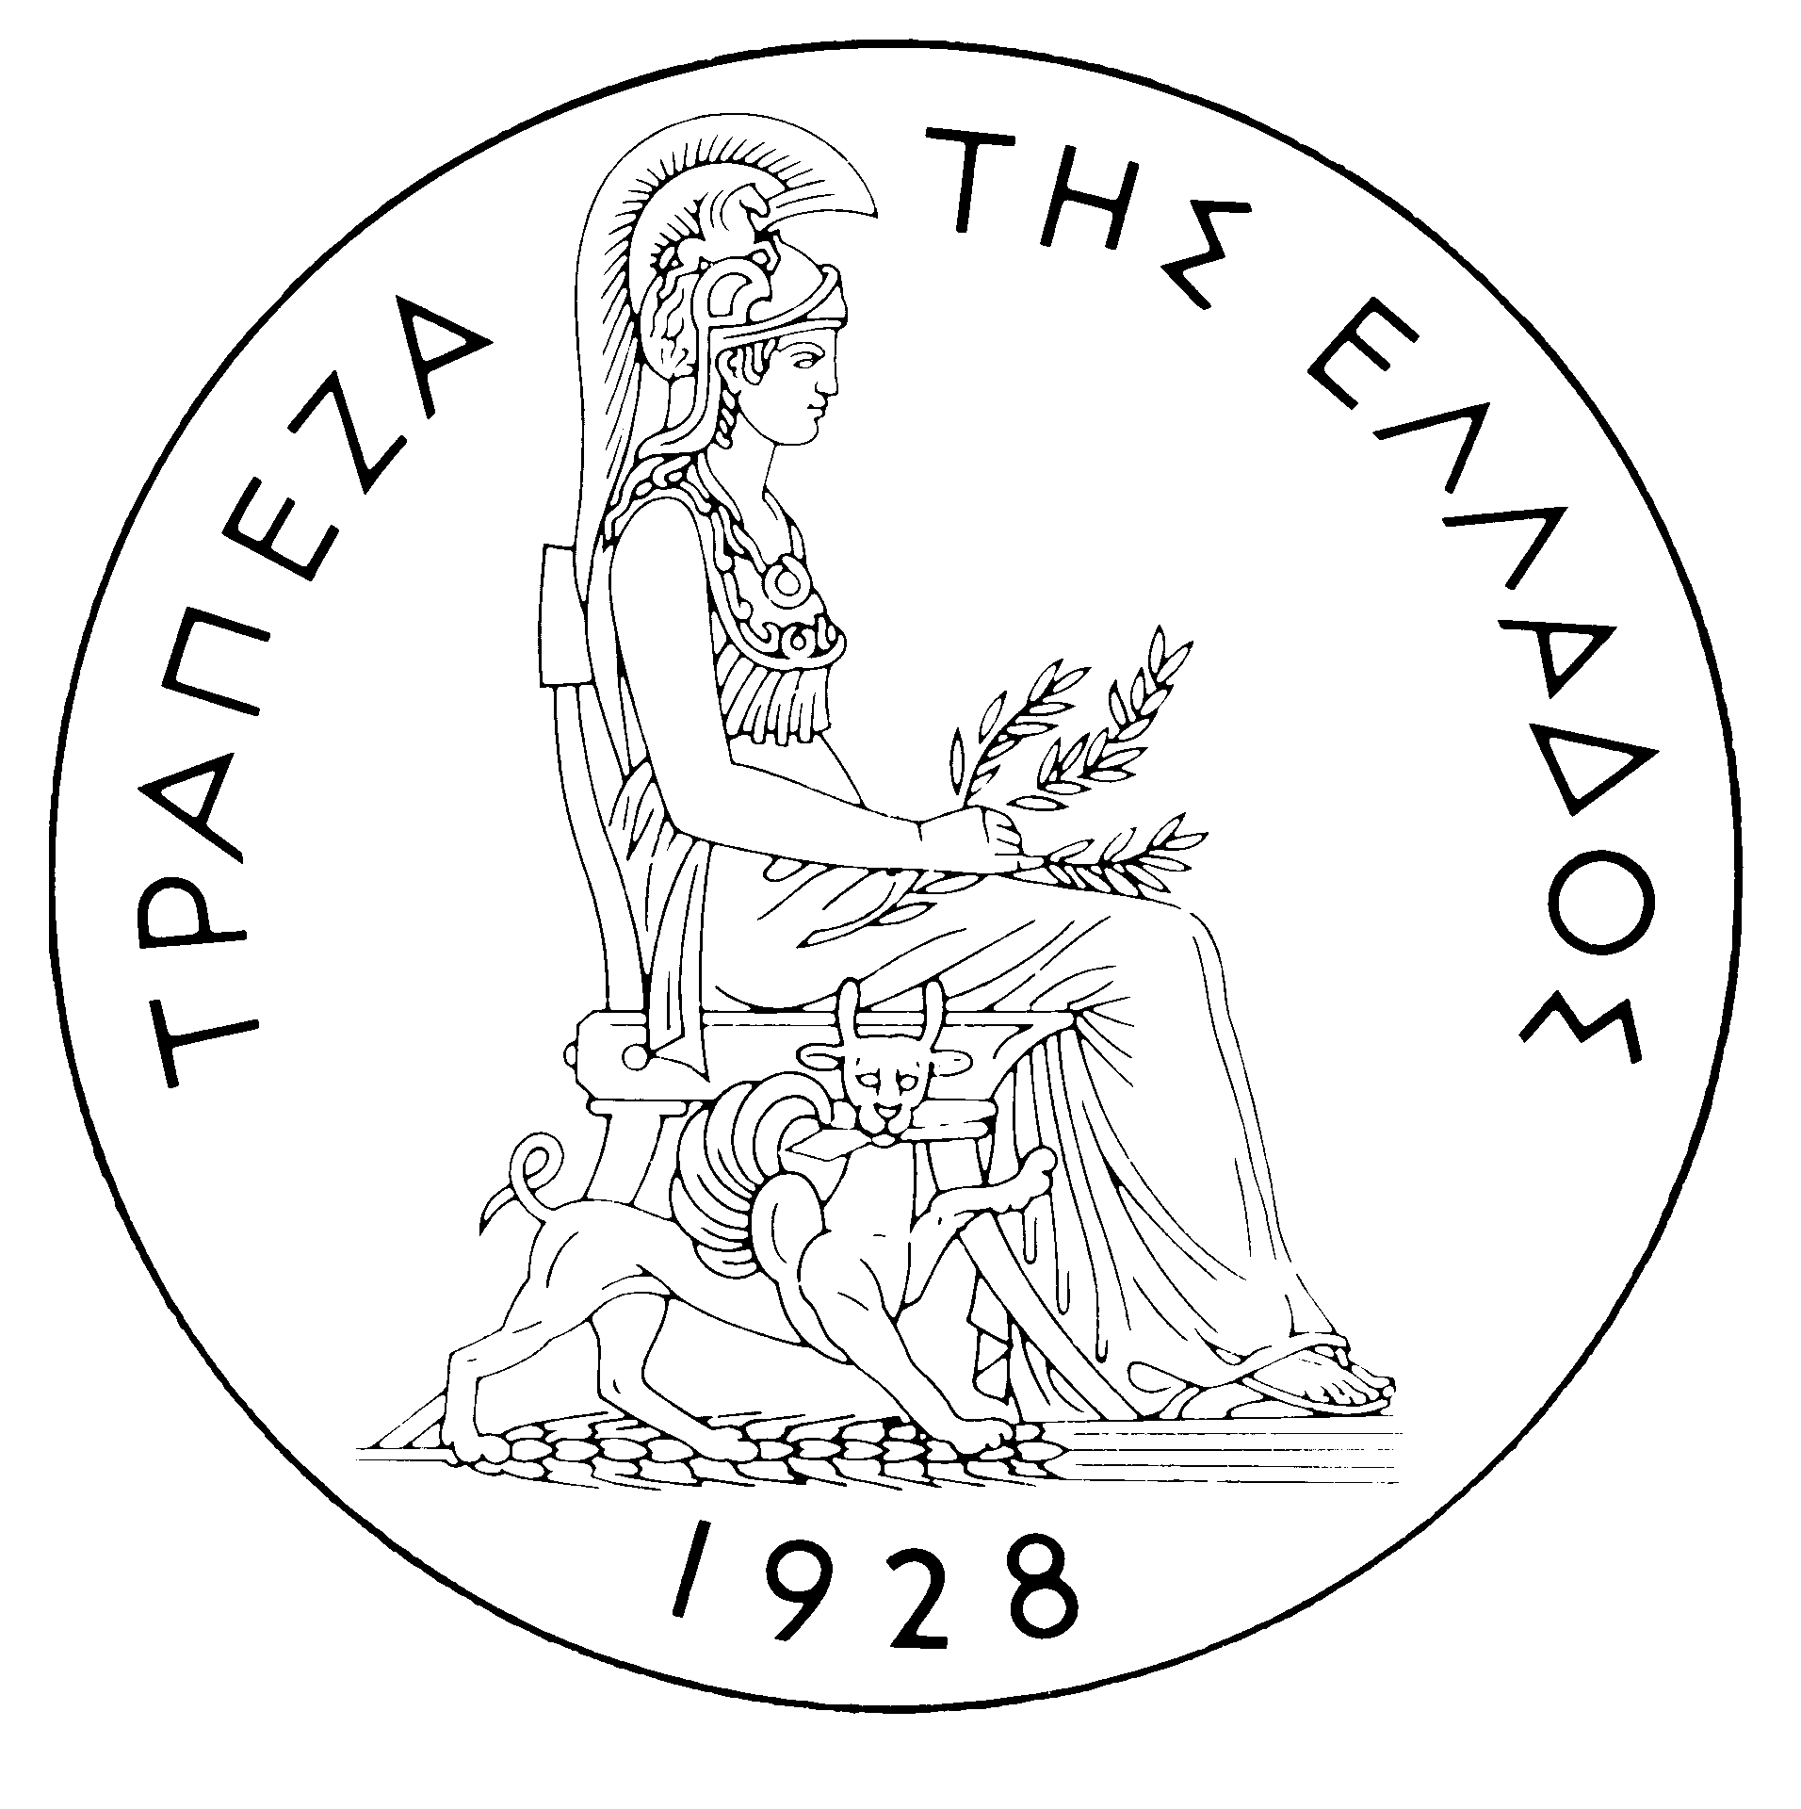
BANK OF GREECE

PRESS RELEASE

Athens, 19 September 2006

Re: Balance of payments: JULY 2006

Current account balance
In July 2006, the current account deficit dropped by €49 million year-on-year and came to €387 million. This improvement is attributable to a considerable increase in the surplus of the services balance, as well as a small decrease in the income account deficit, which more than offset a rise in the trade deficit and the narrowing of the current transfers surplus.
Underlying the widening of the trade deficit was mainly a €129 million hike in net payments for purchases of ships, while the net oil bill and the trade deficit excluding oil and ships showed little change (up €18 and €6 million respectively). The increase in the surplus of the services balance reflects a €373 million rise in net travel receipts, which is attributable to higher (by €333 million or 16.7%) receipts (i.e. travel spending in Greece by non-residents) and lower (by €39 million or 15.7%) payments (i.e. travel spending abroad by residents). Besides, receipts from transport services grew by €27 million and payments rose by €38 million (as a result, net receipts fell by only €11 million), while net payments for “other” services rose by €21 million. The narrowing of the income account deficit is accounted for by a €37 million decline in net interest, dividend and profit payments. Finally, the drop in the current transfers surplus mainly reflects lower (by €166 million) net current transfers from the EU to general government. It should be recalled that current transfers from the EU mainly include receipts from the Guarantee Section of the European Agricultural Guidance and Guarantee Fund (EAGGF) in the context of the Common Agricultural Policy and receipts from the European Social Fund, while current transfers to the EU include Greece’s contributions (payments) to the Community Budget.
In January-July 2006, the current account deficit widened by €6,296 million over the same period of 2005 and reached €14,664 million, reflecting mainly a rise in the trade deficit and, to a lesser extent, an increase in the income account deficit and a narrowing of the services and the current transfers surpluses.
The widening of the overall trade deficit (including oil and ships) by €4,776 million was almost equally due to rises in the deficit excluding oil and ships, the net oil import bill and net payments for purchases of ships (of €1,633, €1,632 and €1,510 million respectively). It should be pointed out that receipts from goods exports (excluding oil and ships) showed a remarkable rise (of €778 million), which, however, was more than offset by a hike (of €2,084 million) in the corresponding import bill. The services surplus narrowed by €342 million, as a result of, mainly, a €557 million drop in net transport receipts and, secondarily, a €304 million rise in net payments for “other” services. By contrast, net travel receipts grew by €519 million, as receipts (i.e. travel spending in Greece by non-residents) rose by €432 million (or 8.2%), while payments (i.e. travel spending abroad by residents) declined by €87 million (or 6.2%). The income account deficit grew by €967 million, mainly as a result of higher net interest, dividend and profit payments. Finally, the current transfers surplus narrowed by €211 million, as the decrease in net (mainly EU) current transfers to general government more than offset a rise in net current transfers to the other sectors (excluding general government).
Capital transfers balance
In July 2006, the capital transfers balance improved considerably, as it showed a surplus of €495 million, compared with a deficit of €22 million in the corresponding month of 2005. (Capital transfers from the EU mainly include receipts from the Structural Funds – except for the European Social Fund – and the Cohesion Fund under the Community Support Framework.)
In January-July 2006, the surplus of the capital transfers balance almost doubled year-on-year and reached €2,003 million. This reflects almost exclusively a €965 million (or 89%) rise in EU capital transfers to general government.
Combined current account and capital transfers balance (according to the old method of presentation)
The combined current account and capital transfers balances (according to the old method of presentation) improved considerably in July 2006, as it showed a surplus of €107 million, compared with a deficit of €458 million in the same month of 2005. In January-July 2006, however, the overall deficit reached €12,661 million, compared with €7,343 million in the same period of 2005.
Financial account balance
In July 2006, net outflows under residents’ direct investment abroad reached €153 million, chiefly featuring outflows of €32 million for the participation of PIRAEUS BANK in the share capital increase of BANCA DE CREDIT S.A. (Romania), €28 million for the partial acquisition of BANCPOST (Romania) by EUROBANK and €20 million for the participation of CARREFOUR MARINOPOULOS in the share capital increase of CARREFOUR (Bulgaria). With respect to non-residents’ direct investment in Greece, a net inflow of €113 million was observed, mainly concerning re-investment of profits and lending to subsidiaries in Greece by their foreign parent companies. Under portfolio investment, there was a net inflow of €428 million, as non-residents’ purchases of Greek government bonds and Greek firms’ shares more than offset residents’ purchases of foreign Treasury bills and shares, along with the repayment of short-term Greek government securities. "Other" investment recorded a net outflow of €910 million, as the increase in residents’ external assets (almost exclusively accounted for by resident credit institutions’ and institutional investors’ higher deposit and repo holdings abroad) outweighed a rise in residents’ external liabilities.
In January-July 2006, direct investment showed a net inflow of €970 million (compared with a net inflow of just €15 million in the corresponding period of 2005). Specifically, net inflows of non-residents’ funds for direct investment in Greece reached €1,464 million, while net outflows of residents’ funds for direct investment abroad came to €495 million. Over the same period, a net inflow of €2,542 million was recorded under portfolio investment, as the inflow of non-residents’ funds for investment in Greece (mainly in Greek government bonds and shares of Greek firms, of €6,734 and €4,211 million respectively) more than offset the repayment of short-term Greek government securities and residents’ outflows for investment in foreign bonds, Treasury bills and shares. Finally, under “other” investment, a net inflow of €9,476 million reflects the fact that the inflow of non-residents’ funds (of €13,547 million), mainly to deposits and repos in Greece, far outweighed residents’ outflows (of €4,071 million) for corresponding investment abroad.
At end-July 2006, Greece’s reserve assets reached €2.2 billion. (It should be recalled that, since Greece joined the euro area in January 2001, reserve assets, as defined by the European Central Bank, include only monetary gold, the "reserve position" with the IMF, "Special Drawing Rights", and Bank of Greece claims in foreign currency on residents of non-euro area countries. Conversely, reserve assets do not include claims in euro on residents of non-euro area countries, claims in foreign currency and in euro on residents of euro area countries, and the Bank of Greece participation in the capital and the reserve assets of the ECB.)
Note: Balance of payments data for August 2006 will be released on 20 October 2006.

