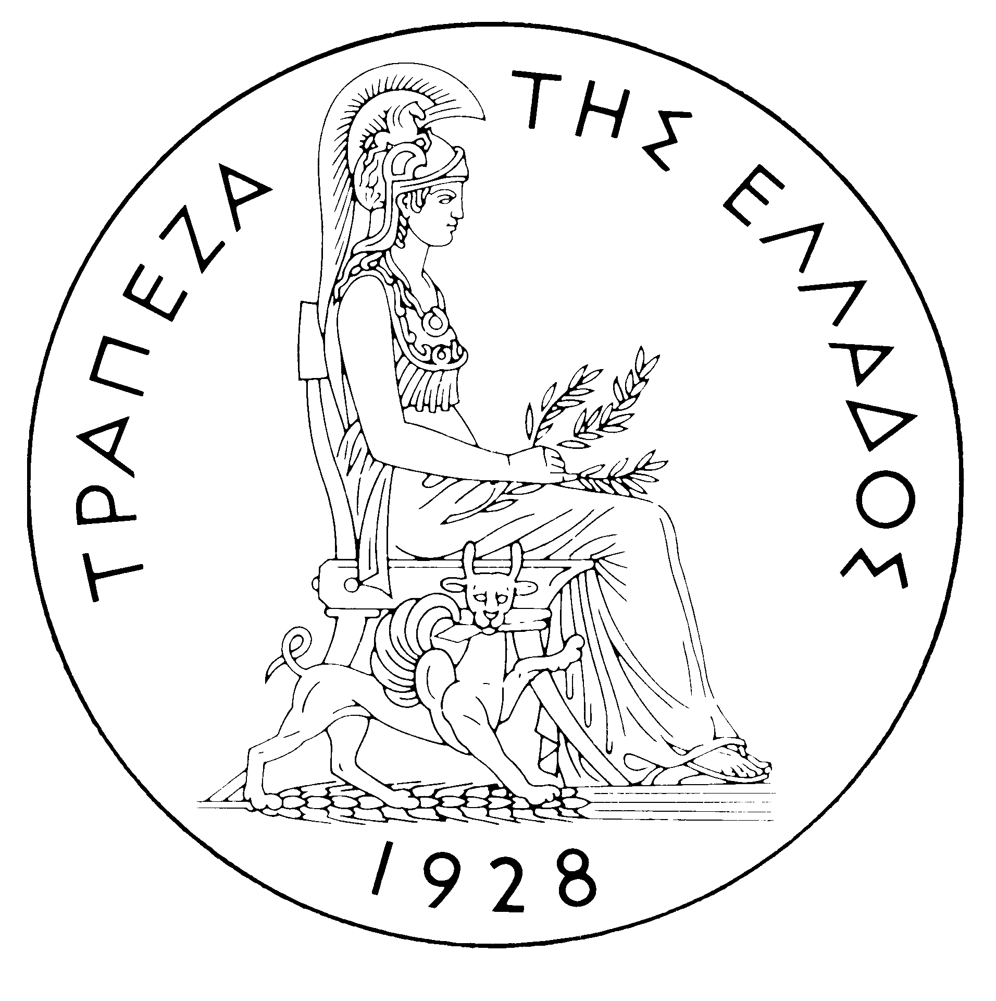

BANK OF GREECE

PRESS RELEASE

Athens, 29 September 2006

Subject: Zolotas lecture by Professor Alexandre Lamfalussy

On Friday, 29 September 2006 at 12.00, at the Head Office of the Bank of Greece Professor Alexandre Lamfalussy gave a lecture in honour of Professor Xenophon Zolotas entitled: “Monetary Policy and Systemic Risk Prevention – Challenges ahead for Central Banks”.

In his lecture, Professor Lamfalussy addressed the issue of the systemic stability of the international financial system. He argued that policy-makers are currently at a crucial juncture. Whilst the excess liquidity that exists in the world economy is unlikely to have much of an impact on inflation, its consequences for financial fragility are less clear, especially in conditions of global imbalances and rapid financial innovation. In such an environment, the tasks of managing the excess liquidity and of pushing on with the implementation of a strong regulatory framework represent the major policy challenges which face central banks at this time.

Professor Alexandre Lamfalussy is a distinguished economist and one of the leading central bankers. He was, among other things, General Director of the Bank for International Settlements, President of the European Monetary Institute and Chairman of the Committee of Wise Men on the Regulation of European Securities Markets.

The lecture was attended by the Minister of Economy and Finance, bank executives and members of the academic community.

