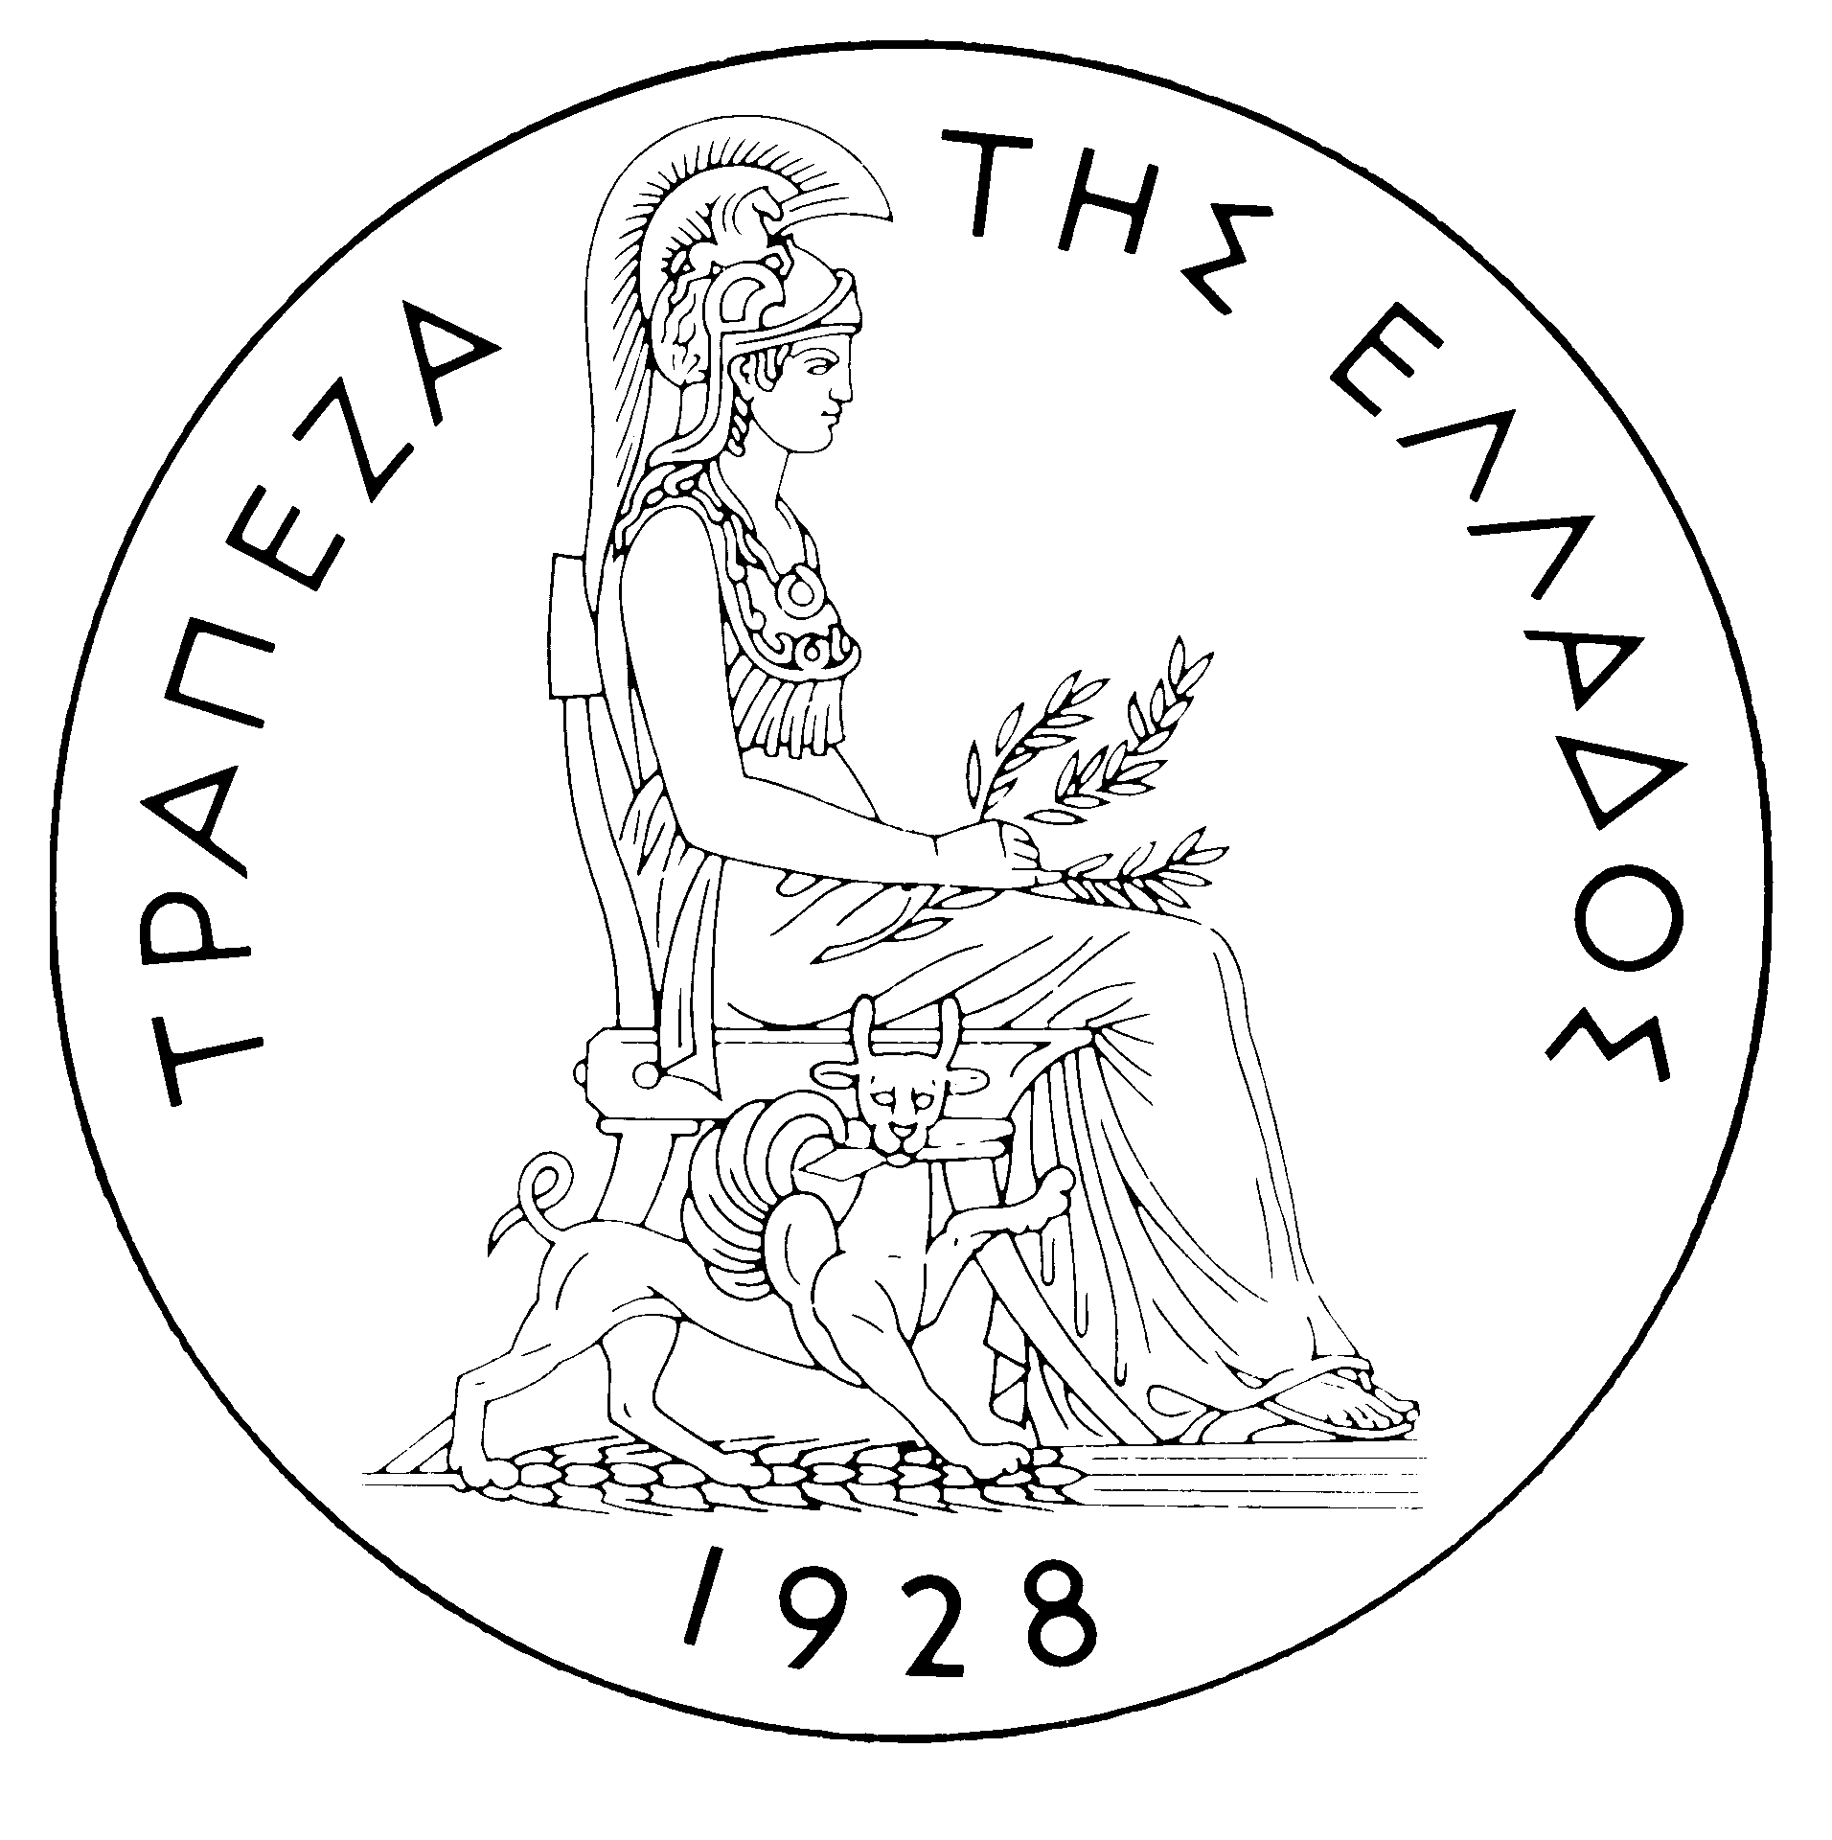
BANK OF GREECE
EUROSYSTEM

PRESS RELEASE

Athens, 21 November 2006

Re: Balance of payments: SEPTEMBER 2006

Current account balance
In September 2006, the current account balance showed a deficit of €1,168 million, compared with €617 million in the same month of 2005. This expansion mainly reflects an increase in the trade deficit and, secondarily, in the income account deficit, as well as a very small decline in the surplus of the current transfers balance. These developments were offset to a small extent by the growth of the surplus of the services balance.
Underlying the widening of the trade deficit by €521 million were increases of €246 million, €186 million and €89 million in net payments for purchases of ships, the other goods deficit and the net oil import bill respectively. The €90 million rise in the surplus of the services balance reflects a €97 million hike in net travel receipts (receipts grew by €102 million or 6.3% and payments by only €5 million) and a €26 million increase in net receipts from transport services (transport – mainly shipping – receipts rose by €103 million or 9.5% and payments by €77 million), while net payments for “other” services rose by €33 million. The widening of the income account deficit by €104 million is mainly accounted for by a rise in interest payments on non-residents’ deposits in Greece, on loans granted to residents and on non-residents’ Greek government bond holdings. Finally, the small drop in the current transfers surplus reflects a commensurate slight decline in net current transfers from the EU to general government. It should be recalled that current transfers from the EU mainly include receipts from the Guarantee Section of the European Agricultural Guidance and Guarantee Fund (EAGGF) in the context of the Common Agricultural Policy and receipts from the European Social Fund, while current transfers to the EU include Greece’s contributions (payments) to the Community Budget.
In January-September 2006, the current account deficit widened by €7,435 million over the same period of 2005 and reached €16,036 million, reflecting mainly a rise in the trade deficit and, to a lesser extent, an increase in the income account deficit and a narrowing of the services and the current transfers surpluses.
The widening of the overall trade deficit (including oil and ships) by €6,027 million was a result of hikes in net payments for purchases of ships, the net oil import bill and the deficit excluding oil and ships (of €2,323 million, €2,074 million and €1,630 million respectively). It should be pointed out that receipts from exports of goods (excluding oil and ships) showed a remarkable rise (of €916 million or 12.1%), but the increase in the corresponding import bill (of €2,546 million or 11.1%) was larger in absolute terms. The services surplus narrowed by €107 million, mainly as a result of, mainly, a €483 million drop in net transport receipts (transport – chiefly shipping – receipts grew by only €140 million or 1.3%, while transport payments increased by €624 million or 13.7%) and, secondarily, a €351 million rise in net payments for “other” services. By contrast, net travel receipts grew by €728 million (travel receipts rose by €637 million or 6.8%, while payments declined by €90 million or 5.0%). The income account deficit increased by €1,198 million, mainly as a result of higher net interest, dividend and profit payments. Finally, the current transfers surplus narrowed by €104 million, as the decrease in net current transfers (mainly from the EU) to general government more than offset a rise in net current transfers to the other sectors (excluding general government).
Capital transfers balance
In September 2006, the capital transfers balance showed a surplus of only €60 million, compared with a surplus of €264 million in the same month of 2005, mainly as a result of lower capital transfers from the EU to general government. (Capital transfers from the EU mainly include receipts from the Structural Funds – except for the European Social Fund – and the Cohesion Fund under the Community Support Framework.)
In January-September 2006, the surplus of the capital transfers balance grew substantially year-on-year and reached €2,065 million. This reflects almost exclusively a €709 million (or 50%) rise in EU capital transfers to general government.

Combined current account and capital transfers balance (according to the old method of presentation)
The combined current account and capital transfers balance (according to the old method of presentation) showed a deficit of €1,107 million in September 2006, €754 million up year-on-year. In January-September 2006, the overall deficit reached €13,972 million, compared with €7,255 million in the same period of 2005.
Financial account balance
In September 2006, no considerable flows were recorded under direct investment. It should be pointed out that, as regards non-residents’ direct investment in Greece, an inflow of €142 million primarily reflects borrowing by subsidiaries in Greece from their parent companies abroad.
Under portfolio investment, a net inflow of €1,857 million was recorded, mainly reflecting non-residents’ purchases of Greek government bonds (of €3,125 million) and, secondarily, purchases of shares of Greek firms by non-residents (of €459 million), which, however, were partly offset mainly by purchases of foreign bonds by residents. "Other" investment recorded a net outflow of €503 million, chiefly because the decline in foreign credit institutions’ deposit and repo holdings in Greece outweighed the decrease in residents’ corresponding holdings abroad.
In January-September 2006, direct investment showed a net inflow of €888 million (compared with a net outflow of €635 million in the same period of 2005). Specifically, net inflows of non-residents’ funds for direct investment in Greece reached €3,711 million, while net outflows of residents’ funds for direct investment abroad came to €2,823 million. Over the same period, a net inflow of €5,647 million was recorded under portfolio investment, as the inflow of non-residents’ funds for investment in Greece (mainly in Greek government bonds and shares of Greek firms, of €11.3 billion and €3.8 billion respectively) by far exceeded the repayment of short-term Greek government securities and the outflow of residents’ funds for investment in foreign bonds, shares and Treasury bills. Finally, under “other” investment, a net inflow of €7,873 million mainly reflects the fact that the inflow of non-residents’ funds to deposits and repos in Greece was more than double the outflow of residents’ funds for corresponding investment abroad.
At end-September 2006, Greece’s reserve assets reached €2.2 billion. (It should be recalled that, since Greece joined the euro area in January 2001, reserve assets, as defined by the European Central Bank, include only monetary gold, the "reserve position" with the IMF, "Special Drawing Rights", and Bank of Greece claims in foreign currency on residents of non-euro area countries. Conversely, reserve assets do not include claims in euro on residents of non-euro area countries, claims in foreign currency and in euro on residents of euro area countries, and the Bank of Greece participation in the capital and the reserve assets of the ECB.)
Note: Balance of payments data for October 2006 will be released on 20 December 2006.

