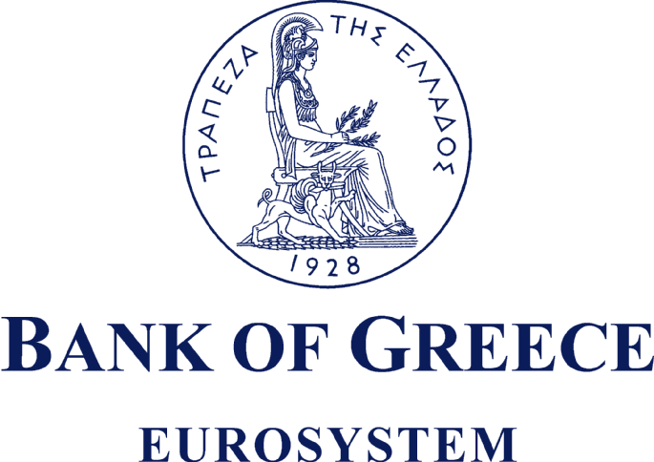

PRESS RELEASE

Athens, 21 February 2007

Re: Balance of payments: DECEMBER 2006

Current account balance
In December 2006, the current account balance showed a deficit of €2,815 million, i.e. €294 million higher than in December 2005. This expansion reflects mainly a surge in the trade deficit and – to a lesser extent – the narrowing of the surplus of the services balance and the growth of the income account deficit. By contrast, the surplus of the current transfers balance almost doubled.
Underlying the €384 million rise in the trade deficit were increases of €227 million in net payments for purchases of ships and of €354 million in the other goods (excluding oil and ships) deficit, while the net oil import bill dropped by €198 million. The €168 million fall in the surplus of the services balance is mainly attributable to a decline in net transport receipts. The widening of the income account deficit by €58 million is accounted for by an increase in net interest payments to non-residents. Finally, the considerable growth of the current transfers surplus (by €316 million) mainly reflects a €373 million increase in net current transfers from the EU to general government, while net transfers to the other sectors declined. It should be recalled that current transfers from the EU mainly include receipts from the Guarantee Section of the European Agricultural Guidance and Guarantee Fund (EAGGF) in the context of the Common Agricultural Policy, as well as receipts from the European Social Fund, while current transfers to the EU include Greece’s contributions (payments) to the Community Budget.
In 2006, the current account deficit widened by €9,003 million over 2005 and reached €23,640 million or 12.1% of GDP (compared with 8.1% of GDP in 2005, according to revised data), reflecting mainly a rise in the trade deficit and, to a lesser extent, an increase in the income account deficit. During the same period, the services surplus did not show any considerable change, while the current transfers surplus showed a relatively small increase. In particular, it should be noted that the rises in net payments for purchases of ships, the oil deficit and net interest payments contributed by 27%, 24% and 16% respectively to the surge in the current account deficit in 2006.
The widening of the overall trade deficit (including oil and ships) by €7,727 million was a result of hikes of €2,132 million, €2,438 million and €3,157 million in the net oil import bill, net payments for purchases of ships and the trade deficit excluding oil and ships, respectively. (It should be borne in mind that, according to the methodology followed, the transactions concerning purchases and sales of ships that are recorded in the balance of payments are only those carried out by shipping firms established in Greece through credit institutions operating in Greece. Therefore, transactions concerning purchases and sales of ships carried out by such firms through credit institutions abroad are not recorded in the balance of payments statistics.) It should be pointed out that receipts from exports of goods (excluding oil and ships) showed a considerable rise (of €1,013 million or 9.6%), but the increase in the corresponding import bill (of €4,170 million or 13.6%) was much larger. The services surplus contracted slightly, as the €604 million increase in net travel receipts was more than offset by a €300 million drop in net transport receipts and a €444 million rise in net payments for “other” services. (Specifically, travel receipts rose by €551 million or 5.1%, while travel payments declined by €53 million or 2.2%. Moreover, transport receipts grew by €453 million or 3.3%, while transport payments increased by €754 million or 12.1%.) The income account deficit grew by €1,443 million, mainly as a result of higher net interest, dividend and profit payments. Finally, the current transfers surplus rose by €308 million, almost exclusively because net (mainly EU) current transfers to general government grew, reflecting a drop in general government payments (i.e. payments to the Community Budget).
Capital transfers balance
In December 2006, the capital transfers balance showed a surplus of €454 million, €92 million up year-on-year, mainly as a result of a considerable increase in capital transfers from the EU to general government. (Capital transfers from the EU mainly include receipts from the Structural Funds – except for the European Social Fund – and the Cohesion Fund under the Community Support Framework.) In 2006, the surplus of the capital transfers balance grew by €993 million year-on-year and reached €3,041 million. This mainly reflects a rise in net EU capital transfers to general government.

Combined current account and capital transfers balance (according to the old method of presentation)
The combined current account and capital transfers balance (according to the old method of presentation) showed a deficit of €2,361 million in December 2006, €202 million up year-on-year. In 2006, the overall deficit reached €20,599 million, compared with €12,589 million in 2005.
Financial account balance
In December 2006, quite considerable flows were recorded under direct investment, notably residents’ investment abroad. The most important movement was a €357 million outflow for the acquisition of VOJVODJANSKA BANK (Serbia) by the NATIONAL BANK OF GREECE. Under portfolio investment, a net inflow of €2,652 million was recorded, mainly reflecting residents’ sales of foreign bonds and Treasury bills, as well as non-residents’ purchases of shares of Greek firms, which were partly offset by a decline in non-residents’ holdings of Greek government bonds and Treasury bills and bonds of Greek firms. "Other" investment recorded a relatively small net outflow of €382 million, reflecting the fact that the drop in foreign credit institutions’ deposit and repo holdings in Greece was largely offset by a decline in Greek credit institutions’ deposit and repo holdings abroad and an increase in residents’ short-term loan obligations vis-à-vis non-residents.
In 2006, direct investment showed a net inflow of €954 million (compared with a net outflow of €679 million in 2005). Specifically, net inflows of non-residents’ funds for direct investment in Greece reached €4,275 million (from €488 million in 2005), while net outflows of residents’ funds for direct investment abroad came to €3,322 million (from €1,167 million in 2005). In 2006, a net inflow of €8,115 million was recorded under portfolio investment, as the inflow of non-residents’ funds for investment in Greece (mainly in Greek government bonds and shares of Greek firms, of €11.2 billion and €6.0 billion respectively) largely exceeded the repayment of short-term Greek government securities and outflows of residents’ funds for investment in foreign bonds, shares and Treasury bills. Finally, under “other” investment, a net inflow of €11,519 million mainly reflects the fact that the inflow of non-residents’ funds to deposits and repos in Greece was more than three times the outflow of residents’ funds for corresponding investment abroad (€17.0 million, compared with €5.5 million).
At end-December 2006, Greece’s reserve assets reached €2.2 billion. (It should be recalled that, since Greece joined the euro area in January 2001, reserve assets, as defined by the European Central Bank, include only monetary gold, the "reserve position" with the IMF, "Special Drawing Rights", and Bank of Greece claims in foreign currency on residents of non-euro area countries. Conversely, reserve assets do not include claims in euro on residents of non-euro area countries, claims in foreign currency and in euro on residents of euro area countries, and the Bank of Greece participation in the capital and the reserve assets of the ECB.)
Note: Balance of payments data for January 2007 will be released on 21 March 2007.

