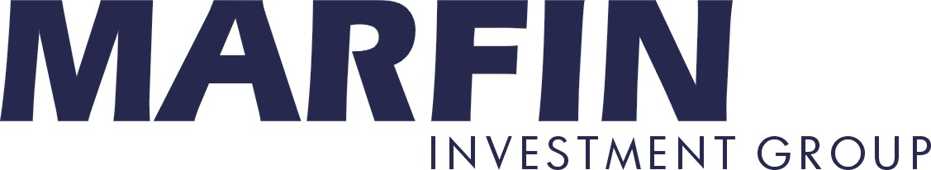

31/10/2007

PRESS RELEASE

Dubai Financial Group will increase its stake in
Marfin Popular Bank and
Marfin Investment Group over time

Dubai Financial Group ("DFG"), the financial holding company for Dubai Group will increase its stake in Marfin Popular Bank ("MPB") up to 30% and in Marfin Investment Group ("MIG") up to 20% over time.

In this regard:

- Dubai Financial Group has purchased today 19,832,865 shares of MPB at the price of €12 per share from the founder of the Group Andreas Vgenopoulos increasing its economic stake in MPB from 17.4% to 19,9%. Unrelated to this transaction, Dubai Financial Group has also entered in a derivative structure with a market participant in relation to 8,231,982 shares of MPB, whilst maintaining the economic interests in such shares.

- Dubai Financial Group is applying to Central Bank of Cyprus in order to obtain its approval to increase its economic stake in MPB over time, subject to market conditions, up to 30%.

- Dubai Financial Group will agree with MPB to buy its 6,45% stake in MIG (53,532,184 shares) at the price of €7 per share in order to increase its shareholdings in MIG from 9.6% to 16,0%. This transaction is subject to an MPB shareholders approval and will be not effected until the 31st January 2008 due to certain lock-up restrictions.

- Dubai Financial Group intends to increase its stake in MIG over time, subject to market conditions, up to 20%.

Mr. A. Vgenopoulos will be joining Dubai Financial Group as the Chairman of its subsidiary, DFG SOUTH EASTERN EUROPE for a period of five (5) years.
He will also be nominated by Dubai Financial Group and voted for serving in a top executive position in both MPB and MIG for a period of five (5) years. During his term, Mr. A. Vgenopoulos is expected to lead an aggressive expansion of these companies in their respective areas of activity, appoint and supervise his successors and an expanding management team. In the context of the above, Dubai Financial Group confirms that it wishes to keep MPB and MIG listed and based in Cyprus and Greece respectively.

Note: Info about

Dubai Financial Group

Dubai Financial Group (DFG) is the financial holding company for Dubai Group, a member of Dubai Holding. Its core practice is the identification and acquisition of financial services companies, to build long-term value through state-of-the-art governance. Identifying opportunities across the banking, consumer finance, exchanges and asset management sectors, DFG will reinforce the Group’s position as the principal entity mandated to drive its activities in the regional and international markets. It has significant stakes in regional and global institutions such as Thomas Cook, Bank Islam, Bank Muscat, Taib Bank and Dubai Bank.

Marfin Popular Bank

Marfin Popular Bank (MPB) is the largest banking group in Cyprus, among the five largest in Greece, with a strong international footprint. It is the successful outcome of the recent consolidation involving mid-cap banks in Cyprus and Greece. The MPB Group is present in 13 countries either via licensed banking institutions or via representative offices and has more than 405 branches, 6,250 employees worldwide and customers in excess of one million. MPB has currently banking branches in the Ukraine, Serbia, Romania, Estonia, Australia, UK, Guernsey, Cyprus and Greece. In addition, MPB has representative offices in Canada, Russia, South Africa and the USA.

MPB currently has total assets of €29.1 billion and total equity in excess of €3.4 billion; the Company is listed on the Cyprus and Athens Stock Exchanges with a current market capitalization of approximately €8.5 billion.

Marfin Investment Group

Marfin Investment Group Holdings S.A. (MIG) is an investment holding company based in Greece. The Company’s aim is to deliver superior returns to shareholders, primarily by making private equity-type investments, as well as investments in privatisations and infrastructure projects in Southeastern Europe, the CIS, and surrounding regions.
Currently, MIG has holdings in market-leading Food & Beverage, Healthcare, IT, Telecommunications, Shipping, Hospitality and Tourism, Real Estate portfolios and Financial sector companies. MIG is listed on the Athens Stock Exchange with a market capitalization of approximately €5.5 billion.

