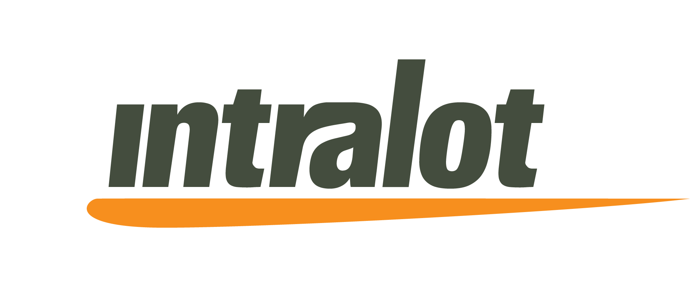



INTRALOT: CONTRACT WITH BOTH LEADING LOTTERIES

OF THE NETHERLANDS

April 29, 2008

INTRALOT’s subsidiary, INTRALOT Nederland, following an unprecedented dual international tender, has signed a contract with both leading lotteries of the Netherlands, De Lotto and De Nederlandse Staatsloterij.

De Nederlandse Staatsloterij is the oldest continuing Lottery of the World, with an uninterrupted operational record of 282 years that currently operates lottery games, while De Lotto has a wide portfolio of games, including numerical games, scratch tickets and fixed odds betting. The two lotteries are competing with each other in the local market and their market share has increased significantly during the last years. Their turnover for 2007 reached 1,1 billion €.

The term of the Agreement is 7 years with an option to extend for 3 more one-year terms. The new system will initiate operation in the third quarter of 2009.

INTRALOT will undertake the supply, maintenance and support, as well as the facilities management of the system of both lotteries. More precisely, INTRALOT will provide the two lotteries with a common central system, the LOTOSTM O/S platform, and will equip the points of sale with 1.000 of its microLOT terminals and 4.500 of its new Iris terminals, introducing to this large scale project its state-of-the-art Icon Digital Imaging Technology. The 5.500 provided terminals blend in a unique tailor made POS solution for the Dutch Lotteries, providing best efficiency and ergonomics in the retailer shops. A Prime and a Disaster Data Center, Customer Relation Management, as well as a call center for retailers and players will be provided as well.

Moreover, INTRALOT will cover the Lotteries´ new media needs with its B-On platform, rendering this project the biggest B-On operation ever in the European territory. Considering that nearly 50% of both lotteries’ sales are performed online to 2,5 million subscribers, the B-On platform is an excellent tool for the evolution of the two lotteries.

Furthermore, the company offers a number of value added services and applications to be incorporated into the core system, in order to increase the lotteries’ efficiency, such as POS equipment, risk management for FOB and Instant tickets distribution.

INTRALOT S.A. CEO, Mr. Constantinos Antonopoulos, stated: “The pioneering decision of the two lotteries to jointly procure a tender, gave INTRALOT the opportunity to design a unique custom-made solution that meets the needs of both lotteries. While the Dutch lotteries benefit from great economies of scale, INTRALOT delivers a solution and service that minimizes risk and maintains stringent security, optimizing at the same time performance and goal achievement. We are very proud to be part of this project, since it is considered to be one of the most technologically advanced projects ever implemented in the global gaming industry, creating new potential for the sector. INTRALOT drives the two lotteries into a new era, maximizing the benefits they will bring to their respective beneficiaries.”

De Nederlandse Staatsloterij CEO, Mrs. Y.R.C. (Yvonne) van Oort commented: “We are convinced that with Intralot, we have found the right partner for realizing the strategic objectives of both Nederlandse Staatsloterij and De Lotto. Improving our efficiency, reducing our complexity and better support for our retail outlet has always been at the heart of this project. We are excited about the opportunities that INTRALOT will provide to the lotteries, and are looking forward to a successful implementation”.

Tjeerd Veenstra, Executive director of De Lotto: “The Lotteries faced in this tender procedure two extra major challenges. First challenge was the change into a full service management agreement. The second challenge was to establish a co-operation between two autonomous lotteries that will maintain in competition. INTRALOT‘s proposal was absolutely convincing in facilitating a professional and cutting edge solution. We are looking forward to our future partnership.”

