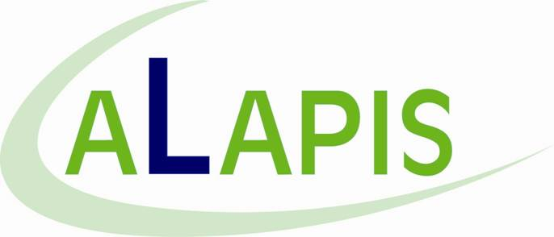

Consolidated Financial Results H1 2008

Athens, August 28, 2008:

ALAPIS HOLDING INDUSTRIAL AND COMMERCIAL SOCIETE ANONYME OF PHARMACEUTICAL, CHEMICAL AND ORGANIC PRODUCTS (“Alapis” or the “Group”) is pleased to announce its financial results for the first half of 2008.

Turnover in H1 2008 amounted to €464.4 mil, up 248.5% versus €133.2 mil in H1 2007. EBITDA increased by 219.4% and reached €125.4 mil, versus €39.3 mil in the corresponding period of last year, while earnings after tax and minorities reached €72.2 mil, up 213.5% from €23.1 mil in H1 2007.

Specifically, the Healthcare division of the Group (Human and Veterinary) generated turnover of €382.3 mil and EBITDA of €103.7 mil in H1 2008, while the Non-Healthcare division of the Group generated turnover of €82.1 mil and EBITDA of €21.8 mil.

The above increases in all financial results of H1 2008 over the respective period in 2007 are attributed to the consolidation of newly acquired companies, as well as the significant organic growth exhibited across all divisions of the Group.

Recent developments and prospects:

In June 2008, Alapis formed a company in the US under the name "ALAPIS RESEARCH LABORATORIES INC", whose scope is the research and development of generics and other pharmaceutical products. The new company will develop pharma laboratories in Boston, MA

In July 2008, Alapis acquired Pharmacare Ltd. for an amount of €950,000. Pharmacare Ltd is headquartered in Nicosia, Cyprus and is active in the distribution of veterinary products on behalf of large multinationals such as BAYER HEALTH CARE AG, LOHMANN ANIMAL HEALTH, BOEHRINGER INGELHEIM, DANISCO, IQF, 3M, AGROLABO and INTRACARE in the Cypriot market.
In accordance with its EGM decision of February 4, and its Board of Directors' resolution dated June 26, the Group commenced its own share buy-back programme. Specifically as of August 26, Alapis had acquired a total of 13.536.242 own shares, representing 1.38% of the Group’s issued share capital.

On August 26, the consortium consisting of Hutchison Port Holdings Limited, Hutchison Ports Investments Sarl, Alapis and L.Y.D. S.A. was proclaimed as the “Provisional Concessionaire” for the 30-year Concession of the Container Terminal of the Thessaloniki Port Authority S.A.

The financial results recorded by Alapis in H1 2008 are in line with the Group’s business plan, and as a result management reiterates its guidance for 2008. More specifically, management expects FY 2008 turnover of €900 mil, EBITDA of €250 mil and net earnings after tax of €160 mil.

