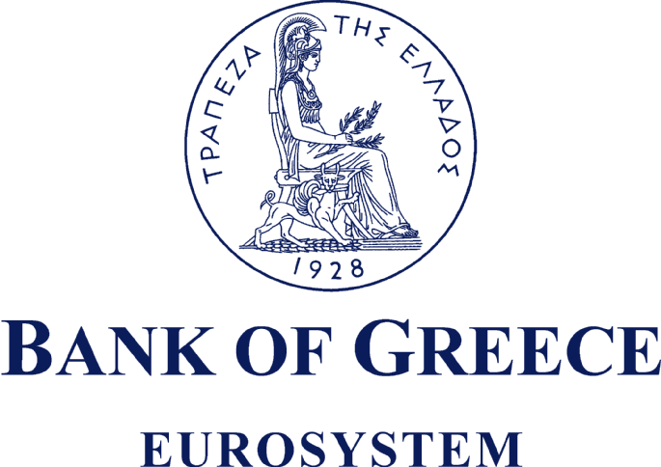
NOTIFICATION
Decisions of the General Meeting
It is hereby announced that the 78th Annual Ordinary General Meeting of Shareholders of the Bank of Greece, held on Monday 18 April 2011 at 12.00 noon, was attended by 104 shareholders, representing 8,073,033 shares out of 19,864,886 shares in whole (i.e. 40.64%).
The General Meeting made the following decisions:
- It approved the Governor’s Annual Report, the Balance Sheet and the other Financial Statements for the year 2010, including the Auditors’ Report.
- It approved the appropriation of net profits, totalling € 190,452,292, as follows:
€ 13,309,473 for the payment of dividend of €0.67 per share on 19,864,886 shares (equal to 12% of the Bank’s capital);
€ 12,000,000 for extraordinary reserve;
€ 25,943,542 for the payment of an additional dividend of €1.306 per share on 19,864,886 shares;
€ 12,395,689 for the payment of income tax (at 24%, in accordance with Article 14(10) of Law 3943/2011); and
€ 126,803,588 payable to the Government.
The total dividend will amount to €1.976 per share and is subject to withholding tax of 21%, in accordance with Article 14(2) of Law 3943/2011. The net dividend to be received by shareholders, following the tax withholding, will be €1.56104 per share.
Dividend beneficiaries will be shareholders registered with the Dematerialised Securities System (DSS) as at 12 May 2011 [record date].
The cut-off date for exercising the right to this dividend payment will be the 10th of May 2011. As from the same date, the Bank of Greece shares will be tradable on the Athens Exchange, carrying no right to participate in this dividend payment.
The dividend will be paid from 18 May 2011 onwards, according to the procedure laid down in Article 5.5 of the Athens Exchange Rulebook and the specific provisions of the Regulations of the DSS, as follows:
a) through the operators, namely the securities companies selected by shareholders and authorised for the collection of the dividend.
On 18 May 2011, the Bank will credit the accounts of the operators, who will then pay the beneficiaries. It should be noted that investors may revoke their authorisations to the operators by an application to Hellenic Exchanges S.A. (HELEX S.A.), which should be lodged at least five business days before the date of payment of the dividend.
b) directly by the Bank of Greece, either by crediting the bank account designated by shareholders or by cheque, when investors:
- have not authorised their operators;
- have revoked, by an application to HELEX S.A., the authorisation granted to their operators for the collection of the dividend;
- hold their shares in a Special Account of their Investor Share.
The payor Bank will be the Bank of Greece.
In the event that bank accounts cannot be credited for any reason, beneficiaries may collect their dividends at the Bank of Greece as from 26 May 2011.
- It approved the amendments to Articles 2, 5B, 13, 14, 17 and 55A of the Bank’s Statute and the insertion of new Articles 37A and 55E.
- It approved the remuneration and travel expenses of the members of the General Council for the year 2010.
- It elected the audit company Ernst & Young S.A. as auditor for the year 2011 and approved its fees.
- It discharged the members of the General Council and the Auditors from all personal responsibility in connection with the Bank’s activities and management for the year 2010.
- It re-elected Messrs Georgios Mylonas and Michael Chandris and elected Mr Dimitrios Asimakopoulos as members of the General Council.
Athens, 18 April 2011
Administration Department
Secretariat Section

