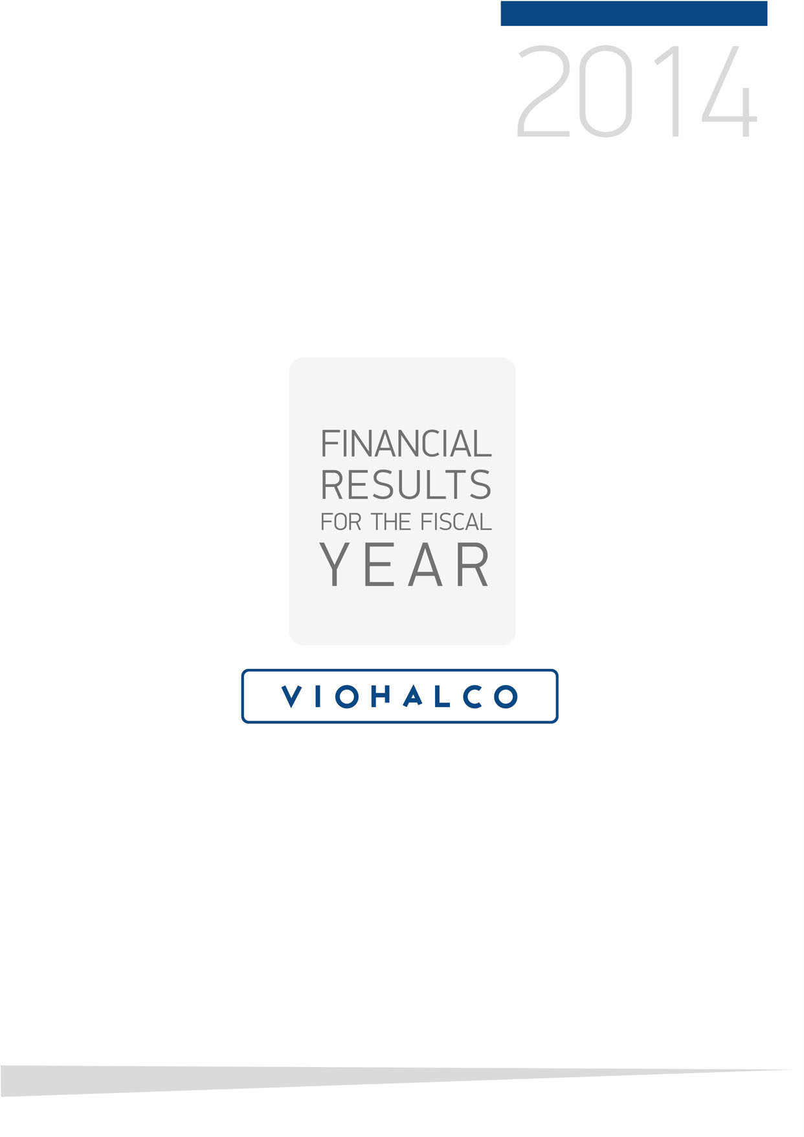

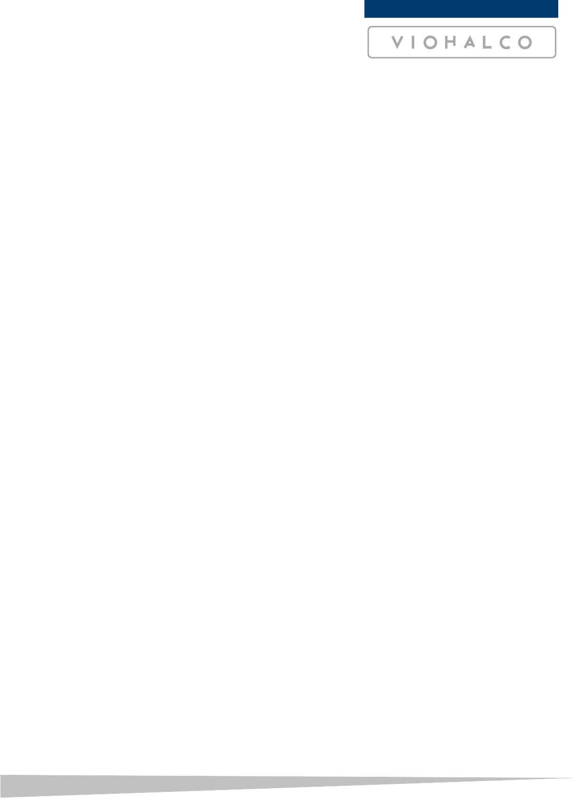
FINANCIAL RESULTS FOR THE FISCAL YEAR 2014

Brussels, 31 March 2015 – Viohalco SA (Euronext Brussels, Athens Exchange: VIO), hereafter “Viohalco”, “the Company”, today announces its financial results for the year ended 31 December 2014.

Key Highlights
- Financial highlights
  - Consolidated revenue of EUR 2,943 million, up 2% from 2013, mainly driven by increased sales volumes in most business sectors, partially offset by the lower copper price and reduced conversion prices in the copper and cables sector
  - EBITDA of EUR 120 million compared to EUR 4 million in 2013
  - Positive EBIT of EUR 4 million, compared to a negative EBIT of EUR 109 million in 2013, due to increased revenues, costs improvements, the positive impact on inventories of a lower decline in the copper price compared with 2013 and positive non-recurring items of EUR 2 million versus the negative EUR 91 million posted in 2013
  - Loss before income tax of EUR 90 million, compared to a loss of EUR 192 million in 2013
  - Loss of the period of EUR 88 million versus EUR 224 million in 2013, significantly affected by the lower income tax in 2014 due to the recalculation of the deferred tax balance in 2013
  - Loss attributable to the owners of the Company amounted to EUR 59 million (EUR 0.2941 per share) compared to a loss of EUR 173 million (EUR 0.8583 per share) in 2013
  - As at 31 December 2014, net debt amounts to EUR 1,484 million, compared to EUR 1,274 million as at December 2013
  - Successful secondary listing of Viohalco SA/NV on Athens Exchange on 14 February 2014 under the symbol “VIO” (“BIO” in Greek characters)

- Operational highlights

  - Restructuring of aluminium operations commenced following absorption of Elval Colour in May 2014 and Etem in December 2014 by Elval Group
  - Upgrade of Elval’s Oinofyta plant on track with new continuous casting line in operation, upgrade of coating production line completed, and orders for new machinery placed
  - Copper production facilities enhanced through installation of fire-refining furnace at Halcor’s subsidiary, Sofia Med, resulting in higher utilisation of scrap
  - Upgrade of existing equipment and installation of new equipment at the Fulgor cable plant completed
  - Production of high-voltage submarine cables for the Cyclades Islands Interconnection project started in September 2014
  - Operation of a new induction furnace at the steel subsidiary Sovel and commencement of a EUR 10 million investment for a new induction furnace at Sidenor’s Thessaloniki steel plant
  - Three new contracts for the supply of a total of 163 kt of steel pipes for pipeline construction in the US signed by Corinth Pipeworks
  - Enhanced tenant mix at River West shopping mall following introduction of widely popular brands
  - Construction of a new retail park in Corinth

Group financial review

Viohalco continued to operate in a difficult macroeconomic environment and challenging market conditions in 2014 driven by modest growth of the economies in the Eurozone, competitive pressure, volatility of the LME prices of aluminium, copper and zinc and delays in energy projects. Despite these challenges, the Group registered a gradual improvement in its financial performance.

Summary consolidated statement of profit or loss

 | For the year ended 31 December
Amounts in EUR thousand | 2014 | 2013
Revenue | 2,943,462 | 2,885,071
Gross profit | 205,653 | 174,982
EBITDA before non-recurring items (1) | 117,540 | 94,892
EBITDA (2) | 119,624 | 4,072
EBIT before non-recurring items (3) | 2,011 | -17,846
EBIT (4) | 4,094 | -108,666
Loss before income tax | -90,033 | -192,038
Loss of the year | -87,543 | -223,931
Loss attributable to owners of the Company | -59,405 | -173,336

- EBIT before non-recurring items plus amortisation and depreciation
- EBIT plus amortisation and depreciation
- Operating result before non-recurring items
- Operating result

The consolidated revenue of Viohalco Group for 2014 amounted to EUR 2,943 million, an increase of 2%, compared to the EUR 2,885 million recorded in 2013. The trend in Group revenue was largely driven by growing sales volumes in the aluminium and copper and cables sectors and the increase in the average price of primary aluminium to EUR 1,405 per ton in 2014 compared with EUR 1,395 per ton in 2013. On the other hand, the 6.2% decline in the copper price from EUR 5,514 per ton in 2013 to EUR 5,174 per ton in 2014and the reduced conversion prices in the copper and cables sector negatively affected revenue.
EBIT improved from a negative EUR 109 million in 2013 to a positive EUR 4 million in 2014. In addition to the improvement in the operating results of the steel and steel pipes and aluminium sectors, this recovery was mainly driven by the significant reduction of non-recurring items, from a negative EUR 91 million in 2013 to a positive EUR 2 million in 2014. Non-recurring items in 2014 included EUR 2.4 million of impairment losses on PP&E, EUR 0.6 million of idle costs, EUR 0.3 million of impairment losses on investment property and a EUR 5.3 million reversal of impairment losses on investment property.
Net finance costs increased by 12% to EUR 96 million in 2014 from EUR 86 million in 2013, mainly due to increased borrowings and refinancing costs.
Loss before income tax of Viohalco in 2014 amounted to EUR 90 million compared to a loss before income tax of EUR 192 million in 2013. Loss before income tax is the sum of operating profit of EUR 4 million, net finance costs of EUR 96 million and the share of profit of equity-accounted investees of EUR 2 million.
Loss of the year amounted to EUR 87.5 million in 2014, compared to a loss of EUR 224 million for 2013. It resulted from the sum of the loss before income tax and the income tax expenses which amounted to positive EUR 2.5 million in 2014 versus negative EUR 32 million in 2013. This variation in income tax expenses was due to the recalculation of deferred tax balances in 2013, resulting from the change in the Greek corporate tax rate from 20% to 26%.

Summary consolidated statement of financial position

 | As at 31 December
Amounts in EUR thousand | 2014 | 2013
ASSETS
Property, plant and equipment | 1,759,024 | 1,692,668
Investment property | 141,497 | 125,395
Other non-current assets | 103,968 | 132,956
Non-current assets | 2,004,489 | 1,951,019
Inventories | 860,709 | 773,729
Trade and other receivables | 535,085 | 464,333
Cash and cash equivalents | 99,612 | 173,401
Other current assets | 12,639 | 4,768
Current assets | 1,508,045 | 1,416,231
TOTAL ASSETS | 3,512,534 | 3,367,250
EQUITY | 1,243,006 | 1,340,692
LIABILITIES
Loans and borrowings | 944,599 | 944,135
Deferred tax liabilities | 138,091 | 162,357
Other non-current liabilities | 100,775 | 81,148
Non-current liabilities | 1,183,465 | 1,187,640
Loans and borrowings | 638,848 | 503,305
Trade and other payables | 430,718 | 319,841
Other current liabilities | 16,497 | 15,772
Current liabilities | 1,086,063 | 838,918
TOTAL LIABILITIES | 2,269,528 | 2,026,558
TOTAL EQUITY & LIABILITIES | 3,512,534 | 3,367,250

Non-current assets increased by 2.7% from EUR 1,951 million in 2013 to EUR 2,004 million in 2014. This increase is mainly due to the increase in PP&E (EUR 66 million) and investment property (EUR 16 million) and was partially offset by the lower value of other non-current assets (EUR 29 million).
Current assets increased by EUR 92 million, or 6.5%, from EUR 1,416 million to EUR 1,508 million. This is mainly due to higher inventories (EUR 87 million) and trade and other receivables (EUR 71 million), largely offset by lower cash and cash equivalents.

Liabilities increased by 12% from EUR 2,027 million in 2013 to EUR 2,270 million in 2014, driven by higher loans and borrowings of EUR 136 million and trade and other payables of EUR 111 million.

See appendices for the consolidated statement of profit or loss (Appendix A), the consolidated statement of financial position (Appendix B) and the statement of business sectors (Appendix C).
Performance by business sector
Viohalco SA’s financial performance is impacted by the performance of its key subsidiaries, which in turn, are significantly affected by market conditions in their respective sectors.

Viohalco operates under the following organizational framework that comprises four core business sectors:
- Aluminium: Elval S.A. and its subsidiaries (“Elval”), operate in the aluminium sector, delivering an extensive range of products from aluminium coils and sheets for general applications and aluminium foil for household use, to special products, including rolled and extruded aluminium products for the shipbuilding, automotive and construction industries and lithographic coils.
- Copper & Cables: Halcor S.A. and its subsidiaries (“Halcor”), are active in the production of a wide range of copper and copper alloy solutions that span from copper and brass tubes, copper strips, sheets and plates to copper bus bars and rods. Hellenic Cables S.A., a subsidiary of Halcor, engages in the manufacturing of a full portfolio of cables and conductors, enamelled wires, copper and aluminium wire rods, as well as in plastic and rubber compounds.
- Steel & Steel Pipes: Through Sidenor S.A. and its subsidiaries (“Sidenor”), Viohalco is active in the manufacturing of long and flat steel products, as well as downstream products. Corinth Pipeworks S.A., a subsidiary of Sidenor, engages in the production of pipes for the transmission of natural gas, oil and water networks, as well as hollow sections that are used extensively in construction projects.
- Real Estate Development Sector & Other Services: Viohalco creates value from the development of its former industrial real estate properties in Greece and Bulgaria and also holds participations in smaller companies, mainly providing services.

Notes:
- Elval S.A., Halcor S.A., Hellenic Cables S.A., Sidenor S.A. and Corinth Pipeworks S.A. are separately quoted on the Athens Exchange.
- The summary consolidated statements of profit or loss presented below are the published ones by each subsidiary to the Athens Exchange (as per Viohalco’s press release on March 13, 2015).

Aluminium
Elval’s consolidated revenue increased by 5.1% to EUR 1,060 million versus EUR 1,009 million in 2013, largely driven by increased sales volumes which rose by 6.2% during the period. The profit of the period attributable to owners of the Company totalled EUR 17 million (EUR 0.137 per share) compared to EUR 0.4 million (EUR 0.0029 per share) in 2013. Elval’s volume increase and the reduction in costs were counterbalanced by higher premiums that prevailed in the international aluminium markets. Despite pricing pressures, the rolling sector of Elval retained its profitability, due to increased volumes and cost improvements. However, the extrusion sector remained loss making during the period. In addition, the increase in after tax profitability was largely due to the fact that income tax in 2014 was significantly lower than in the previous year, due to a recalculation of the deferred tax in 2013, as a result of increased tax rates. It is also worth noting that during 2014, Elval initiated its restructuring process, aiming at offering complete solutions to customers, especially in architectural applications.

The summary consolidated statement of profit or loss of Elval is as follows:
 | For the year ended 31 December
Amounts in EUR thousand | 2014 | 2013
Revenue | 1,060,398 | 1,008,502
Gross profit | 84,433 | 82,141
EBITDA | 78,978 | 74,165
EBIT | 31,847 | 28,435
Profit before income tax | 18,610 | 15,545
Profit/(loss) of the year | 15,698 | -3,166
Profit attributable to owners of the Company | 17,018 | 365

Copper and Cables
Halcor’s consolidated revenue (incl. Hellenic Cables) in 2014 amounted to EUR 1,080 million compared to EUR 1,102 million in 2013, representing a decrease of 2%. The loss of the period attributable to owners of the Company amounted to EUR 51 million (EUR 0.5059 per share) in 2014 compared to a loss of EUR 58 million (EUR 0.5725 per share) in 2013. The decrease in revenue was due to the decline in the price of copper in comparison to the previous year (average price of copper in 2014 at EUR 5,170 per ton versus EUR 5,514 per ton in 2013), but also due to the reduced conversion prices in certain product categories. On the contrary, the volume of sales marked a significant increase for most products. The modest growth of the economies in the Eurozone intensified competitive pressures and negatively affected conversion prices for Halcor products. Nevertheless, continued improvement in economic conditions in the US and the UK led to increased sales and better margins. Demand for installation products was especially depressed, while demand for industrial products showed signs of stabilisation, after a drop in 2013, and as a result the Group increased sales of such products. In addition, the lower decline in the copper price during the period resulted in an improved gross margin, as it affected the valuation of the basic operating stock of all manufacturing companies of the Halcor Group to a lesser extent than in 2013. Finally, at the end of the year, in order to more accurately reflect the real values of its assets, Halcor changed its accounting policy with respect to valuation of land, buildings and machinery. This change had a significant positive effect of EUR 113.6 million (net of tax) on the equity, but a negative effect of EUR 23.4 million on the Group’s profit and loss (EUR 14.8 million after tax and minority interests). Thus, the consolidated loss of the period attributable to owners of the Company, without the effect of the revaluation of assets, would have amounted to EUR 36.4 million. However, these effects of the revaluation of the assets are not reflected in Viohalco’s financials, as they have been restated to comply with the accounting policy adopted by Viohalco Group for the preparation of consolidated financial accounts.

Hellenic Cables revenue in 2014 amounted to EUR 359 million, versus EUR 345 million in 2013, an increase of 4%. The loss of the period attributable to owners of the Company stood at EUR 30 million (EUR 1.0258 per share) compared to a loss of EUR 21.1 million in 2013 (EUR 0.7125 per share). Despite the sales volume increase of 15% for the main products, the revenue increase versus 2013 was smaller due to lower copper prices. As mentioned above, Hellenic Cables Group also revaluated its fixed assets, which resulted in a negative effect of EUR 8.3 million on net profitability and a positive effect of EUR 28.7 million (net of tax) on equity. Thus the loss of the period attributable to owners of the Hellenic Cables, without the effect of the revaluation of assets, would have amounted to EUR 22 million. Profitability was further affected by a loss due to the valuation of the unhedged metal stock of the manufacturing subsidiaries due to the decline in the copper price. Moreover, financial performance was negatively affected by the inactivity costs during the upgrade of existing equipment and installation of new equipment for the production of high voltage submarine cables at the Fulgor plant and lower margins due to increased competition. However, Hellenic Cables Group is optimistic regarding its prospects for 2015, following the signature of two important contracts for the supply and installation of high voltage submarine cables.

The summary consolidated statement of profit or loss of Halcor is as follows:
 | For the year ended 31 December
Amounts in EUR thousand | 2014 | 2013
Revenue | 1,079,874 | 1,102,022
Gross profit | 29,932 | 16,541
EBITDA | -5,222 | 6,703
EBIT | -28,754 | -15,554
Loss before income tax | -73,009 | -53,637
Loss of the year | -59,470 | -63,669
Loss attributable to owners of the Company | -51,235 | -57,979

Steel and Steel Pipes
Sidenor’s consolidated revenue (incl. Corinth Pipeworks) during 2014 reached EUR 822 million compared to EUR 808 million in FY 2013, marking an increase of 1.8%. The loss of the period attributable to owners of the Company amounted to EUR 50 million (EUR 0.5165 per share) compared to a loss of EUR 74 million (EUR 0.7663 per share) in 2013. During 2014, Sidenor achieved significant improvement in its financial results compared to 2013 despite unfavourable conditions in the Greek economy, the construction sector and the international steel market. The mild recovery in the reinforcing bars market in Greece due to the resumption of significant infrastructure projects, the improvement in costs of the Stomana Industry subsidiary, the new higher value added products (such as special steels and 2.5 meter wide steel plates), along with growing penetration into the plate products market in the US, have all contributed to the improvement in the financial results.
Corinth Pipeworks’ consolidated revenue reached EUR 188 million during FY 2014, compared to EUR 165 million during FY 2013, marking an increase of 13.8%. The result of the period attributable to owners of the Company amounted to a loss of EUR 5.6 million (EUR 0.0447 per share), versus losses of EUR 6.1 million (EUR 0.0494 per share) during FY 2013. In 2014, there was a significant slow-down in and delays to energy projects worldwide, particularly during the first half of the year. This led to decreased demand for pipes, which coupled with more intense competition put pressure on profitability. However, during the second half of the year, demand for large diameter pipes increased, especially in the US, which led to a partial recovery in this market. Taking advantage of this situation, Corinth Pipeworks signed three new contracts totaling 163 kt for the supply and internal and external coating of steel pipes in the US. It must be noted that two of the three contracts signed were with the same customer and represent the biggest projects ever undertaken by Corinth Pipeworks Group in the US.
The summary consolidated statement of profit or loss of Sidenor is as follows:
 | For the year ended 31 December
Amounts in EUR thousand | 2014 | 2013
Revenue | 822,135 | 807,668
Gross profit | 75,493 | 53,579
EBITDA | 23,048 | 11,474
EBIT | -20,637 | -40,957
Loss before income tax | -54,927 | -75,394
Loss of the year | -55,588 | -86,191
Loss attributable to owners of the Company | -49,705 | -73,747

Real estate development and other services
Viohalco Group is involved in real estate development, mainly through its subsidiary Noval S.A. The most important properties which are or were developed by Viohalco, are located in Greece and Bulgaria and include, among others, office complexes, shopping malls, industrial buildings and warehouses. In addition, Viohalco holds a number of plots and a series of office complexes and warehouses in Athens, Thessaloniki, Piraeus, Aspropyrgos, Soussaki in Corinth and Heraklion in Crete.
The investment property has a total value of EUR 141.5 million. The table below summarizes the Group’s most important properties:
REAL ESTATE | LOCATION | m² ⁽¹⁾
Ikea store and River West shopping mall | 96, Kifissos Av., Egaleo, Greece | 123,459
Hotel | Karaiskaki Square, Athens, Greece | 23,922
Industrial buildings and offices (ex-BIC plant) | Oinofyta, Greece | 9,314
Mare West (former premises of Corinth Pipeworks) | Corinth, Greece | 13,990
Office complex | 115, Kiffissias Ave., Athens, Greece | 38,261
Office complex | 57, Ethnikis Antistasseos St., Halandri, Greece | 4,454
Office complex | 26, Apostolopoulou St., Halandri, Greece | 10,833
Office building | 53A, Nikola Vaptzarov Blvd, Sofia , Bulgaria | 4,968

- refers to built surface

In 2014, actions were taken that are expected to have positive effects on the real estate development sector. In particular:
- Introduction of new, well-known and widely popular brands (such as Bershka, Mango, Pull & Bear etc.) that enhanced the tenant mix of the River West shopping mall.
- Targeted efforts aimed at leasing out the Office complex on 115, Kifissias Ave resulting in on-going negotiations with several potential tenants, most of them interested in the building as a whole.
- Re-launching of negotiations with potential operators for the lease of the Hotel Karaiskaki Square
- Start of construction works at former premises of Corinth Pipeworks aimed at developing them into a retail park, during the first half of 2014. Works are on track for completion by summer 2015.
In general, optimization of the overall development and management of Viohalco’s investment property has been put under scrutiny and a more effective corporate structure is expected to be in place by the end of 2015.
Viohalco also holds a stake in smaller companies which cover a range of sectors including ceramic sanitary ware and tiles, metals recovery, ERP application services, insurance brokerage, travel brokerage and mechanical engineering applications (Other Services Sector).
Subsequent to the merger with Cofidin SA, as at 16 November 2013, the Viohalco Group also holds an important portfolio of high quality equity instruments and bonds. The value of this portfolio as at 31 December 2014 amounts to EUR 43.8 million.
The summary consolidated statement of profit or loss of the sector is as follows:
 | For the year ended 31 December
Amounts in EUR thousand | 2014 | 2013
Revenue | 11,525 | 20,147
EBITDA | -3,446 | -53,696
EBIT | -5,897 | -56,720
Loss before income tax | -4,824 | -57,554
Loss of the year | -6,548 | -49,998
Please note that, whilst the above financial performance by business sector does give insights into the performance of Viohalco Group as a whole, the consolidated revenue/results for the Viohalco Group does not equal the sum of the revenue/results per sector, since the effects of the revaluation of the assets of Halcor Group (Halcor and Hellenic Cables) have been restated to comply with the accounting policy adopted by Viohalco Group for the preparation of consolidated financial accounts and the intercompany transactions are not eliminated.

Subsequent events
On February 24, 2015, Elval announced that minority shareholders had filed a case to the Courts requesting a cancelation of the absorption of Etem by Elval S.A. Elval S.A. believes that the aforesaid lawsuit will be rejected by the Court.
On March 23, 2015, Elval announced the commencement of the separation process of the sector of painted aluminium coils for architectural use and the sector of production and trading of etalbond.
Halcor Group has accepted written offers for the assumption of new bond loans totalling EUR 12,721,963. The loans will be of a five year maturity and will be used to repay short-term bank loans.
On February 17, 2015, Corinth Pipeworks signed a EUR 4 million extension to its existing loan agreement with Commerzbank amounting to EUR 47.7 million for the financing of the new investment for the LSAW pipe mill for high-strength offshore and onshore energy pipes. Following successful negotiations, the prevailing terms of the existing loan agreement will also apply to the aforementioned extension.

Outlook
With the majority of Eurozone countries experiencing stabilization in their economic conditions, a gradual recovery of construction activity and increased demand for industrial products is expected in 2015. The weaker EUR relatively to USD will also enhance the competitiveness of Viohalco products, providing further revenue growth. In addition, our strategy which is aimed at increasing our penetration in markets providing superior growth opportunities remains unchanged. At the same time, we plan to maintain our strong focus on further improving the efficiency of our operations and implementing ongoing investment programmes aimed at enhancing our production facilities.
The continuous negotiations in 2015 in respect of the re-evaluation of the terms of the local finance program have rendered the macroeconomic and financial environment in Greece volatile. The return to economic stability depends largely on the actions and decisions of the financial institutions in Greece and in the Euro zone. This uncertainty in the economic and financial environment in Greece constitutes a key risk factor and any development in this respect is likely to affect the operations and activities of Viohalco in Greece, and its financial performance and position. However, considering Viohalco companies’ strong customer base outside Greece along with their established facilities abroad minimize the liquidity risk which may arise from the uncertainty of the economic environment in Greece. In addition, Viohalco companies’ debt amounting to € 1,583 million comprises of 60% long term and 40% short term facilities, of which 90% are extended by Greek banks or their subsidiaries abroad and 10% by international banks and supranational financial institutions. Short term facilities are predominately revolving credit facilities, which are reviewed annually with anniversaries spread throughout the year and, within those revolving credit limits, short term loans of various maturities are drawn and when matured are renewed automatically if needed. The Company nevertheless continuously evaluates the potential consequences as to ensure that all necessary measures and actions are taken promptly, to minimize any impact on the operations and activities of Viohalco companies.

More specifically, the outlook for the main sectors of activity is as follows:
For the aluminium sector, the challenge in 2015 will be to further strengthen its revenues through increased exports. In order to achieve this target, extensive investment programs are underway with the aim of increasing the production capacity of all plants, increasing production of improved products for specialized solutions and reducing production costs. Looking at the year ahead, indicators for future sales volumes remain positive as higher production capacity utilization rates at each of the Group's plants is anticipated. In addition, continuous restructuring efforts aimed at offering complete solutions to customers, particularly in the architectural applications sector are underway. Within this framework, following the absorption of Etem, efforts will be made to strengthen the extrusion sector.
For the copper and cables sector, Halcor’s primary strategic objective will be to further increase market share in industrial products and strengthen its activity in new markets that have not been affected by the economic downturn. Optimal management of working capital and net debt reduction will also remain among the Company’s key priorities for the year. Tangible benefits of the investments made to its cables operations over the last three years are expected shortly. Hellenic Cables Group has undertaken major submarine projects for high voltage cables, been certified by international energy utilities and successfully participates in important tenders for underground and submarine cables. The management team’s optimism for this business is based on existing contracts for the sale of high/ultra-high voltage cables and submarine cables, on the strengthening of the sales network, on cost reduction initiatives, as well as on the new prospects for exports to countries within and outside the European Union, driven by reignited activities in the energy sector.

For the steel and steel pipes sector, export activity will benefit from the leverage derived from the Group’s production investments performed during previous years. In particular, the operation of the new induction furnace at the subsidiary Sovel, the upcoming completion of the new induction furnace in Thessaloniki, the installation of the vacuum degasser and the billet conditioning at Stomana Industry in Bulgaria, the investments in Dojran Steel in FYROM for the production of merchant bars and the further enrichment of the product portfolio along with expansion of the Group’s activities into new geographical markets, will contribute significantly to the improvement of its cost structure and its financial results during the period. For the steel pipes sector, optimism is maintained for 2015 supported by the strong backlog of projects secured at the end of 2014. However, the reduction in the oil price may have a negative effect on the market and could lead the demand for oil and gas projects to lower levels. Nevertheless, Corinth Pipeworks remains fully committed to pursuing its investment program. In mid-2015, the pipe production unit using the LSAW method will commence operations, while new investments for the production of 24 meter pipes and the upgrade of the pipes’ internal coating unit have already commenced. The basic pillar of the steel pipes’ strategy still focuses on the penetration of new geographical markets, where it seeks to participate in important energy and infrastructure projects, which are planned to be realized during the coming years. Markets such as North America, the Mediterranean, the Mexican Gulf, Western and Eastern Africa, the North Sea and the Middle East are expected to play a primary role in these efforts.

Regarding the real estate development and other services sector, the new retail park in Corinth will be operational by summer 2015. During 2015, we expect the conclusion of the lease agreements for the office complex in Kifissias Ave. and the Hotel at Karaiskaki Square and the implementation of a more effective corporate structure for the sector.

Statement of the Auditor
The statutory auditor, KPMG Bedrijfsrevisoren - Réviseurs d’Entreprises, represented by Benoit Van Roost, has confirmed that the audit procedures on the consolidated financial statements, which have been substantially completed, have not revealed any material misstatement in the accounting information included in the Company’s annual announcement.

Financial Calendar
Date | Publication / Event
26 May 2015 | Annual General Meeting 2015
28 May 2015 | Subsidiaries’ Q1 2015 announcement
27 August 2015 | Subsidiaries’ Half Yearly 2015 announcement
30 September 2015 | Half Yearly 2015 results
26 November 2015 | Subsidiaries’ Q3 2015 announcement

The Annual Financial Report for the period 1 January 2014 – 31 December 2014 will be published on 24 April 2015 and will be posted on the Company’s web site, www.viohalco.com, on the web site of the Euronext Brussels Exchange europeanequities.nyx.com, as well as on the Athens Exchange web site www.helex.gr.

About Viohalco
Viohalco SA is the parent company of the Viohalco Group and holds participations in approximately 90 companies, six of which are listed on the Athens Exchange. With production facilities in Greece, Bulgaria, Romania, Russia, FYROM and the United Kingdom, where about 8,000 personnel is employed, the Group’s subsidiaries specialise in the manufacture of aluminium, copper and cables, and steel and steel pipes products, generating an annual revenue of EUR 2,9 billion. In addition, the Group owns substantial real estate properties in Greece and redeveloped some of its properties as real estate development projects. For more information about our company, please visit our website at www.viohalco.com.

Contacts

For further information, please contact:
Sofia Zairi
Head of Investor Relations
Tel: +30 210 6787111, 6787773
Email: ir@viohalco.com

Appendix A – Consolidated statement of profit or loss

Appendix B – Consolidated statement of financial position

Appendix C – Segmental information

