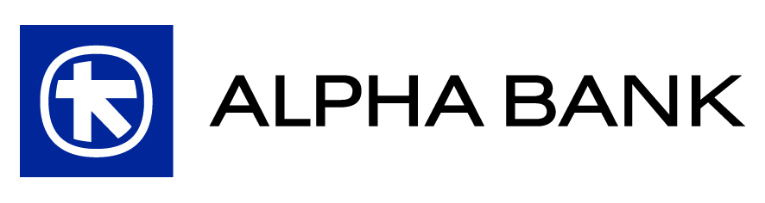

Resolutions
of the Extraordinary General Meeting of Shareholders of Alpha Bank on 3.12.2012
(article 32 para. 1 of codified law 2190/1920, para. 4.1.3.3. of the Athens Exchange Regulations)

The Extraordinary General Meeting of Shareholders of Alpha Bank, which was held on 3.12.2012 at 10:00, was attended in person or by proxy by 5,562 Shareholders, representing 166,892,934 common, nominal, paperless shares with voting rights, out of a total of 734,269,648 shares, of which 534,269,648 are common, nominal, paperless shares with voting rights, namely 31.24% of the voting share capital of the Bank.

Item 1: Issuance by the Bank, and private placement with Crédit Agricole S.A. or a company affiliated thereto, of a bond loan, in paper form, of total principal amounting up to Euro 150 million, convertible by the bondholder into common voting shares of the Bank and redeemable by the latter, upon cancellation of the pre-emption rights of the existing (common and preferred) Shareholders of the Bank. Grant of authority to the Board of Directors of the Bank to issue and place, as well as to agree on the specific terms of, the bond loan and perform the requisite juridical or other acts.

Minimum Required Quorum: 2/3 of the total common shares with voting rights issued by “Alpha Bank A.E.” (the “Bank”).

Achieved Quorum: 31.24% of the total common shares with voting rights issued by the Bank.

The discussion of this specific item was postponed because the required quorum was not achieved. This item will be discussed at the First Iterative Extraordinary General Meeting on Friday, December 14, 2012, at 10:00, at the Hilton Athens Hotel, 46 Vassilissis Sophias Avenue, Athens.

Item 2: Delegation of authority, in accordance with articles 13 para. 1 case (b) and 3a para. 3 section first of codified law 2190/1920, as the case may be, by the General Meeting to the Board of Directors of the Bank: (i) to increase the share capital of the Bank, through the issuance and distribution of new shares, the amount whereof shall be paid in cash and/or by contribution in kind, and (ii) to issue one or more bonds convertible into Bank shares.

Minimum Required Quorum: 2/3 of the total common shares with voting rights issued by the Bank.

Achieved Quorum: 31.24% of the total common shares with voting rights issued by the Bank.

The discussion of this specific item was postponed because the required quorum was not achieved. This item will be discussed at the First Iterative Extraordinary General Meeting on Friday, December 14, 2012, at 10:00, at the Hilton Athens Hotel, 46 Vassilissis Sophias Avenue, Athens.

