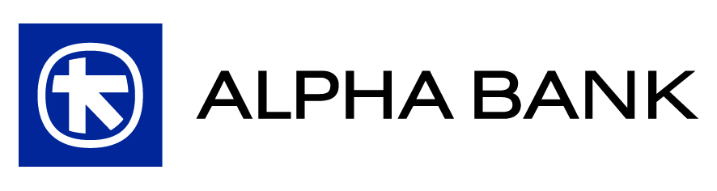

NUMBER OF SHARES AND VOTING RIGHTS

Pursuant to article 27, para. 3, section (b) of codified law 2190/1920, as in force, it is reported that on the day of the Invitation to the Extraordinary General Meeting of Shareholders the total number of shares of the Bank is 734,269,648 shares, of which 534,269,648 are common, nominal, voting, paperless shares and 200,000,000 are preferred, nominal, non-voting, in paper form, redeemable shares issued in accordance with the provisions of law 3723/2008.

