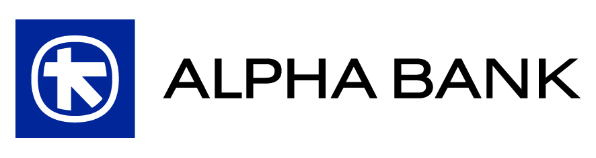

SECOND ITERATIVE EXTRAORDINARY GENERAL MEETING OF SHAREHOLDERS

Thursday, December 27, 2012
(article 27 para. 3 section (d) of codified law 2190/1920)

Item 1^{ο}: Issuance by the Bank, and private placement with Crédit Agricole S.A. or a company affiliated thereto, of a bond loan, in paper form, of total principal amounting up to Euro 150 million, convertible by the bondholder into common voting shares of the Bank and redeemable by the latter, upon cancellation of the pre-emption rights of the existing (common and preferred) Shareholders of the Bank. Grant of authority to the Board of Directors of the Bank to issue and place, as well as to agree on the specific terms of, the bond loan and perform the requisite juridical or other acts.

Minimum Required Quorum: 20% of the total common shares with voting rights issued by “Alpha Bank A.E.” (the “Bank”).

Minimum Required Majority: 2/3 of the total voting rights (present or represented) plus (+) one vote (present or represented).

Within the current adverse environment, where the circumstances dictate the strengthening of the banking system, the recent conclusion of an agreement for the acquisition of Emporiki Bank of Greece (hereinafter “EBG”) by the Bank constitutes an important step towards this direction (hereinafter the “Transaction”). The new group of the Bank and EBG will have high capital adequacy ratios and will hold a significant share in all the business sectors in Greece. Crédit Agricole S.A.’s (hereinafter “CASA”) decision to select the Bank as counterparty is indicative of the prestige and the ability of the Bank, as a partner, to complete reliably and successfully the Transaction.

This is further attested by the fact that CASA, within the context of this Transaction, has agreed with the Bank to invest part of the liabilities of the EBG to the CASA group in the coverage of a bond loan, of a total principal amount of up to Euro 150 million, issued by the Bank, convertible by the bondholder into common paperless voting shares of the Bank and redeemable by the latter. The exercise of the conversion right, solely at the discretion of the bondholder, may be performed upon the 4th anniversary of the completion of the Transaction, under certain conditions associated with the attainment of specific ratios by the combined group.
The conversion price of the bonds will be equal to the quotient of the division where the numerator is the nominal value of each bond and the denominator is the highest price between (i) the offer price per share issued by the Bank, which the Hellenic Financial Stability Fund (“HFSF”) will pay, with a view to participating in and covering the recapitalisation of the Bank and (ii) the average (weighted in terms of trade volume) price of the Bank’s share during the last quarter before the conversion of the said bonds, thus ensuring that the conversion price was determined in a fair and reasonable manner. The conversion price may also be adjusted, in accordance with common practice, in the case of occurrence of corporate events which could result in the amendment of the economic value of the bonds to be issued.
In case that either the (above) conversion terms are not fulfilled or CASA chooses not to convert the bonds of the bond loan, then, ipso facto, the non-converted bonds of the bond loan will be repurchased by the Bank by paying to CASA the amount of Euro 1.00 per each repurchased bond.

Taking into account the aforementioned, the Board of Directors of the Bank proposes to the General Meeting the approval of the issuance of the said convertible bond loan, upon cancellation at the same time of the pre-emption rights of the existing Shareholders (common and preferred), as, in this way, the completion of the Transaction is facilitated and, at the same time, the capital adequacy and liquidity of the combined group are directly enhanced, laying the foundation for a strategic partnership with a leading international financial group.

Item 2^{ο}: Delegation of authority, in accordance with articles 13 para. 1 case (b) and 3a para. 3 section first of codified law 2190/1920, as the case may be, by the General Meeting to the Board of Directors of the Bank: (i) to increase the share capital of the Bank, through the issuance and distribution of new shares, the amount whereof shall be paid in cash and/or by contribution in kind, and (ii) to issue one or more bonds convertible into Bank shares.

Minimum Required Quorum: 20% of the total common shares with voting rights issued by “Alpha Bank A.E.” (the “Bank”).

Minimum Required Majority: 2/3 of the total voting rights (present or represented) plus (+) one vote (present or represented).

Given the uncertainty of the current adverse financial conditions, the Bank deems that, retaining flexibility for the implementation of a share capital increase and/or placement of a convertible bond loan, beyond the framework of law 3864/2010, benefits the Shareholders, ensures the ability of the Bank to respond promptly to constantly altering circumstances and contributes to securing the best possible terms for the Shareholders.

For this reason, the Board of Directors proposes to the General Meeting to approve the delegation of authority to the Board of Directors to increase, during the next two years, the share capital of the Bank and/or issue convertible bond loans, of a total principal up to the amount of the issued and paid-in share capital of the Bank, which amounts to Euro 1,100,280,894.40.

