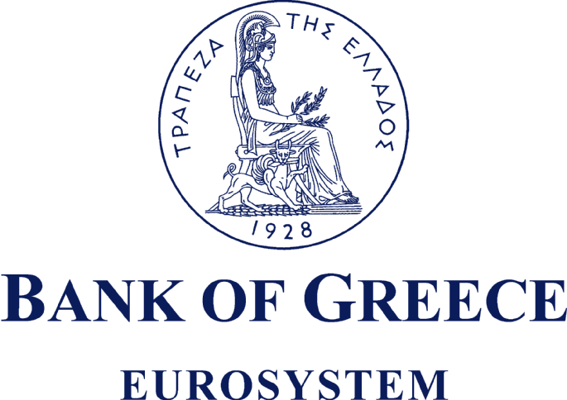

ANNOUNCEMENT

Decisions of the 79th Annual Ordinary General Meeting of Shareholders of the Bank of Greece – Voting results
In accordance with Article 32(1) of Law 2190/1920 and Article 4.1.3.3 of the Athens Exchange Rulebook, it is hereby announced that the 79th Annual Ordinary General Meeting of Shareholders of the Bank of Greece, held on Tuesday 24 April 2012 at 12.00 noon, was attended by 81 shareholders and shareholders’ proxies, representing 8,476,358 shares, corresponding to 112,913 voting rights, out of a total of 19,864,886 shares, corresponding to 264,865 voting rights*(i.e. 42.67% of the share capital).
The General Meeting adopted the following decisions:
- It unanimously** approved the Governor’s Annual Report, the Balance Sheet and other Financial Statements for the year 2011, including the Auditors’ Report.
- It unanimously** approved the appropriation of net profits, totalling €96,636,842, as follows:
€ 13,309,473 for the payment of a dividend of €0.67 per share on 19,864,886 shares (equal to 12% of the Bank’s capital);
€ 3,327,369 for the payment of tax on dividends (at 20%, in accordance with Article 14(9) and (10) of Law 3943/2011); and
€ 80,000,000 payable to the Government.
The dividend for distribution comes to €0.67 per share and is subject to a 25% withholding tax in accordance with Article 14(1) and (2) of Law 3943/2011. The net dividend to be received by shareholders, following such withholding, will be €0.5025 per share.
Entitled to receive the current dividend shall be all shareholders recorded in the register of the Dematerialised Securities System (DSS) as at 4 May 2012 (record date).
The ex-dividend date has been set as 2 May 2012. From this date, Bank of Greece shares will trade on the Athens Exchange without entitlement to the current dividend.
The dividend payment date has been set for 10 May 2012. Dividend payments will be effected in accordance with the procedure laid down in Article 5.5 of the Athens Exchange Rulebook and the specific provisions of the Operating Regulations of the DSS, with the following options open to shareholders:
a) Payment through a market operator, i.e. a securities brokerage firm, chosen and duly authorised by the shareholder to collect the dividend.
On 10 May 2012, the Bank of Greece will credit the bank accounts of the market operators, which will then transfer the dividends to their shareholder customers. It should be noted that a shareholder has the right to revoke such authorisation, by lodging a relevant written request with Hellenic Exchanges S.A. (HELEX S.A.) at least five business days before the dividend payment date.
b) Payment directly from the Bank of Greece, either by crediting the bank account specified by the shareholder or by issuance of a cheque, in instances where:
- the shareholder has not authorised a market operator to collect the dividend on his behalf;
- the shareholder has, in a written request duly lodged with HELEX S.A., revoked such authorisation;
- the shareholder’s shares are held in a Special Account of their Investor Share.
The payor Bank will be the Bank of Greece.
In cases where, for whatever reason, the designated bank accounts cannot be credited, the dividends shall be payable at the Bank of Greece as from 21 May 2012.
- It unanimously** approved the amendments to Articles 1, 8, 13, 26, 28, 31, 55A and 71 of the Bank’s Statute.
- It unanimously** approved the remuneration and travel expenses of the members of the General Council.
- It unanimously** approved the Auditors’ fees for the year 2012.
- It unanimously** discharged the members of the General Council and the Auditors from all personal responsibility in connection with the Bank’s activities and management for the year 2011.
- It elected Mr Christos Polyzogopoulos as member of the Bank’s General Council.
(Number of shares validly voted upon: [8,285,451]. Total number of valid votes: [110,391]. Percentage of the share capital: [41.71%]. Votes IN FAVOUR: [110,391]. Votes AGAINST: [0]. Abstentions: [2,522])
- It elected KPMG Certified Auditors A.E. as Auditors for the year 2012.
(Number of shares validly voted upon: [8,287,696]. Total number of valid votes: [110,420]. Percentage of the share capital: [41.72%]. Votes IN FAVOUR: [110,420]. Votes AGAINST: [0]. Abstentions: [2,493])

Athens, 24 April 2012
Human Resources & Organisation Department
Secretariat Section

* It should be noted that each seventy-five (75) shares confer the right to one (1) vote (Article 13 of the Statute of the Bank of Greece, taken together with decision No. 2/29.2.2000 of the General Council of the Bank increasing the minimum number of shares required for a shareholder to participate, be represented and vote at a General Meeting of Shareholders of the Bank from twenty-five (25) to seventy-five (75), following the split – under Article 9 of the Bank’s Statute – of the share of the Bank of Greece pursuant to decision No. 1/17.1.2000 of the Bank’s General Council, which was approved by Act of the Council of Ministers No. 8/4.2.2000 – Government Gazette A 17/7.2.2000). ** Number of shares validly voted upon: [8,476,358]. Total number of valid votes: [112,913]. Percentage of the share capital: [42.67%]. Votes IN FAVOUR: [112,913]. Votes AGAINST: [0]. Abstentions: [0].

