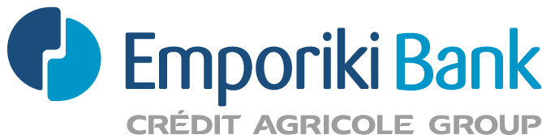

ΔΙΕΥΘΥΝΣΗ ΕΤΑΙΡΙΚΩΝ ΥΠΟΘΕΣΕΩΝ
Κ4-01-063

ΚΑΙ ΓΡΑΜΜΑΤΕΙΑΣ Δ.Σ.
Σοφοκλέους 11, 105 59 Αθήνα
Τηλ.: 210-328 4991 Fax: 210-328 4823
E-mail: secretariat.div@emporiki.gr
Επιστολή μας: 801/Τ2/243

Αθήνα, 14.10.2011

ANNOUNCEMENT

“EMPORIKI BANK OF GREECE S.A.”, announces that – according to article 10, par. 1, of Law 3340/2005, as well as to article 2, par. 2, of the Decision No 3/347/12.07.2005 issued by the Hellenic Capital Market Commission - οn 14/10/2011, covered the share capital increase of its subsidiary “EMPORIKI BANK ALBANIA S.A.” by disbursing the amount of 1,999,340.96€. It is noted that by this disbursement “EMPORIKI BANK OF GREECE S.A.”, as sole shareholder or “EMPORIKI BANK ALBANIA S.A.”, covered in full the amount of the Share Capital Increase of the latter.

Τhe share capital of “EMPORIKI BANK ALBANIA S.A.” after the increase, amounts to 35,567,479.84€ and corresponds to 43,798 common shares of nominal value 812.08€ each.

Consequently, “EMPORIKI BANK OF GREECE S.A.”, owns from now on 43,798 shares of “EMPORIKI BANK ALBANIA S.A.” which represent the 100.00% of its share capital.

