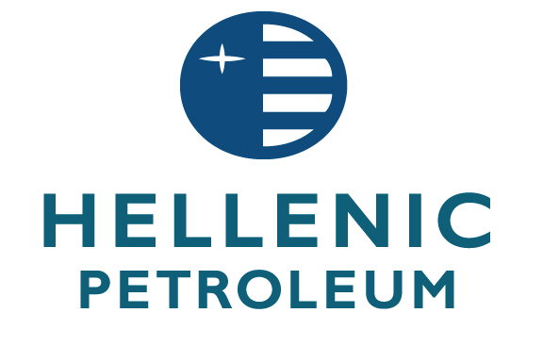

APPOINTMENT OF A NEW BOARD OF DIRECTORS

28 June 2103

HELLENIC PETROLEUM S.A. announces the appointment of new Board of Directors as follows:

α) the following seven (7) members were appointed by Hellenic Republic: Mr Christos-Alexis Komninos, Mr. Ioannis Costopoulos, Mr.Ioannis Sergopoulos, Mr.Vasilios Nikoletopoulos, Mr.Aggelos Chatzidimitriou, Mr.Christos Razelos and Mr. Ioannis Raptis

b) the following two (2) members were appointed by the Shareholder under the corporate name «Paneuropean Oil and Industrial Holdings S.A.»: Mr. Theodoros – Achilles Vardas and Mr. Andreas Shiamishis.

c) the following two (2) members were elected by the employees of the Company: Mr. Panagiotis Ofthalmidis and Mr. Konstantinos Papagianopoulos and

d) the following two (2) members were elected by the Special General Minority Shareholders Meeting: Mr. Theodoros Pantalakis and Mr. Spyridon Pantelias.

Following the above, at the meeting of the Board of Directors no. 1201 that took place on 27.6.2013, the BoD constituted into a body and it decided upon the appointment of its Executive and Non-Executive members, pursuant to the provisions of the company’s Articles of Association and Law no.3016/2002 on Corporate Governance, as follows:

- Executive Members

- Christos-Alexis Komninos, Chairman
- Ioannis Costopoulos , Chief Executive Officer
- Theodoros- Achilles Vardas, Executive Director
- Andreas Shiamishis, Executive Director

- Non - Executive Members

- Vasilios Nikoletopoulos, Non-Executive Member
- Panagiotis Ofthalmidis, Non-Executive Member- Employers Representative
- Theodoros Pantalakis, Non-Executive Member- Minority Shareholders Representative.
- Spyridon Pantelias, Non-Executive Member -Minority Shareholders Representative.
- Konstantinos Papagiannopoulos, Non-Executive Member- Employers Representative
- Christos Razelos, Non-Executive Member.
- Ioannis Raptis, Non-Executive Member
- Ioannis Sergopoulos, Non-Executive Member.
- Aggelos Chatzidimitriou, Non-Executive Member.

The above Board of Directors will have a term of five years, until 26.6.2018, pursuant to article 20 of the company’s Articles of Association.

