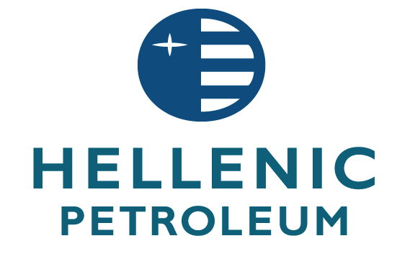

RESOLUTIONS OF THE ANNUAL GENERAL MEETING OF 27 JUNE 2013
“Hellenic Petroleum S.A.” announces that at the Annual General Meeting of the Shareholders of the company, which was held on 27.06.2013, at 12.00 at the Company's premises in Aspropyrgos (17th km of Athens - Corinth National Road), 159 shareholders, representing 261,392,423 shares and voting rights, out of a total of 305,635,185 shares, i.e. 85.53% of the paid up share capital, were present or legally represented at the meeting.
The Annual General Meeting resolved as follows on the following items of the agenda:

1. The Board of Directors’ report for the fiscal year 2012 was approved.

Number of shares accounting for valid votes: 261.392.423
Percentage of the share capital: 85,53%
Total number of valid votes: 261.392.423
Number of votes in favor: 261.392.423 against: - abstained: -

2. The financial statements of the company and the consolidated financial statements of the Group, along with the relevant reports, for the fiscal year 2012 were approved, according to the International Financial Reporting Standards.

Number of shares accounting for valid votes: 261.392.423
Percentage of the share capital: 85,53%
Total number of valid votes: 261.392.423
Number of votes in favor: 261.392.423 against: - abstained: -

3. The distribution of an ordinary dividend of €0.15 per share was approved. The Company's General Meeting decided that the shares will trade ex-dividend on 16.8.2013, while 20.8.2013 is defined as the date for determination of the dividend beneficiaries (record date). Dividend payments (deducting applicable taxes and charges in accordance with the tax law provisions) will start on 26.8.2013 through National Bank of Greece S.A.

Number of shares accounting for valid votes: 261.392.423
Percentage of the share capital: 85,53%
Total number of valid votes: 261.392.423
Number of votes in favor: 261.392.423 against: - abstained: -

4. The acquittal of the members of the Board of Directors and the Auditors from any liability for compensation for the fiscal year 2012, in accordance with article 35 of L.2190/1920.

Number of shares accounting for valid votes: 261.392.423
Percentage of the share capital: 85.53%
Total number of valid votes: 261.392.423
Number of votes in favor: 261.392.423 against: - abstained: -

5. The new Board of Directors has been ascertained and approved. The term of such Board will be with five years, i.e. until 26.6.2018, according to the article 20 par.1 of the Articles of Association of the Company. The Board of Directors is composed as follows:

- Christos-Alexis Komninos
- Ioannis Costopoulos
- Theodoros- Achilles Vardas
- Andreas Shiamishis
- Vasilios Nikoletopoulos
- Panagiotis Ofthalmidis
- Theodoros Pantalakis
- Spyridon Pantelias
- Konstantinos Papagiannopoulos
- Christos Razelos
- Ioannis Raptis
- Ioannis Sergopoulos
- Aggelos Chatzidimitriou

6 a. The approval of the remuneration and fees paid to the members of the BoD and the fees paid to non - executive members of BoD who participate in its Committees for the fiscal year 2012, at the amount of €245.250.

b. In addition, the AGM decided to maintain for the fiscal year 2013 the monthly gross remuneration and compensation of the Board members at the same level as in the previous year. More specifically, the following have been resolved:
The monthly gross fixed remuneration of the members of BoD (applicable since December 2009) has been determined at the amount of € 977.50,
The gross compensation per meeting of BoD (applicable since May 2005) for up to three (3) meetings per month has been determined at the amount of € 390,
The gross remuneration for non - executive members of BoD who participate in its Committees, and do not have an employment agreement with the company has been determined at the amount of € 500, including the Audit Committee in accordance with the provisions of Law 3693/2008, article 37.

Number of shares accounting for valid votes: 261.392.423
Percentage of the share capital: 85,53%
Total number of valid votes: 261.392.423
Number of votes in favor: 261.351.661 against: 102 abstained: 40.660

7. The following were also approved:
An already paid remuneration in the amount of € 407.860,85 for the fiscal year 2012 in total, to the Chairman of BoD Christos-Alexis Komninos (€168.813,59) and to the Chief Executive Officer of the Company Ioannis Costopoulos (€239.047,26).
The maintaining , for the fiscal year 2013, of the annual gross remuneration of the Chairman of BoD Christos-Alexis Komninos at the amount of € 170.000, that has been initially resolved by the Extraordinary General Meeting of 28.12.2009.
The maintaining , for the fiscal year 2013, of the annual gross remuneration of the Chief Executive Officer of the company Ioannis Costopoulos at the amount of € 238.000, that has been initially resolved by the Extraordinary General Meeting of 28.12.2009.

Number of shares accounting for valid votes: 261.392.423
Percentage of the share capital: 85.53%
Total number of valid votes: 261.392.423
Number of votes in favor: 260.867.792 against: 524.631 abstained: 0

8. The election for the fiscal year 2013, according to the provisions of the company’s Articles of Association, of the auditing company PWC (Price Waterhouse Coopers) – registry number (“AM SOEL”) 113, with remuneration set at the amount of €470,000, plus VAT, and the following corporate domicile:

PWC (Price Waterhouse Coopers)
268 Kifissias avenue,
15232 Chalandri
Athens - Greece

Number of shares accounting for valid votes: 261.392.423
Percentage of the share capital: 85,53%
Total number of valid votes: 261.392.423
Number of votes in favor: 254.458.878 against: 6.912.457 abstained: 21.088

9. The following were also approved:

- The granting of a special (ex post) permission in accordance with article 23a paragraph 4 of C.L. 2190/1920 for the extension of the duration of the Memorandum of Understanding between the Hellenic Republic, the Hellenic Republic Asset Development Funds S.A. and Hellenic Petroleum S.A., relating to the sale of DEPA SA and DESFA SA, dated 16.02.2012, until 30.6.2013. Such extension has already been approved by virtue of the resolution of the Board of Directors No. 1197/28.02.2013 and
- The granting of a special (ex ante) permission in accordance with article 23a paragraph 2 of C.L. 2190/1920 for the extension of the duration of the aforementioned Memorandum of Understanding, beyond 30.6.2013, until 30.9.2013.

Number of shares accounting for valid votes: 261.392.423
Percentage of the share capital: 85.53%
Total number of valid votes: 261.392.423
Number of votes in favor: 261.392.423 against: - abstained: -

MAROUSI 28.6.2013
THE BOARD OF DIRECTORS

