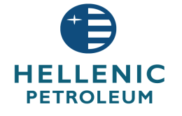

**ANNOUNCEMENT**

December 18, 2014

The Board of Directors of Hellenic Petroleum S.A. decided today the appointment of Mr. Andreas Shiamishis, Group CFO and Executive Board Member, as Deputy Chief Executive Officer. Mr. Shiamishis will retain his duties as CFO and will assume the responsibility of Greek and International Fuels Marketing activities.

Mr. Shiamishis has been an Executive Board Member of Hellenic Petroleum S.A. since 2013 and Group CFO since 2005. He holds an Economics degree and is a Fellow Member (FCA) of the Institute of Chartered Accountants in England and Wales, with significant management experience with Greek and international companies.