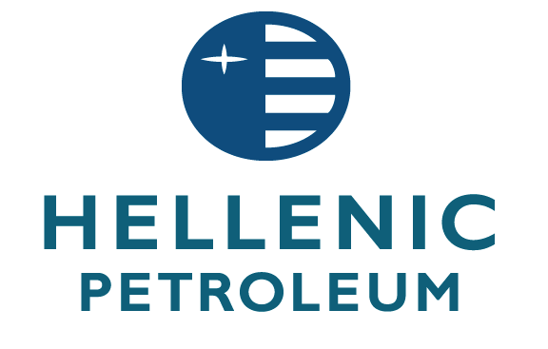

20/12/13

**STOCK OPTION PLAN**

HELLENIC PETROLEUM S.A. (the “Company”) in accordance with article 4 par.1 (ε) of law 3401/2005 announces that:

As part of implementing the employees’ stock option plan of the HELLENIC PETROLEUM S.A. (the “Plan”), as adopted by the Company’s Shareholder Meeting of 25.05.2013 and amended by the Board of Directors of 3rd of December 2013, the beneficiaries of the Plan should submit a declaration to the Company, between 1 November 2013 and 13 January 2014, in accordance with the Plan’s requirements, about their intention to exercise their rights, in part or full. The exercise of the right during the aforementioned the period refers to stock options granted in 2009 and corresponds to 1,704,716 new Ordinary shares of the Company with nominal value of 2.18 euro each, which will result from a share capital increase of the Company, that will take place immediately after the exercise of the rights.

Following the exercise of stock options from the beneficiaries, the Company’s Board of Directors will undertake all necessary actions to increase the share capital of the company and will proceed to the issue of new ordinary shares based on the number of options that will be exercised, while existing shares will not have any pre-emption right on the new issue, according to Article 13 par.13 of the law 2190/1920. The Board of Directors will then proceed to all necessary actions required by the law, so that the shares corresponding to the exercised rights will be admitted for trading to the Athens Stock Exchange.

Currently the Company’s fully paid share capital amounts to 666,284,703.3 euro and is divided into 305,635,182 common shares with a nominal value of 2.18 euro each. According to the plan the issue price of the new shares is set at 7.62 euro per share.

The number of the new shares that will be finally issued and admitted in the Athens Stock Exchange depends on the number of option rights that will be exercised and for which the corresponding amount will be paid.