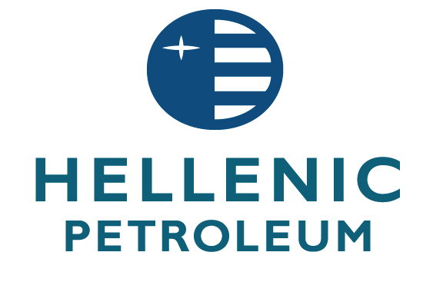

April 19, 2013

ANNOUNCEMENT

Hellenic Petroleum SA (NR/NR) has mandated Alpha Bank, Credit Suisse, Eurobank, HSBC and NBG Securities to arrange a series of fixed income investor meetings in Athens, Zurich, Geneva and London from April 23nd. A RegS capital markets transaction may follow subject to market conditions.

NOT FOR PUBLICATION OR DISTRIBUTION, DIRECTLY OR INDIRECTLY, IN OR INTO THE UNITED STATES.

