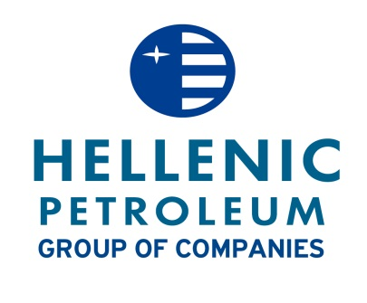

June 10, 2014

**Announcement of proposed amendments to the articles of association**

HELLENIC PETROLEUM SA announces that, according to article 19 par. 2 of Law 3556/2007 and the ATHEX Rulebook, the proposed amendments of Articles 11, (par 2. points b, c, par. 3, par.4 ) 18 par.2, 26 par.6 points a.b.c, par.9 of the Company’s Articles of Association are available on the Company’s website on [www.helpe.gr](http://www.helpe.gr).