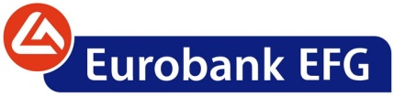

*Monday, January 30, 2012*

**ANNOUNCEMENT**

Pursuant to its recent announcement, Eurobank informs that it is consulting with Alpha Bank in order to complete the merger process the soonest possible, and considers that there are no reasons to delay the completion of the merger.-