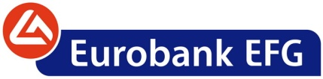

Thursday, September 22, 2011

ANNOUNCEMENT
Reduction of the nominal value of the ordinary share of the Bank through a corresponding share capital decrease

EFG Eurobank Ergasias S.A. (the “Bank”) announces that the Ministry of Development, Competitiveness and Shipping approved, by its decision No K2-8060/20.09.2011, the decrease of the Bank's share capital by reducing the nominal value of the ordinary share from €2.81 to €2.22 and the amendment of article 5 of the Bank's Articles of Association. As resolved at the Repeat Annual General Meeting of 11th July 2011, the share capital decrease amounting to €326 million has been effected in order to offset transformation losses incurred from previous years’ mergers and losses carried forward and it does not change the number of existing ordinary shares nor does it affect the Bank’s accounting and regulatory equity.

Following the decrease, the Bank's share capital amounts to €2,177,670,507.94, divided into 898,448,427 shares, of which a) 552,948,427 shares with voting rights, of a nominal value of €2.22 each, and b) 345,500,000 preference shares without voting rights, issued under L.3723/2008, of a nominal value of € 2.75 each.

The Athens Exchange was informed on 22.09.2011 for the decrease of the nominal value of the Bank's ordinary shares.

Following the above, as of Wednesday, September 28, 2011 the Bank's ordinary shares will be trading at the Athens Exchange with the new nominal value of €2.22 per share.-

