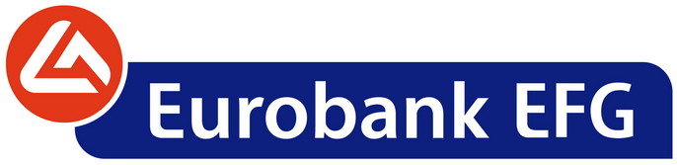

Monday, October 24, 2011

ANNOUNCEMENT

Resolutions of the Bank’s Extraordinary General Shareholders’ Meeting of 24.10.2011

EFG Eurobank Ergasias S.A. («Bank») announces that, at the Extraordinary General Shareholders’ Meeting which was convened today with a quorum of 57% corresponding to the paid up ordinary share capital, the discussion regarding the merger of the Bank with ALPHA BANK S.A. by absorption of the former by the latter was postponed, due to lack of quorum and will be held at the 1st Repeat Extraordinary General Meeting to be convened on Friday, November 4th, 2011, at 12 p.m., at the Divani Caravel Hotel, 2 Vassileos Alexandrou Street, Athens, according to the 30.9.2011 notice. At that Repeat General Meeting, the shareholders will be updated on matters concerning the combined ALPHA-EUROBANK entity to be discussed and resolved upon by ALPHA BANK S.A.’s Extraordinary General Meeting which has been convened to approve the merger.

It is reminded that in case the quorum required by law will not be achieved at ALPHA BANK SA’s 1st Repeat Extraordinary General Meeting that has been convened to decide on the above merger, but will have been achieved at the Bank’s 1st Repeat Extraordinary General Meeting, this Repeat General Meeting of the Bank will be asked to postpone the discussion and decision making on the merger issue and the Meeting to be continued on Tuesday 15 November 2011, at 10 a.m., at the Divani Caravel Hotel.-

