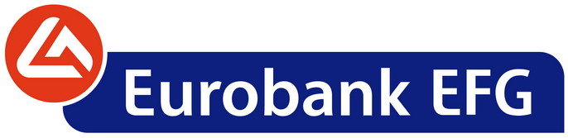

Monday, October 31, 2011

ANNOUNCEMENT

Reply to the Hellenic Capital Market Commission’s request dated 27.10.2011

In reply to the Hellenic Capital Market Commission’s request dated 27.10.2011, the Bank EFG Eurobank Ergasias S.A. (“Bank”) announces that, in the context of the test conducted by the European Banking Authority (EBA), the Bank holds no privileged information regarding its estimated required capital buffer.

The detailed methodology of EBA, according to which the required capital buffers were estimated for the 9% Core Tier 1 ratio, was published on 27th October 2011 together with the relevant results per country. In particular for Greece, EBA notified only that the funds available to the Hellenic Financial Stability Fund (HFSF), amounting to €30 billion, outbalance the required, according to EBA, capital to reach a level of 9% Core Tier 1 ratio.-

