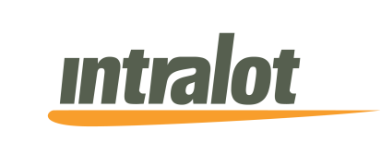

13/7/2015

**Announcement**

Following the decision of the Extraordinary General Meeting of the Shareholders of the company dated 19.06.2015 which (2nd issue) approved in accordance with article 23a of Codified Law 2190/1920 the amendment and reinstatement of the shareholders agreement to a single document that had been signed in 2001 between the shareholders of Intralot Inc that is based in the State of Georgia, U.S.A., the company informs that the process of signing the above mentioned agreement concluded. The above agreement foresees, among others, the following: increase of the members of the BoD of Intralot Inc. from 3 to 5, the right of the minority shareholders to appoint one member each in the BoD given they own at least 5% of Intralot Inc., the pricing in case of acquisition of the shares of the minority shareholders in the case that the option rights will be exercised (call or put option) from a company’s subsidiary with a price of 1 mil. USD for every 1% of shares transferred, an amount that has been justified as fair according to a relative financial valuation (fairness opinion) of an independent audit firm, as well as pre-emption rights of the existing shareholders and common option rights (drag along & tag along, call & put) in case of transfer of shares.