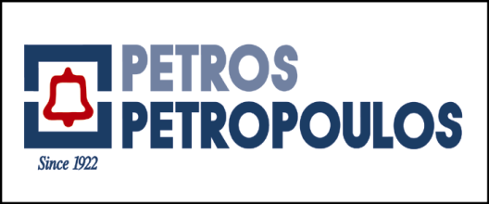

**Athens, 28 December 2017**

An agreement was signed today between Petros Petropoulos AEBE and Kubota Corporation, based in Japan. With this agreement, the two companies committed to a long-term cooperation to distribute Kubota machinery in Greece.

Kubota Corporation is one of the world's largest manufacturers in the fields of agricultural tractors, related machinery, engines for industrial machinery, project machinery, irrigation and water treatment systems.

Kubota has over 30 years of presence in Greece, with a significant market share. Petros Petropoulos AEBE extensive sales and technical support network will continue and reinforce its efforts to meet the needs of customers.

This new activity will constitute an Autonomous Business Unit for Petros Petropoulos AEBE. Sales from this Unit are expected to make a positive impact on the 2018 financial results.

*Petros Petropoulos S.A. was established in Thessaloniki in 1922. It manufactures, modifies, distributes and supports a wide range of automotive products including automobiles, trucks and buses, generating sets, diesel engines, boats, outboard engines, agricultural, earthmoving and industrial equipment, batteries, lubricants and tires. The Company holds a leading position in the Greek market in the sectors which it serves.*