ΚΡΙ-ΚΡΙ βιομηχανια γαλακτοσ Αbee  3^{Ο} χλμ. σερρων – δραμασ 62125 σερρεσ  Τηλ: 23210 68300, fax: 23210 68311  Αρ. γ.ε.μη. 113772252000, α.φ.μ.: 094289571 | 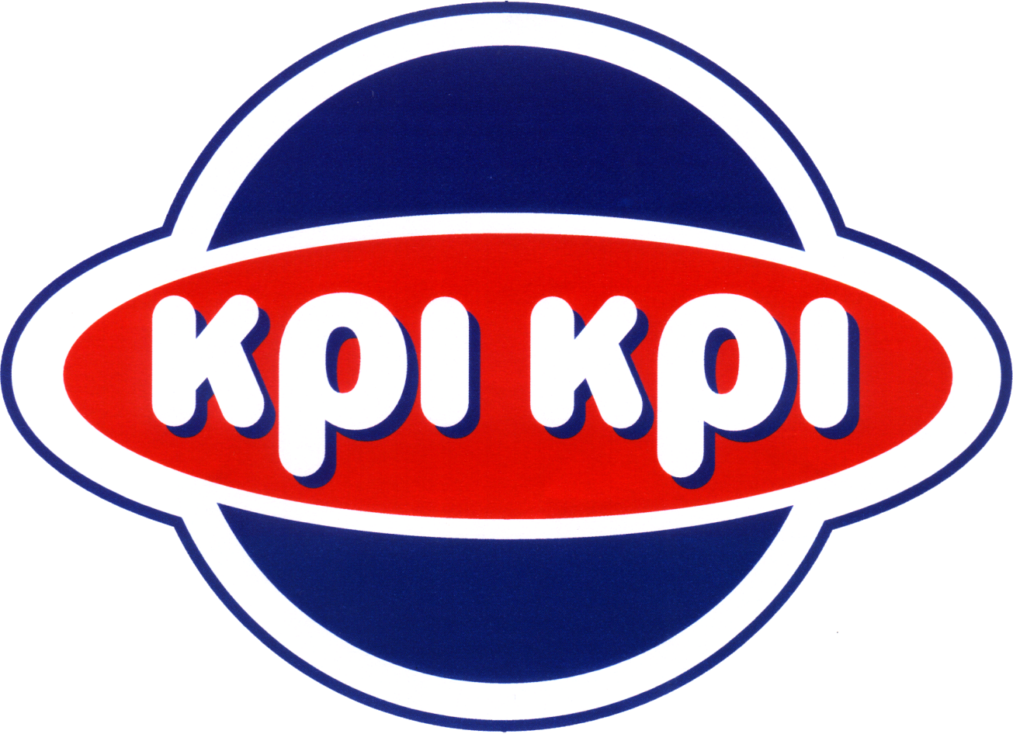 | KRI-KRI milk industry s.a.  3rd km. SERRES – DRAMA, 62125, SERRES, greece  TEL: +30 23210 68300, fax: +30 23210 68311  reg No: 113772252000, VRN: el094289571

Serres, 27.5.2020

Financial Calendar 2020

KRI-KRI S.A. announces amendments to Financial Calendar for 2020, with reference of the date of the release of interim financial statements for Q1-2020.

Release of interim Q1-2020 Financial Statements:
Thursday, 28th of May 2020 (after the market close of the Athens Stock Exchange).

