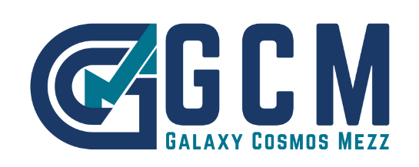

*Nicosia, November 3, 2022*

**Announcement**

**Notification of voting rights**

Galaxy Cosmos Mezz PLC (”the Company”) announces, in accordance with Article 14 of the Alternative Market Regulation, as in force, and following relevant notification from the Reggeborgh Invest BV dated November 2, 2022, that the latter holds directly as of October 31, 2022 (first day of trading of the Company shares on the EN.A. PLUS segment of the Alternative Market of Athens Stock Exchange), 4,826,611 common registered voting shares of a nominal value of €0.27 each, namely 5.55% of the total number of 86,194,164 common shares and voting rights of the Company.